**Contract Management 101**

**Module 2**

**Contract Management Overview**

|  |
| --- |
| 03/10/2015 Current Version |
| 12/02/2014 Original Version |

Table of Contents

Contract Management Overview 3

Course Introduction 4

Three Phases of Contract Management 7

The Importance of Pre-Award Planning 20

Contract Execution and Why it Matters 28

Tips & Tools to Plan Ahead 40

# Contract Management Overview

## Course Introduction

**Slide 2 – Course Introduction**

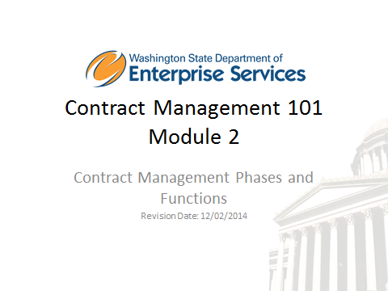

Welcome to Contract Management 101, Module 2. This is a new Training driven by Procurement Reform, and is required for all Contract Managers.

In order to receive credit for this course, you will need to score 80% or higher on the module assessment. The assessment will begin at the end of this module. Once you have successfully completed all four modules and assessment, you will receive a Contract Management 101 certificate of completion.

Also included in the training course are knowledge checks. These are not graded, they are simply used to test your knowledge of the materials in the course.

We strongly recommend you print the workbook for the course. As you proceed through the training, use the workbook to write down any notes and/or questions you might have.

The workbook can be accessed here: http://des.wa.gov/about/pi/ProcurementReform/Pages/PRTraining.aspx

**Disclaimer:**

At the time of publication in January 2015, all materials and RCWs referenced are current. Updated course work will be made available if and when revisions are needed. As always, confirm current RCW references.

Notes

**Slide 4 – Module Overview**

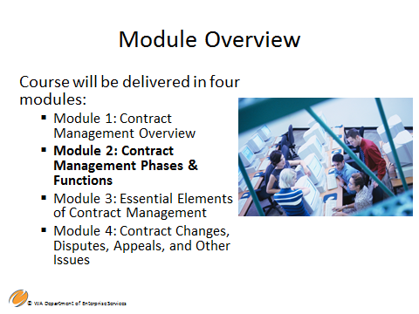

There are four modules in the Contract Management 101 training.

This course is **Module 2**:

* Contract Management Phases & Functions

The audience for the Contract Management 101 training course is contract management professionals in agencies with responsibility for administering, managing and monitoring contracts, vendor performance, and payments.

The desired outcome of this training course is to equip all Washington State contract management professionals with the basic knowledge and understanding to manage contractors, ensure compliance to the statement of work and contractor performance. These professionals will understand the role and responsibilities of a contract manager, the contract management cycle, and the basics skills to deal with situations that require contract changes or modifications due to contract disagreements.

This course does not address federal requirements that may apply to your contracts; for example if federal funding is part of your funding source then often federal reporting and contract terms are also required. Always check your funding source to identify any additional reporting or budget requirements and restrictions to ensure the proper use of funds.

Notes

**Slide 5 – Course Overview**

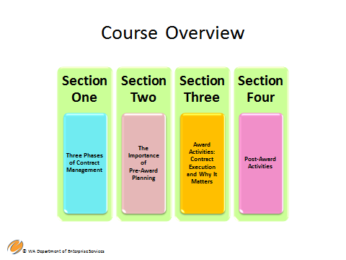

**Contract Management 101 Module 2 – Contract Management Phases and Functions –** there are 4 sections in this course that will cover the following topics:

**Section One – Three Phases of Contract Management**

* Contract Management Processes
* Pre and Post-Award Activities

**Section Two – The Importance of Pre-Award Planning**

* Procurement Initiation
* Planning for Effective Contract Management

**Section Three – Award Activities: Contract Execution and Why it Matters**

* Evaluation and Selection
* Negotiation and Contract Formation

**Section 4 – Post-Award Activities**

* Planning for Effective Contract Management and Monitoring
* Tips and Tools to Plan Ahead

These topics (listed here) are intended to take you through the objectives for this module.

It is important to note this training module will cover the topics identified on the slide. As you learned in the previous contract management training course, the importance of understanding your role and responsibilities within the contract management process. It is also important to be familiar with the roles and responsibilities of other purchasing, procurement, and contracting staff you collaborate with to accomplish your task. For example, the Purchasing and Procurement Professional will advise on things such as types of contract and pricing model and not the contract manager.

For purposes of this training course, the laws and policies discussed are those of the state and individual agencies and do not reflect federal requirements. Federal requirements tend to be more restrictive and may apply if using federal funds.

Notes

**Slide 6 – Learning Objectives**

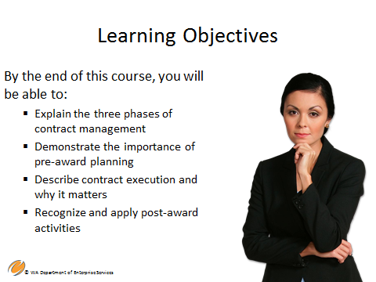

By the end of this course you will be able to:

* Explain the three phases of contract management
* Demonstrate the importance of pre-award planning
* Describe contract execution and why it matters
* Recognize and apply post-award activities

Notes

**Slide 7 – Three Phases of Contract Management**

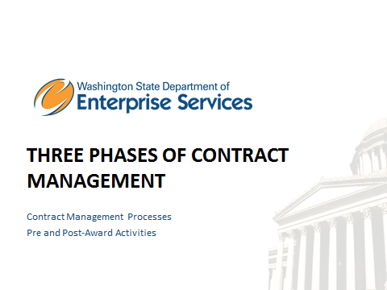

Section One - Three Phases of Contract Management, includes;

* Contract Management Processes
* Pre and Post-Award Activities

Notes

**Slide 8 – Three Phases of Contract Management**

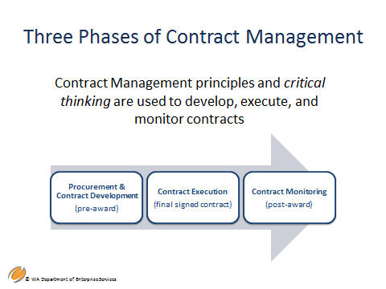

* Next, we’ll discuss the three phases of contract management

Notes

**Slide 9 – Contract & Project Management**

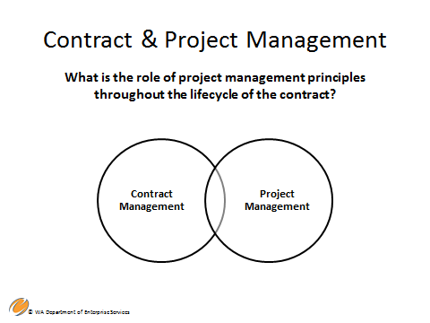

As discussed in Module 1, Contract Management can benefit from the application of principles and processes, methods, knowledge and skills commonly employed by project managers. By treating the procurement as a project, you can more effectively achieve a favorable outcome.

**Definition of a procurement:**

The combined functions of identifying needs, initiating a procurement project, selecting a vendor, contracting with a vendor, purchasing of goods or services, managing the resulting contract, and using goods and/or deploying services provided by a non-State entity on behalf of the State.

As the Contract Manager, you are a part of or manage all phases of the procurement – from start to finish. Procurements are projects.

Notes

**Slide 10 – Collaboration and Critical Thinking**

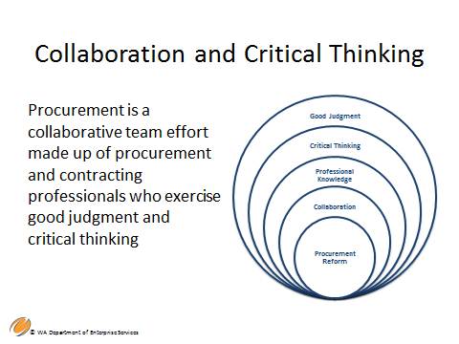

**Collaboration and Critical Thinking**

As noted in Module 1, Procurement Reform shifted culture from one of Prescriptive laws and policies to a more collaborative team environment made up of procurement professionals and contract managers who exercise good judgment and critical thinking skills when procuring goods or services. Of course this is still done in compliance with all applicable laws and policies.

As a refresher, examples of critical thinking include:

* Refer back to the agency mission, the RFP, and original scope of work often and in collaboration.
* Be clear about the signature authority and communicate often.
* Be familiar with and use the contract and refer to it often.
* Ability to “right-size” the procurement within the boundaries of statute and state policy.

Notes

**Slide 11 – Pre-Award Activities**

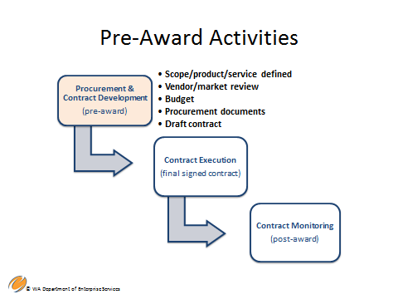

The following is a look at pre-award activities of the procurement and contract development phase.

1. Define the scope of work or the product requirements.
2. Conduct market research – are there vendors available? Is competition the best method or is sole source the best option?
3. What is your budget? Are there any specific rules regarding your funding?
4. Assist your procurement professionals with the development of the procurement document (either competitive or sole source), including the draft contract.
   * It is recommended that you include your standard contract template or draft contract in the competitive procurement document so that potential bidders are aware of and understand your agency’s terms and conditions prior to bidding.
   * The vendor should provide initial exceptions about these terms and conditions with their bid.
   * The exceptions to terms and conditions are ironed out during contract negotiation
   * Agency sample documents or templates should be approved as to form.

**Approval as to form.** Approval as to form by the Office of the Attorney General (ATG) verifies the legality of the contract instrument, but does not necessarily imply concurrence in or approval of the content. It is a good business practice to have the agency’s contract format or template reviewed “as to form” by the ATG prior to usage. As long as the ATG-approved contract format is used, it is not necessary that each contract executed by the agency be approved “as to form” by the ATG.

**Note:** In addition to approval “as to form,” it is advisable to have contracts reviewed by an Assistant Attorney General for “substance and content,” whenever additional legal advice is needed prior to finalizing the document. Each agency may determine which contracts they submit to the ATG for review.

1. Release competitive procurement document.

**Please note:** A procurement can also result in a purchase order, which is a purchaser’s written document to a vendor formalizing all the terms and conditions of a proposed transaction, such as a description of the requested items, delivery schedule, terms of payment, and transportation. In other words, for the purposes of public procurement, it’s a contract.

Notes

**Slide 14 – Award Activities**

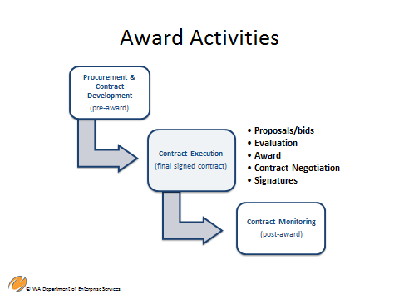

Award Activities

**Competitive award activities**

* Proposals/bids are received
* Evaluation of all bids
* Award to apparent successful bidder
* Contract Negotiations, if any
* Signatures of both parties – contract execution

**Sole source award activities**

* Justification of sole source award
* Contract Negotiations, if any
* Signatures of both parties – contract execution

**Slide 15 – Post-Award Activities**

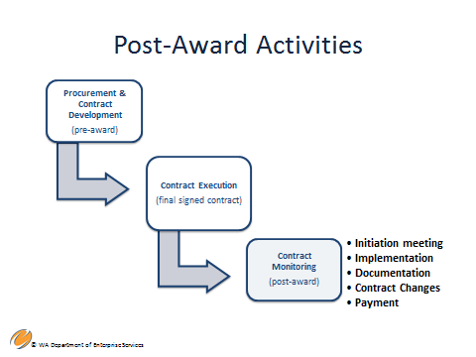

Post Award Activities include the following:

* + Initiation or kick-off meeting.
  + Implementation of the project or product purchased.
  + Documentation, documentation, documentation.
    - While documentation is a key element of the entire procurement, it is essential in the post award phase.
  + Contract Changes
  + Contract payments or payment for goods.

**Note**: in agencies with a central contracting organizational structure, this phase is the transition phase from the procurement professional to the contract manager, although the contract manager has been an essential partner in the procurement. The Post-Award activities include critical activities such as contract monitoring.This will be addressed on subsequent slides.

Notes

**Slide 18 – The Importance of Pre-Award Planning**

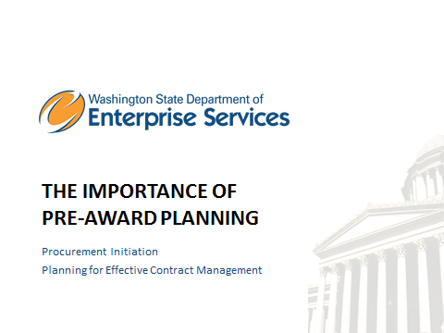

**Section 2 –** The Importance of Pre-Award Planning will cover the following topics:

* Procurement Initiation
* Planning for Effective Contract Management

Notes

**Slide 19 – Contracting in Washington – Pre-Award**

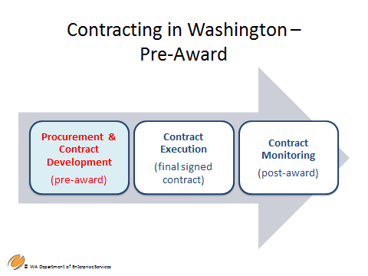

Next, let's discuss the pre-award phase and why planning matters…

Notes

**Slide 20 – Why Planning Matters**

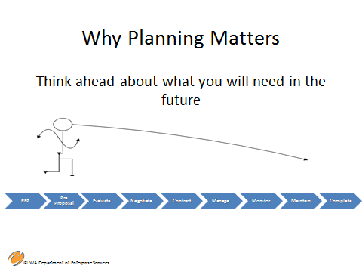

Planning matters! it is the key to a successful procurement outcome!

Take time to think about what you may encounter during the procurement's lifecycle as well as the resultant purchase. Think through each future step These include: the development of the solicitation document, pre proposal, evaluation, negotiation, entering into a contract, managing, monitoring and maintaining the contract.

The following are important elements that a contract manager needs to consider and care about through the lifecycle of the procurement:

1. Scope Identification and Management - What is the scope of work or requirements for the goods?
2. Resource Identification and Management - Procurement professionals, subject matter experts, management, stakeholders
3. Agency Mission Alignment - Does the procurement align with your agency mission and goals?
4. Budget Approval - Do you have an approved budget and are there any special rules or requirements attached to your funding?
5. Parameters and Constraints - Does your procurement violate agency bargaining agreements?
6. Market Condition Identification - Conduct market research to determine the market capacity. is it a highly competitive market or do only a minute number of vendors provide the services?
7. Risk Identification and Management - What could go wrong? what are the risks of the procurement and what are your initial strategies for mitigating them? conduct an initial risk assessment.
8. Short and Long Term Business Needs - Dependencies and Lifecycle

1. Plan for the entire life-cycle of the purchase of goods or services. Such things include, but are not limited to:

• Will training be required?

• Will continuous maintenance be required?

• How will this purchase affect other projects? - Are there redundancies?

• What is the total life cycle of the good or service purchased?

Example - You purchase software for your agency to track internal customer IT requests. Is this a long-term or short-term solution?

1. Roles and Responsibilities Identified - For example, who will conduct the procurement? Who will manage the contract?
2. Monitoring Plan Baseline - Develop your initial monitoring plan from your initial or pre-award risk assessment

Notes

**Slide 21 – Additional IT Considerations**

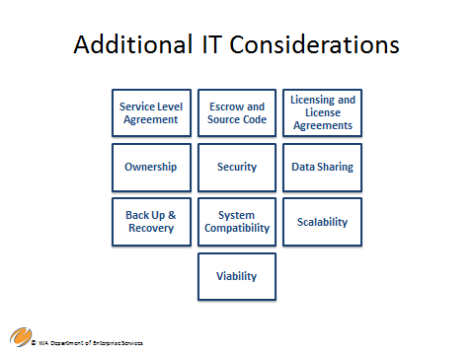

* **Additional IT Considerations**
* **Service Level Agreements** - An SLA is part of a service contract where a service is formally defined. For example, providers will commonly include SLA's within the terms of their contracts with customers to define the level of service being sold in plain language, which could provide technical definition in terms of meantime between failures and meantime to repair or recover, various rates, or other measurable details.
* **Escrow and Source Code** - Source code escrow is the deposit of source code of software with a third-party escrow agent. The source code is released to the licensee if the licensor files for bankruptcy or otherwise fails to maintain the software as promised in the software license agreement.
* **Licensing and License Agreements** - A legal agreement governing the use or redistribution of software. A typical software license grants an end-user permission to use one or more copies of software in ways where such a use would otherwise potentially constitute copyright infringement of the software owner's exclusive rights under copyright law.
* Click-Through software Agreements are an example of a software license!
* O**wnership** – Be sure to include language in the contract terms and conditions that clearly define ownership of the final product. Do you own the product completely, or do you need permission from the vendor to use the final product.
* **Security** (facility access, data security, etc.) - Determine risks and develop appropriate language to insure security. see OCIO security standards, policy 141
* **Data Sharing** - How do you share data with other parties? See OCIO security standards, policy 141
* **Back Up and Recovery** - What provisions and language has been developed in your agreement to cover this?
* **System Compatibility** - Will your IT purchase be compatible with other applicable systems?
* **Scalability** - Ability of a system, network, or process to handle a growing amount of work in a capable manner or its ability to be enlarged to accommodate that growth.
* **Viability** of the vendor you are contracting with – the agency needs peace of mind that the vendor company will still be there in the future. Here is where an escrow agreement may be important.

In-depth IT contract considerations will be covered in a future it academy being developed by DES in consultation with statewide subject matter experts. Be sure to talk to your Purchasing and Procurement Professional if you are taking on an IT contract - they can help.

Notes

**Slide 22 – Why Your Participation in Solicitation Matters**

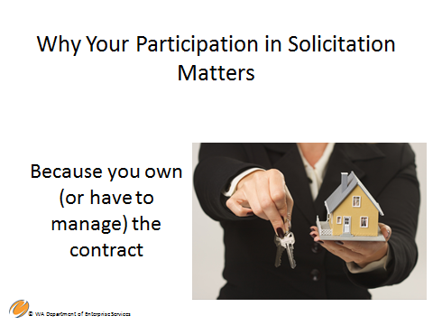

As the contract manager, your participation in the procurement matters! You are the business owner and will manage the contract. It is important for you to partner with your Agency procurement professional. Involve them early in the process so that they can advise and assist you on all facets of your business need, including:

* Selection of Appropriate terms and conditions.
* Development of Schedule – They can provide you with appropriate timelines to best accommodate your needs and develop an estimated procurement schedule to include in the procurement document as a guide for potential bidders.
* Risks identified early – They can identify risks from the procurement perspective, while providing insight to help you identify risks from a subject matter perspective.
* Prepare for Selection – They can develop documents that are transactionally relevant, mitigate risks, meet legal requirements and add value.
* Selection of vendor – They can guide you through the procurement process, including evaluations and debriefings.

**Note**: In agencies with central contracting organizational structures, the procurement professional is in charge of the procurement, up through and including the execution phase. They are usually the procurement coordinator and guide the contract manager, the evaluation team and others through the process. The contract is then transitioned to the contract manager upon execution. The procurement professional continues to be a resource for legal and other issues that may arise throughout the period of performance of the contract.

Notes

**Slide 23 – Contract Execution and Why it Matters**

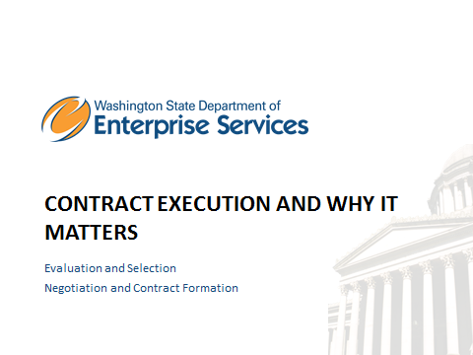

Section Three – Contract Execution and Why it Matters will address the following topics:

* Evaluation and Selection
* Negotiation and Contract Formation

Notes

**Slide 24 – Contracting in Washington – Final Signed Contract**

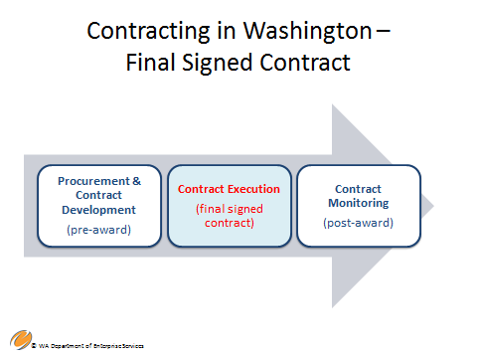

An executed contract (fully signed contract), is the result of the Contract Execution phase which includes negotiation of the contract with the Apparent Successful Vendor (ASV). It is important to note the ASV is not the successful vendor until the contract is executed.

The ASV is selected through the evaluation phase of the procurement. The evaluation criteria is developed as part of the competitive procurement document so that bidders are aware of how they will be evaluated. It is critical to follow the evaluation criteria set forth in the procurement document in order to avoid potential protests by vendors.

Note: It’s important to remember that no work can begin until the contract is executed (signed).

Notes

**Slide 25 – Evaluation and Selection**

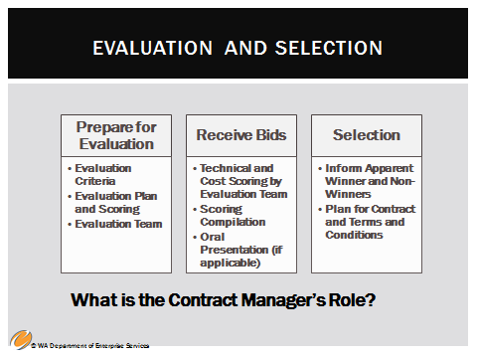

Evaluation and Selection includes:

Preparation for Evaluation

* Evaluation Criteria and scoring methodology – Developed by the procurement team (procurement professional, contract manager, other subject matter experts, etc.) and included in the competitive procurement document
* Evaluation Team – Determine the team early in the process and set up time on their calendars in accordance with the estimated procurement schedule.
* Evaluation Plan– How will the scores be compiled? on a consensus basis, by averaging scores, etc.? This is usually decided by the evaluation team.

Receive the Bids

* Bids are received by the procurement coordinator
* Scoring by Evaluation Team – The team, led by the procurement coordinator scores the bids in accordance with the criteria as described in the procurement document. Do not make any changes to the scoring criteria provided to the bidders or you will run the risk of a protest that will be upheld!
* Scoring Compilation – However you have determined to score (consensus, averaging scores, etc.) compile the final scores to determine the highest bidder or bidders at this point.
* Oral Presentations or demonstrations (if applicable) – Conduct oral presentations or demonstrations amongst the top bidders.
* Call references for top bidder or bidders – References should have been requested in the procurement document and provided by the bidder. This step is at the agency’s discretion but is highly advisable.

Select the Winning Bid

* Inform Apparent Winner and Non-Winners – This must be done in writing through WEBS at a minimum - RCW 39.26.160. Email is a very effective notification method and is often used in conjunction with WEBS notification. it allows you to provide instructions on how to schedule a debriefing, if a non-successful bidder, and let the apparent successful bidder know what the next steps are.
* Schedule debriefings with non-successful vendors
* Allow for any protests – RCW 36.29.170. Only vendors who have debriefed are allowed to protest.

Note: The contract managers role during this phase is dependent upon the procurement organizational structure in your agency. In an agency with a centralized contract organizational structure, the procurement professional (Procurement Coordinator) would guide the contract manager and his or her team through this process. Know your **agencies structure and process.**

**Slide 28 – Contract Negotiations**

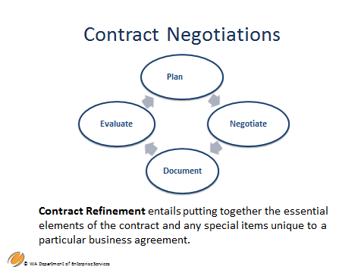

Contract negotiations apply generally to competitive procurement and non-competitive contracts or sole source contracts.

It’s important that your negotiation team include the procurement coordinator, procurement professionals and subject matter experts – essentially, anyone who will add value to the process having procurement expertise to subject matter expertise. The objective is to obtain the best deal for the state.

The degree of negotiation, if required, depends on the complexity of the project and the contract. The agency determines if it is necessary or advisable to conduct negotiations. Negotiations may be held with the apparent successful vendor if more favorable contract terms are required or if the proposal is not sufficiently precise or direct. This is also the time to discuss terms and conditions that the vendor has disagreed with or requests modification of. these should have been submitted in the vendor’s proposal. ultimately, the result should be a win-win for both the agency and the vendor. Negotiations would not include discussion of any work outside the scope of work.

If the terms offered in the initial proposal are considered fair and equitable, an award may be made without negotiation.

Be sure to document all negotiation outcomes and decisions. In many cases it is necessary to require the vendor to edit their original proposal to include those decisions and outcomes.

Notes

**Slide 29 – Contract Terms and Conditions**

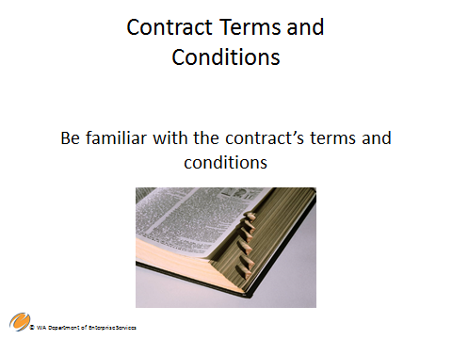

As the contract manager, it is important that you be familiar with the contract’s terms and conditions – Both the special terms and the general terms and conditions.

**Special terms and conditions –** Those terms and conditions that are unique to the procurement transaction. The special terms contain, at a minimum, identification of the parties, the statement of work, period of performance and compensation, which are contained in the contract instrument.

**General terms and conditions –** In the State of Washington, the G.T&C’s are those terms that are standard to most contracts and have been approved as to form by the Attorney General’s office through your assistant attorney general. they are designed to protect your agency and the state. They include provisions for assignments, general confidentiality, conflict of interest, copyright provisions, venue, dispute resolution, indemnification, non-discrimination and ADA compliance laws, terminations clauses and termination procedures among others.

Rely on your procurement professional in order to understanding terms – they are important to understand, especially when negotiating any areas where the contractor has objected to the terms and conditions (T&C’s) (this may also require some legal review).

Notes

**Slide 30 – Reasons to Walk Away**

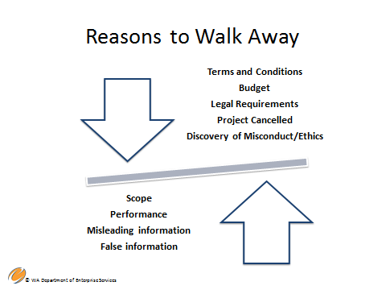

A critical area of negotiations is knowing when to walk away.

Here are some of the various areas in which you may determine it is best to walk away from negotiations.

Agency Side:

* Unable to come to agreement on certain Terms and Conditions. The vendor may want changes that increase your agency risk to an unacceptable level.
* Budget Issues – The vendor may have proposed more than the agency can afford and the agency and vendor cannot come to agreement to refine the statement of work in order to bring costs within acceptable levels.
* Legal Requirements outside of your control – New legislation or other legal requirements that now cause your agency not to proceed with award.
* Project cancelled – Either your agency or the funder (state budget, federal funding, private funder) has cancelled the project and the project funding.

Vendor:

* Scope – It is determined through negotiations that the vendor cannot adequately carry out the scope of work.
* Misleading , unethical or false Information – For example, it is discovered during negotiations that the vendor provided information that was intentionally not true or correct or that the vendor has been involved in unethical activities.

**Note**: It is important to have Executive buy-in when walking away.

Notes

**Slide 31 - Post-Award Activities**



**Section Four -**  **Post-Award Activities** will cover the following topics:

* Planning for Effective Contract Management and Monitoring
* Tips and Tools to Plan Ahead

**Slide 32 – Contracting in Washington – Post-Award**

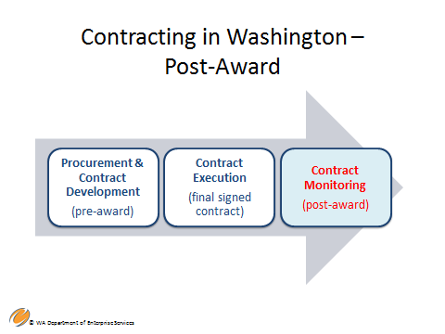

Now that the contract is executed, the period of performance begins. It is at this point that the contract is transitioned in full to the contract manager. However, the contract manager should still consider them self a partner with the Purchasing and Procurement team who initiated the contract. They will be a valuable resource throughout the period of performance should any issues arise.

The contract manager will now begin to monitor the contract. The level of monitoring is based on the initial risk assessment conducted during the pre-award phase.

**Contract Monitoring –** Means any planned, ongoing, or periodic activity that measures and ensures contractor compliance with the terms and conditions of the contract. The level of monitoring depends on the risk assessment of the services provided and the contractor’s ability to deliver. Every communication with a contractor is an opportunity to monitor activity.

The *purpose* of monitoring is to track and ensure:

* 1. Compliance with the terms and conditions of the contract and applicable laws and regulations
  2. Adherence to the project schedule and appropriate progress toward the expected results and outcomes
  3. Quality of services or products is as expected
  4. Health and safety of clients; and
  5. Identification and resolution of potential problems and provision of constructive, timely feedback.

Monitoring Activities may include:

* 1. Periodic contractor reporting
  2. On-site reviews and observations
  3. Invoice reviews
  4. Audit report reviews
  5. Client surveys
  6. Other periodic contact with the contractor

Contract management and monitoring will be discussed in greater length in module 3, The Essential Elements of Contract Management.

While the contractor has responsibility to perform under the terms of the contract, the contract manager has responsibility for reasonable and necessary monitoring of the contractor’s performance to ensure contract compliance.

Notes

**Slide 35 – Tips and Tools to Plan Ahead**

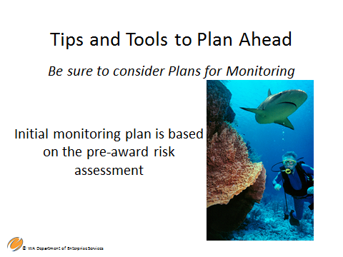

The initial monitoring plan is based on the initial risk assessment during the pre-award phase but remember, monitoring plans can change as risk changes so conduct periodic risk assessments during the period of performance.

The following are a few examples of tips to help with planning and monitoring:

* Put due dates on calendars, build in reminders, use excel spreadsheet to track deliverable due dates.
* Track and review invoicing.
* Develop and Maintain Documentation tools to trace competitive procurement document and Contract Requirements.

As the contract manager you should document and keep everything pertaining to the contract including amendments and changes. This also includes informal communication such as emails, telephone calls and conversations (memorialized in writing), etc. document, document, document!

Notes

**Slide 36 – Tips and Tools to Plan Ahead**

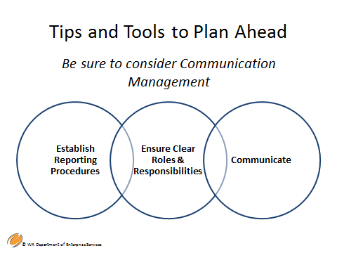

**Another key aspect of effective contract management is communication management.**

Consider the following elements;

* **Establish and communicate reporting procedures** - with your team, other stakeholders, procurement professionals and most importantly, with your vendor.
* **Ensure clear roles & responsibilities** - Make sure everyone on your team and the vendor's team clearly understand the roles and responsibilities as written in the contract.
* **Communicate** with the contractor and internal staff regarding the contract manager's role
  + Determine who has signature authority to approve invoices.
  + Clarify who has authority to instruct the contractor.
  + Consider if communication should come through you, or be reported to you.

**Slide 37 – Tips and Tools to Plan Ahead**

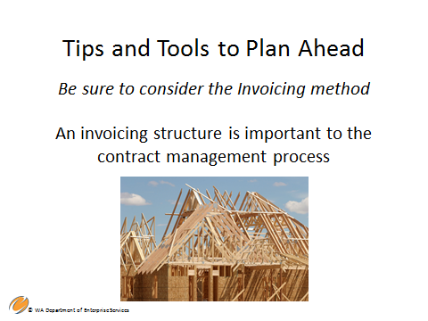

Invoicing instructions can be addressed in the procurement document but must be included in the contract document. Always check these documents to help determine the accuracy of the invoice before approving. When approving invoices make sure they are in accordance with the terms set forth.

**Invoicing Structure**

* 1. Ensure invoice approval process is developed – who reviews, who approves? Understand the process to get invoices paid in your agency.
  2. Retain key information (including budget account codes).
  3. Do not approve things that are not allowed or addressed in the contract.

Notes

**Slide 38 – Treat the Contracting Process Like a Project**

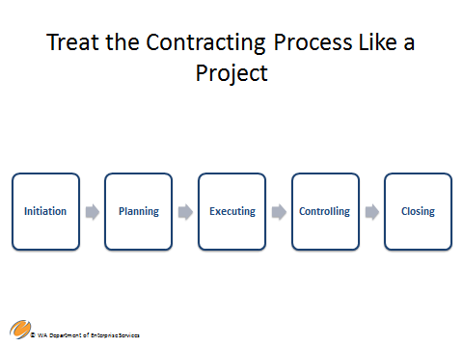

It is important to treat your contract like a project.

Like a project, a contract has a set start and end. You initiate the work, conduct planning for the contract, complete contract management tasks, and control aspects of the project including monitoring and oversight of risks.

For purposes of this learning objective, ‘controlling’ does not mean managing the contractor. Your sphere of control in this situation will focus on implementation of the contract and controlling the outcome through proactive monitoring activities and oversight of contract risks.

Notes

**Slide 39 – Summary and Key Points**

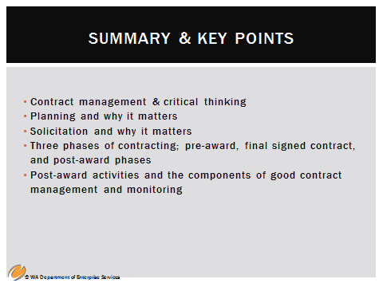

In this module, we covered:

1. Contract management & critical thinking
2. Planning and why it matters
3. Solicitation and why it matters
4. Three phases of contracting; pre-award, final signed contract, and post-award phases
5. Post-award activities and the components of good contract management and monitoring

**The next course is Module 3 – Essential Elements of Contract Management**

Notes



Contact Us By Phone

For questions, feel free to contact us by phone at 360-407-2200.

Locations & Directions

Our headquarters office is at 1500 Jefferson, on the Capitol Campus in Olympia, Washington. DES operations are also located throughout the state.

[Enterprise Services headquarters at 1500 Jefferson Building](http://www.des.wa.gov/about/AboutDES/Pages/LocationsDirections.aspx#1500Jefferson)

[Other Enterprise Services locations](http://www.des.wa.gov/about/AboutDES/Pages/LocationsDirections.aspx#OtherLocations)

DES Headquarters at 1500 Jefferson Building

The headquarters of Enterprise Services is the 1500 Jefferson Building, which will also serve as the state’s new data center. The building is part of state government’s historic Capitol Campus and is the newest structure built on the grounds since 1992.

Mailing Address

Washington State Department of Enterprise Services PO Box 41401 Olympia, WA 98504-1401

Physical Location

1500 Jefferson Street SE Olympia, WA 98501 - [Map](http://www.des.wa.gov/SiteCollectionDocuments/campus-map.pdf)