FAQs - A New Environmental Procurement Preference Training

Q: For whom is this training required?
A: The WA-State Environmental Procurement Preference Training is required only for those procurement professionals who write solicitations as defined by DES C&P. Most recently, it is the same group who were required to take the WA-State EO 18-03 training within the LMS.

Q: How do I find the training in the LMS?
A: Copy and paste the title into the LMS search bar: WA-State Environmental Procurement Preferences
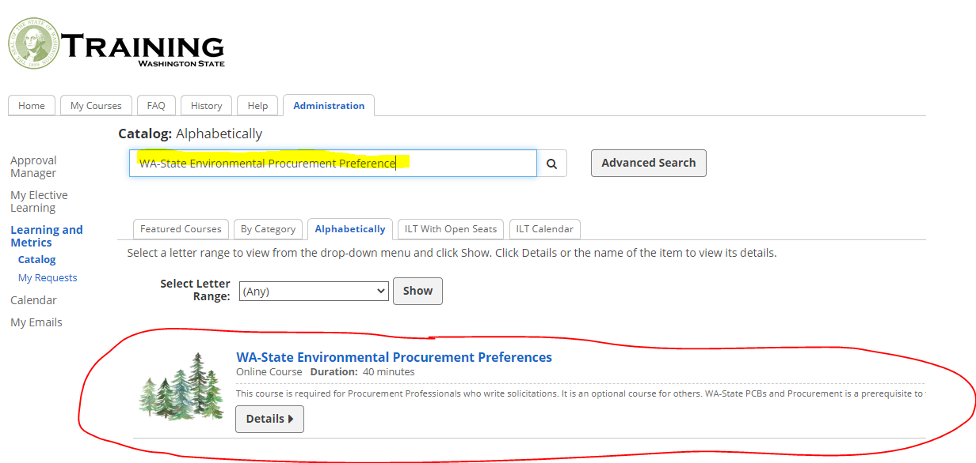

Q: When are we supposed to take the training?
A: Scheduled release on 8/1/2020, and must be completed by 2/1/2021. Must be completed within 6 months of any new employee or employee new to these duties.

Q: How long will it take me to get through this training?
A: This is a self-led course that typically takes folks about 30 to 40 minutes to complete.

Q: Does this Training replace the PCBs training?
A: Not at this time. The Environmental Procurement Preference Training and the PCBs & Procurement Training are still two different trainings. We intentionally created the new Environmental training with PCBs training as a prerequisite because those required to take the Environmental training are in the same group who are required to already have taken the PCBs training. We made the current Environmental training shorter to benefit those who have already taken PCBs, so no re-work needs to be done. In February 2021 we will roll the two courses together and eliminate the PCBs course entirely for all new staff in the future. Staff who are new to Procurement duties after February will take a longer Environmental training than you are all taking now because it will require a PCBs portion. For those concerned about their training transcript, after Feb 2021 it will still give full credit to those who have taken both courses.

Q: Where can I learn more?
A: The Environmental Procurement Preferences webpage provides more details. If it does not answer all of your questions, you may contact our training team.

Q: What if I have technical questions about how the eLearning works?
A: We have a ready-made Troubleshooting Tips page that you can hand off to your IT professionals and LMS Admins that will answer all of their technical questions about the training program. It also provides resources for additional questions.

Q: But who in my own organization knows about this training?
A: You may find a list of the communications that have gone out regarding this training on our Latest Communication Page.

What have we missed? Feel free to email me Sundae Delgado, if you have further questions.
Last updated on 8/3/2020

