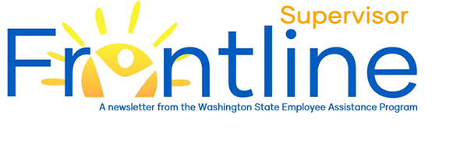
May 2021
Together, we can realize our shared vision of a nation where anyone affected by mental illness can get the appropriate support and quality of care to live healthy, fulfilling lives — a nation where no one feels alone in their struggle. – National Alliance on Mental Illness

Mental Health Awareness
In this month’s newsletter:
Mental Health Awareness
Mental Health in the Workplace
Supporting the Employee
Referring to the EAP
Resources
Contact EAP
eap.wa.gov
Toll free: (877) 313-4455
Phone: (360) 407-9490
Interpreters available.
TTY: call 711 via WA Relay

May is Mental Health Awareness Month. The National Alliance on Mental Illness (NAMI) and many other organizations across the country, including the Washington State Employee Assistance Program, work to raise awareness, offer support and resources, and change perceptions about mental health in general and mental illness specifically. This year’s theme, “You Are Not Alone”, emphasizes the critically important message that no one should feel alone or live without the resources and support they need.
To learn more about mental health statistics, factors affecting mental health and disparities in support and treatment, read the May issue of the EAP Frontline Employee Newsletter.

Mental Health in the Workplace
Employee mental health and an effective workplace are closely linked. When employees are provided mental health support and resources, organizations experience lower healthcare costs, higher productivity, reduced absenteeism and lower disability costs. Employees with poor mental health exhibit declines in work performance, have higher rates of illness, are absent more often and are involved in more accidents. Organizations also experience higher turnover rates. An investment in employee mental health tends to results in a healthier, more productive workplace.
Given the prevalence of mental illness and its impact on the workplace, it is important for supervisors to recognize the potential signs of poor mental health of an employee.
Some of these signs are:
- Decreased productivity
- Strained or conflict-filled work relationships
- Morale problems
- Difficulty concentrating, making decisions, or remembering things
- Displays of anger or blaming others
- Safety risks, accidents
- Frequent absenteeism and/or tardiness
- Complaints of being tired all the time
- Working excessive overtime over a prolonged period
- Strange or grandiose ideas
- Alcohol and drug abuse

Supporting the Employee
While it might be tempting to diagnose an employee’s health problems, the supervisor’s role is to focus on work performance and employee support. Based on the existence of a combination of the signs described previously, a conversation with the employee might be needed. Discussing changes in work performance and workplace behaviors is a place to start. Here are some tips for the conversation:
- Find a quiet, private space
- Express concern and show compassion
- Ask open-ended questions
- Listen and let the employee explain in their own words what’s happening
- Provide clear feedback based on your own observations
- Avoid language that blames or judges
- Ask the employee what help they think and feel they need
- Collaborate with the employee to develop a plan
- Provide resources that align with the plan and with your role as supervisor
- Make a compassionate referral to the EAP, if indicated.
If an employee makes comments indicating thoughts of self-harm, take the comments seriously. Call the EAP at (877) 313 – 4455 or National Suicide Prevention Lifeline at (800) 273 – 8255. In the event of an emergency, call 911.

Referring to the EAP
The Washington State EAP is a free, private and confidential resource for employees and the adult household family members. Supervisors are encouraged to offer the EAP as a supportive resource. Referral types and the referral process are noted on EAP’s site.

Resources
- Mental Health in the Workplace, Centers for Disease Control and Prevention (CDC)
- Center for Workplace Mental Health, American Psychiatric Association Foundation
- How to Support and Monitor Employee Mental Health, Business.com

Supporting the Supervisor
Supporting employees as they experience and navigate mental health challenges can be taxing for the employee and the supervisor. To obtain support, consult and advice, consider contacting the EAP at (877) 313 - 4455 and asking for an organizational consult with an EAP Counselor.

