**Contract Management 101**

**Module 4**

**Participant Workbook**

**Contract Changes, Disputes, Appeals, and Other Issues**

Current Version 04/07/2015

Original Version 12/02/2014

Table of Contents

Contract Changes, Disputes, Appeals, and Other Issues 3

Course Introduction 3

When Things Don’t Go As Planned 6

When An Agency And Contractor Disagree 18

Best Practices and Lessons Learned 31

Resources 44

# Contract Changes, Disputes, Appeals, and Other Issues

## Course Introduction

**Slide 2 – Course Introduction**

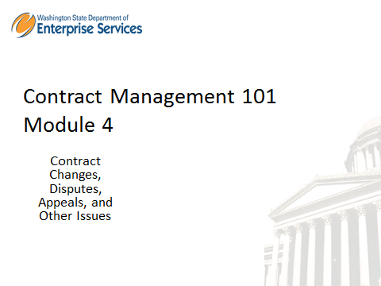

**Welcome to Contract Management 101 Module 4 –** Contract Changes, Disputes, Appeals, and Other Issues

This is a new training driven by Procurement Reform, and is required for all Contract Managers.

In order to receive credit for this course, you will need to score 80% or higher on the module assessment. The assessment will begin at the end of this module. Once you have successfully completed this module and the assessment, you will receive a Contract Management 101 certificate of completion.

Also included in the training course are knowledge checks. These are not graded, they are simply used to test your knowledge of the materials in the course.

We strongly recommend you print the workbook for the course. As you proceed through the training, use the workbook to write down any notes and/or questions you might have.

The workbook can be accessed here: http://des.wa.gov/about/pi/ProcurementReform/Pages/PRTraining.aspx -or – simply click “Workbook” on the top right corner of the screen. Click on the workbook to download it to your desktop.

**Disclaimer:**

|  |  |
| --- | --- |
| Notes |  |

**Slide 4 – Module Overview**

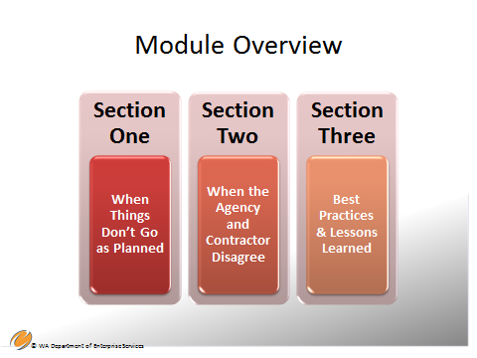

**Contract Management 101 Module 4 Overview –** there are 3 sections in this module:

**Section One – When Things Don’t Go as Planned**

* Contract Modifications
* Change Orders and Tracking
* Signature Authority

**Section Two – When the Agency and Contractor Disagree**

* Disputes Happen
* Corrective Actions and Cures
* Disputes
* Dispute Resolution
* Contract Termination

**Section Three – Best Practices & Lessons Learned**

* What Have We Seen and Learned the Hard Way?
* Reflection
* Module Summary and Close

For purposes of this training course, the laws and policies discussed are those of the state and individual agencies and do not reflect federal requirements. Federal requirements tend to be more restrictive and may apply if using federal funds.

|  |  |
| --- | --- |
| Notes |  |

**Slide 5 – Learning Objectives**

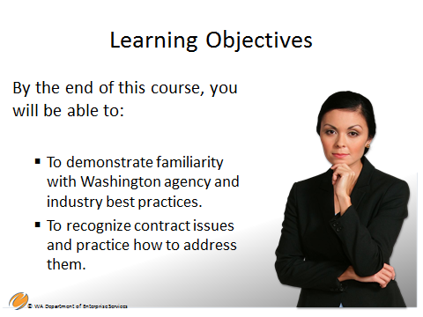

By the end of this course, you will be able to:

* To demonstrate familiarity with Washington agency and industry best practices.
* To recognize contract issues and practice how to address them.

|  |  |
| --- | --- |
| Notes |  |

**Slide 6 – When Things Don’t Go As Planned**



Section One– When Things Don’t Go as Planned will cover the following topics:

* Contract Modifications
* Change Orders and Tracking
* Signature Authority

|  |  |
| --- | --- |
| Notes |  |

**Slide 7 – When Contract Changes Happen….**

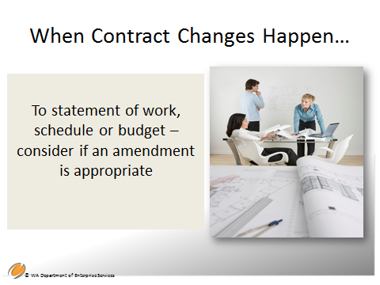

**When Contract Changes Happen - the contract can be modified or amended for a variety of reasons:**

* **Administrative change/amendment:** A change to a contract in writing, that does not affect the substantive rights of the parties. Administrative changes are done in a variety of ways such as a bilateral amendment, a unilateral memo to the file, or other methods. Always check to see how administrative amendments are done in your agency.

Examples of administrative changes:

* A change in the address to which an invoice is mailed.
* A due date or milestone change in the statement of work.
* Contractor change of address.
* A change in a contractor or agency representative.

* **Non-substantial change/amendment**: This is a written change to general statement of work, schedule, or budget. Statement of work changes can include clarifications, additions and deletions to the deliverables, tasks, etc. as long as they are within the scope of work.

* **Substantial change/amendment**: These are changes that are within the scope of work but represent substantial changes in the quantity, duration, cost, or nature of the work *and may not be* appropriate as a contract amendment.

If your agency does decide to make substantial changes, be sure to have compelling reasons why it makes solid business sense to make those changes. Remember: The amendment must be in writing.

Amendments that would result in changes to the scope of work are not appropriate. You should conduct a new competition. Do not circumvent the competitive procurement process.

**Other important amendment guidelines**:

* Amendments should be executed prior to the end of the contract period of performance.
* Amendments should reference or include the clause(s) from the original contract being changed.
* Be as specific and concise as possible.
* Always work with your procurement professionals!

See sample amendment below.

|  |  |
| --- | --- |
| Notes |  |

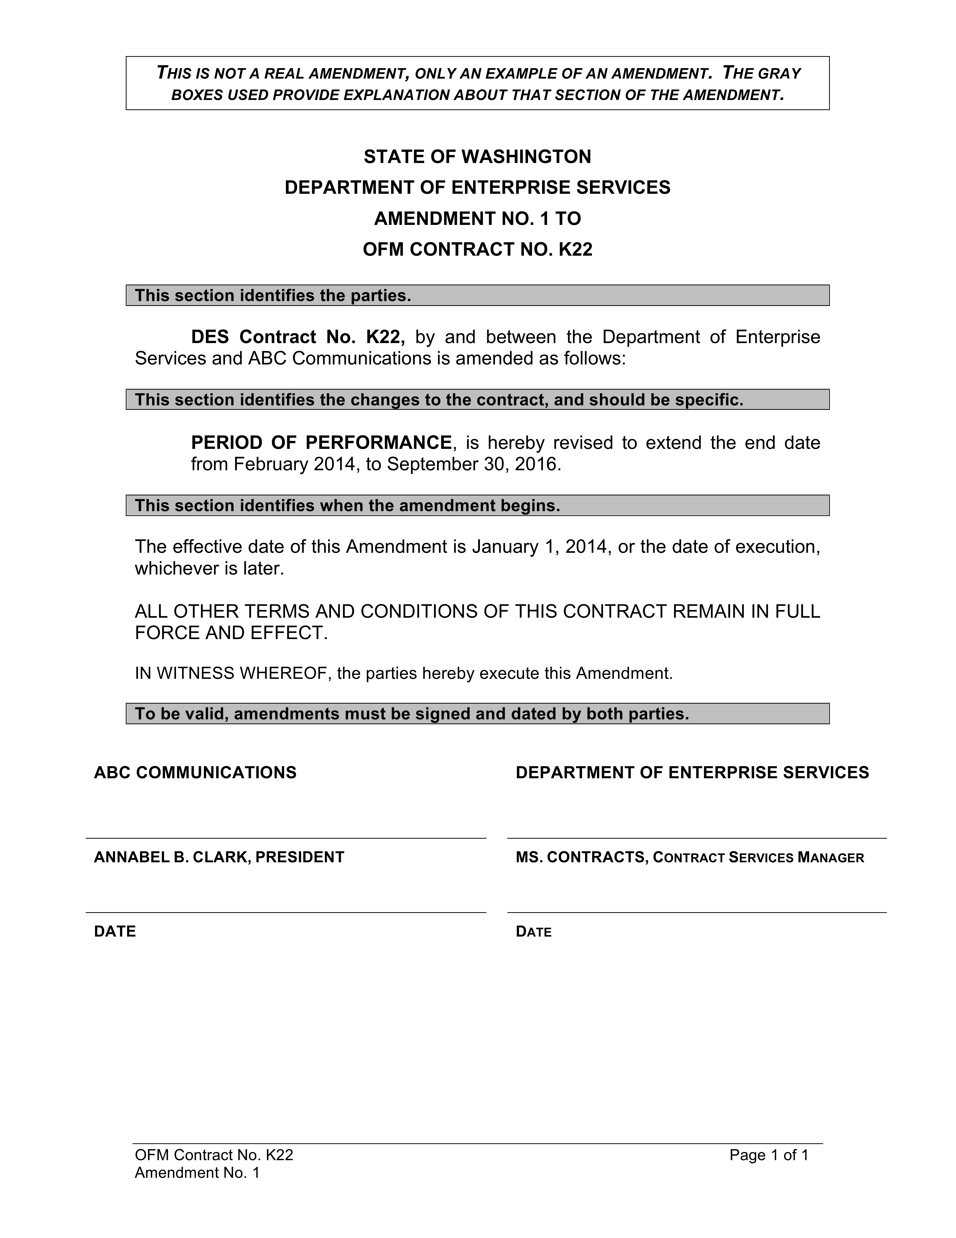

**Slide 8 – New Contract or Amendment?**

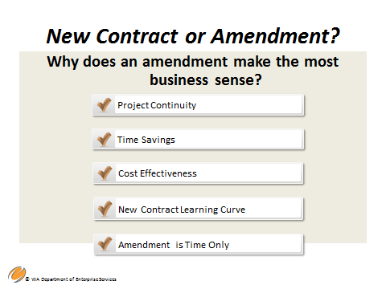

Given what you have already learned about amendments there are other determining factors to consider when deciding between a new contract or a contract amendment.

**Do an amendment if:**

The work is within the original scope of work and achieves:

* Project continuity – in other words, amending the current contract will eliminate the possibility of disruption of services.
* Time savings – Competitive procurement takes time. If the proposed amendment is within the scope of work and doesn’t substantially increase the contract value, then it is unnecessary to do a new procurement.
* Cost effectiveness – If the amendment is within the scope of work, it may be more cost effective to amend the current contract.
* Learning curve on new contractor is avoided – Bringing a new contractor on board in the middle of a project will cost you both time and money. The new contractor would have to come up to speed on all activities that have occurred so far, or have to learn processes and systems that the current contractor already has knowledge of.
* If the amendment is for time only, no additional dollars –In this situation, It makes business sense to allow the current contractor to complete the contract.

Note: Usually if you add additional dollars, there should be additional or continued deliverables or services that equal the additional dollars.

|  |  |
| --- | --- |
| Notes |  |

**Slide 11 – New Contract or Amendment?**

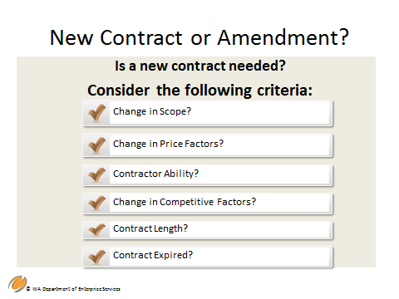

How do you decide if a new contract is needed? The most important thing to remember is that you must not circumvent the competitive process.

The following are reasons why you should enter into or consider entering into a new contract**:**

* The required changes are to the nature or scope of work - you should always enter into a new contract if this is the case.
* Significant change in contract price factors, unless provided for in original solicitation document or contract.
* Contractor ability - In this case, the additional work you require is within the original scope of work but, your current contractor either does not have the capacity to do the additional work, or lacks the skills to do it.
* Changes in competitive factors since initial procurement. Has the competitive field grown? You may want to consider a new competitive procurement to consider other contractors that are available. They may provide better services and their costs might be more competitive.
* Contract extension period is lengthy. (Unless provided for in the original solicitation document or contract - i.e. and an option to renew.)
* Contract expiration - If the original contract has ended, you must enter into a new contract.

Be sure to consult with your procurement professional if you think a new contract or an amendment is necessary.

|  |  |
| --- | --- |
| Notes |  |

**Slide 12 – Contract Changes – Which?**

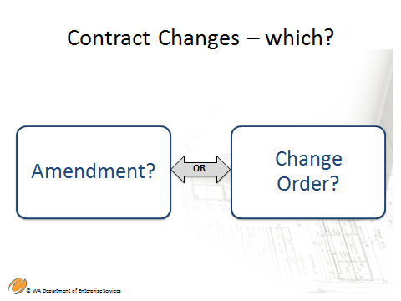

**Contract Changes - Which?**

Contract amendments and change orders allow for the contract to be changed without a new competition.

**Amendments:** An amendment is a change to one of the special terms and conditions of a contract. Any type of contract can be amended, and almost any clause in a contract can be amended by the mutual agreement of both parties, as long as it is within scope of the original contract. It is strongly recommended not to change the General Terms and Conditions in an amendment without consulting with your Assistant Attorney General first. General Terms and Conditions should remain static throughout the contract term.

**Change Order:** A written alteration that is issued to modify or amend a contract or purchase order. It's a request which directs the contractor to make changes to the contracted statement of work or specifications. This is a common practice with large and more complex Information Technology contracts, and it relates primarily to changes caused by unanticipated conditions encountered during the project that are not covered by the initial project plan. The contract describes the change order or change management process and provides a method to document and track all change orders. Common causes for change orders are:

* The project's work was incorrectly estimated.
* The contract manager or team discovers obstacles or possible efficiencies that require them to deviate from the original plan.
* During the course of the project, additional features or options are perceived and requested.

The contract manager typically generates a change order (either in partnership with the contractor or as requested by the contractor) that describes the new work to be done (or not to be done), and the price to be paid for the new work. Once this change order is submitted and approved it serves to alter the original contract and becomes part of the contract.

If you don't work with your procurement professional on change orders, make sure they are aware of, and get copies of, any change orders.

|  |  |
| --- | --- |
| Notes |  |

**Slide 13 – Change Orders**

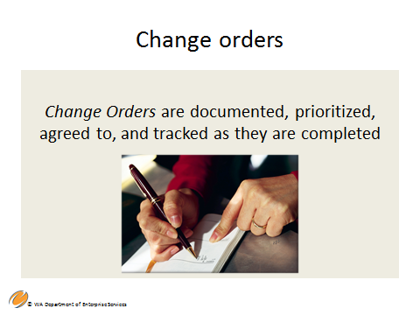

**Change Orders**

Thoroughly document contract changes that are done through a change order process, which can only be conducted if it is allowed by your contract.

The change order process is an element of change management [which is a key aspect of project management], and is a common practice in large and complex IT projects.

Here are some pointers about change orders:

* Change orders are the result of a change request made by either the contract manager on behalf of the agency or the contractor. Regardless of who makes the request, the change order must be agreed upon by both parties.
* Changes in the statement of work, product, system or services, not involving adjustment to the bottom line contract amount or contract schedule, can be documented and managed through the change management process as a simple change order. Typically they can be approved by the contract manager.
* Changes that involve adjustment to the contract amount or the overall project schedule, while requiring both contractor and contract manager approval, should also be authorized by relevant management who has signature authority in your agency.
* Occasionally, change requests are significant enough that they have an impact on the scope of work. In this situation, the contract manager and the agency must make a business decision – is it ok to do a change order, or should the change be done through a competitive process? When faced with this issue, ask yourself the following questions to justify your decision (and document your answers):
* Does the change cause a non-substantial or insignificant change to the scope of the contractor is it significant enough to warrant a new competitive solicitation?
* Is the project jeopardized by taking the time to conduct the competitive solicitation?
* Would the current contracted project be affected if a new contractor were chosen to handle the change?
* Would other systems be affected?
* If the current project includes IT deliverables, will the change be precluded or affected by the propriety rights of the current contractor?

|  |  |
| --- | --- |
| Notes |  |

**Slide 14 – Tracking Change Orders**



Tracking Change Orders

Change orders are documented, prioritized, agreed to, and tracked as they are completed.

* The key point is to track what changes have been requested, which have been approved and which have been rejected.
* You can use a simplified tracking method or a complex change management strategy. Focus on the use of change order forms, change logs and change review meetings between the contractor and the contract management team.
* The major threat to the change order process is scope creep. That is, changes can extend project timelines. Effective tracking will help you avoid scope creep.
* Be sure to submit copies of all your change orders to your procurement professional. Including them on substantial change order requests and possible changes to the overall scope will assure they are prepared to advise you.

|  |  |
| --- | --- |
| Notes |  |

**Slide 17 – Signature Authority**

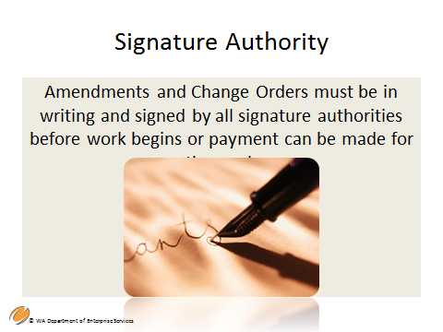

Signature Authority

Amendments, just like contracts, must be in writing and signed by all signature authorities before work begins or payment can be made for the work. Some change orders require only Contract Manager approval and some require approval by signature authorities. Find out what is required in your agency for the specific contract you are working on.

It's important to plan for the time needed to acquire signatures for contract amendments.

* Remember to include enough time in your process, in case an amendment becomes needed later.
* Don't start work until the amendment is signed.

PLEASE REMEMBER - This course does not give you signature authority! Only your agency can do that!

|  |  |
| --- | --- |
| Notes |  |

**Slide 18 – When an Agency and Contractor Disagree**

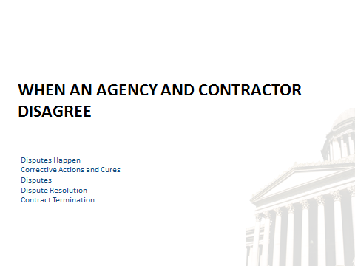

Section Two – When an Agency and Contractor Disagree, will cover the following topics:

* Disputes Happen
* Corrective Actions and Cures
* Disputes
* Dispute Resolution
* Contract Termination

|  |  |
| --- | --- |
| Notes |  |

**Slide 19 – Disputes Happen**

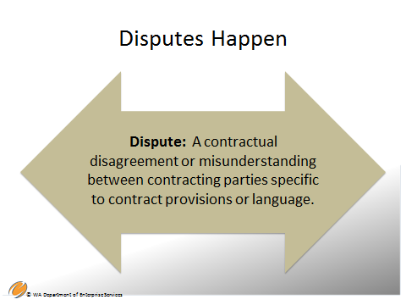

The definition of “dispute” on this slide is from the National Institute of Government Purchasing (NIGP): The Institute for Public Procurement.

While disputes can ultimately end in formal litigation, resolution is generally through pre-established administrative procedures or agreed upon alternative dispute resolution provisions. Litigation is always the last alternative. Good contract management and monitoring will uncover things that might be going wrong and allow you to mitigate the issue before it gets to the level of “dispute.” It’s to the agency’s benefit to solve issues quickly and efficiently to help ensure a successful outcome.

|  |  |
| --- | --- |
| Notes |  |

|  |  |
| --- | --- |
| Notes |  |

**Slide 20 – Corrective Actions and Cures**

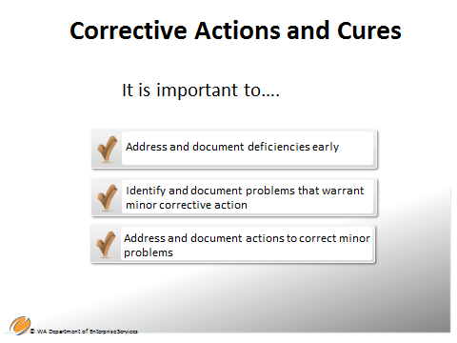

**How do you address minor problems with the contractor?**

**It is important to Address and Document Deficiencies Quickly**

* The first order of business when issues arise is to consult with your procurement professional. Corrective action is a process of increasingly escalating steps.
* Start the process when it’s a small issue through phone calls or meetings with your contractor. After each phone call and meeting, send an email to the contractor memorializing everything that was said and the outcome or decisions made. Documentation includes the date, time, who you spoke with, and description of conversation.
* If the vendor disagrees with your summation, they should email you and let you know. Silence can be construed as acceptance. Be sure that they know this.
* Cure – you must always allow the contractor the opportunity to “cure” or correct the problem.
* By not acting on these issues right away, you could be setting a precedence of acceptance, which sometimes makes resolution more difficult.
* With any corrective action, formal or informal, your contract is your guide!

**Here are six examples of problems that warrant corrective action**

1. Failure to produce key deliverables.
2. Inferior quality of services.
3. Failure to perform all or part of the contract.
4. Consistent late deliverables.
5. Late submission of reports on a recurring basis.
6. Significant audit or monitoring findings.

**Here are five example of a minor corrective process**:

1. Notify the contractor verbally and in writing.
2. Provide expectations for correcting the problem or ask the contractor to suggest corrections by a specific date. This must be in writing and you must approve it if the contractor has submitted the plan.
3. Specify date or time for corrective action to be complete. Don’t let the date slip.
4. Document the process fully.
5. If a successful resolution is achieved, let the contractor know in writing and continue moving forward with your project, including monitoring.

Note: This is a good time to revise your monitoring plan as your risk level has now increased.

|  |  |
| --- | --- |
| Notes |  |

**Slide 21 – Corrective Actions and Cures**

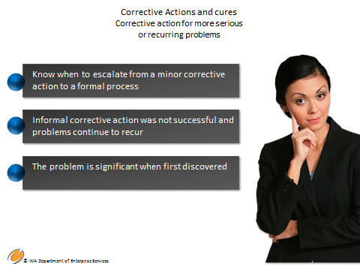

Corrective Action for More Serious or Recurring Problems.

Formal Corrective Action – Contract problems must be addressed as soon as they are discovered to prevent them from recurring or becoming serious. Formal corrective action is an option when direct negotiation and other less formal means of dispute resolution have failed. Formal corrective action means action initiated by the agency and taken by the contractor.

They often take three forms; 1. they can correct identified deficiencies; 2. They can produce recommended improvements to correct a deficiency; and 3rd. they can demonstrate that the deficiency is either invalid or does not warrant action.

* A first step in formal corrective action is to communicate in writing to the contractor describing where performance is deficient. Clearly identify problems including dates and number of occurrences and specific contract references.

Formal Corrective action activities should be coordinated with all necessary parties to avoid waving rights that might be available to the state. These parties include; your procurement professional, the agency’s management, the agencies in-house counsel, (if any), and the agencies assigned Assistant Attorney General.

* Ask the contractor to submit a corrective action plan with firm deadlines. Your agency must approve the plan.
* Diligently track all corrective action taken. This might include regular meetings or other communications. Do not let deadlines slip!
* All corrective action initiated by the agency must be documented in writing. If the corrective action is successful in resolving problems, the contractor should be notified in writing that resolution has been achieved. Also, the documentation should be retained in the contract file.
* If corrective action is unsuccessful at this stage and cure has not been made, you may proceed with a dispute process or take other appropriate courses of action as advised. Remember: Cure is very important. Unless a cure notice has been issued prior to termination for default, "should your agency choose that course", it may result in an invalid termination. Work very closely with your advisors.

|  |  |
| --- | --- |
| Notes |  |

**Slide 22 – Corrective Actions and Cures**

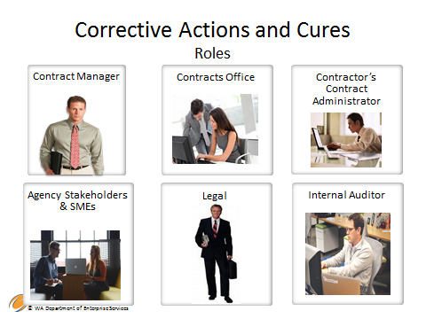

As the Contract Manager you are acting on behalf of your agency and not yourself. This is called the “Law of Agency.” In other words, your agency has authorized you to act on the agency’s behalf to create a legal relationship with a third party.

In your role as Contract Manager

* You facilitate and document the corrective action plan under advisement of the Assistant Attorney General (AAG) assigned to your agency and your assigned procurement professional.
* Tracks and monitors checkpoints once action is agreed upon in consultation with contracts office staff and legal advisors.

Contracts Office Staff

* The people in the contracts office coordinate with or assist the Contract Manager with the corrective action process.
* They identify legal requirements and enlists the assistance of both the agency legal counsel, if any, and the Assistant Attorney General.

Contractor's Contract Administrator

* The person in this role should have the authority to bind contractor to the correction action plan and the cure decision.
* Reports progress to the Contracts Manager in writing.

Agency Management, Stakeholders and SMEs

* Provides input to the corrective action plan.
* Reviews and validates results.

Legal – Assistant Attorney General and In-house Counsel (if any)

* Reviews and advises on best course of action.
* Identifies legal impact to and rights of the agency.
* AAG defends the agency.

Internal Auditor

* Provides advice and consultation on any financial problems involving the contract such as misuse of funds, fraud, etc.

|  |  |
| --- | --- |
| Notes |  |

**Slide 23 - Disputes**

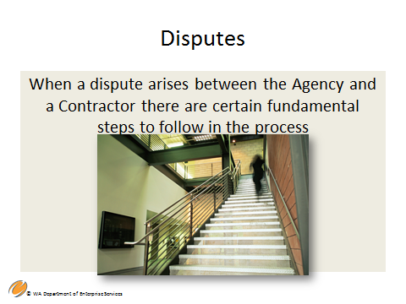

Disputes – When a dispute arises between the agency and a contractor the primary source document to refer to is the contract and the general terms and conditions. Contract terms and conditions should include a clause specifically addressing disputes and the option for an alternative dispute resolution process as determined by the parties. The disputes clause sets forth the process to be followed. Invoking the disputes clause is an option available to either party, but is not required. If the dispute process is elected, the process must be followed as described in the contract.

A Dispute is a process not entered into lightly. It should be taken slow with attention to detail. A clear and specific statement of work can help mitigate or avoid contract disputes.

 A contract dispute is typically the result of a serious difference of opinion between the agency and contractor about contract terms, conditions, or performance. The contract disputes process generally follows a formal corrective action process, such as a notice to cure.

When a dispute arises between the agency and a contractor, there are certain fundamental steps to follow in the process:

* Provide written notice of the dispute.
* Work in good faith with the contractor to resolve the dispute.
* If the dispute is with a pre-qualified master services contractor, then DES may be able to assist in the resolution of the dispute.

**Slide 26 – Dispute Resolution**

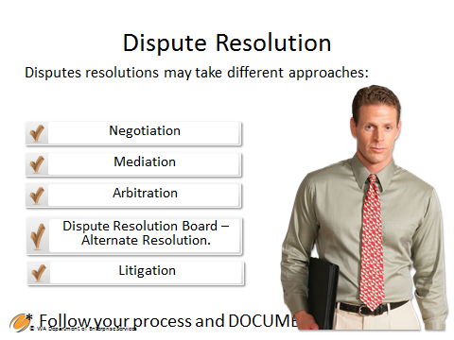

**Dispute Resolution**

One of the benefits of Involving your agency Procurement Professional early in the lifecycle of your contract is that they will be prepared should a contract dispute arise.

Dispute provisions may take different approaches. If your contract does not contain a dispute clause, usually your only alternative is litigation, which in most cases is not preferable. It is very important to try to resolve the dispute through a dispute resolution process. Here are some examples:

**Negotiation - Work with Chain of Command**

* Typically a negotiation will include giving a written statement of the issues to both parties at a higher level, usually the head of the Agency and the management of your contractor.
* The contractor will coordinate with appropriate personnel within your agency.
* Any decisions from the negotiation are not binding until ratified in a new contract or contract amendment.
* A decision from the negotiation may result in withholding of payment or termination of the contract.

**Mediation - Neutral 3rd Party**

* The mediator does not make decisions for the parties, nor are the outcomes of the mediation legally binding (unless ratified in a new contract or to an amendment to the original contract).
* The mediator facilitates a discussion between parties that are unable to come to a decision on their own. This is done to help each party understand the legitimate claims of the other and ultimately come to a mutually agreeable compromise.

**Arbitration – Arbitrator or Judge**

* The parties involved will usually have their legal counsel present. There are procedural rules already in place for this process that don’t need to be documented in the contract.
* The final decision is ratified in a new contract or an amendment to the original contract.

**Dispute Resolution Board (DRB)**

* The parties establish an alternate board typically comprising three independent and impartial persons selected by the parties.
* Recent studies have shownthat the dispute resolution board process has great success in resolving difficult and contentious disputes at far less costs than traditional litigation.

**Litigation**

* When all else fails, litigation comes into play as the last resort. Litigation is the "traditional" dispute resolution mechanism involving a courtroom, judge, and sometimes a jury. A litigation case begins when one party the plaintiff sues the other the defendant. Your agency’s AAG is counsel for your organization.

|  |  |
| --- | --- |
| Notes |  |

**Slide 27 – Types of Contract Termination and when to Use Them**

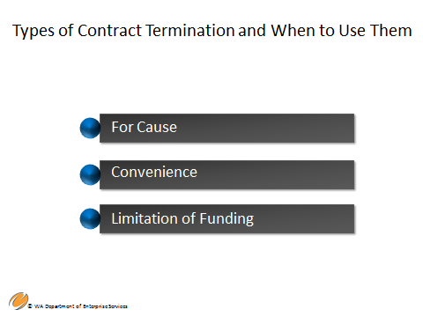

Types of Contract Termination and When to Use Them:

For Cause

* The agency must demonstrate through documentation and other methods that the contractor has not performed according to the terms of the contract. This step follows the same process as the formal corrective action, including sending a notice to cure, and/or using dispute processes. Work closely with your procurement professional, the agency’s in-house legal counsel, and your agencies assigned Assistant Attorney General when considering invoking this clause.

WAC Section 200-305 outlines the Debarment Program and the reasons and steps involved when a ‘for cause’ finding has been made. Washington state agencies can now terminate a contract if the contractor is being debarred or refer a contractor for debarment. There will be a specific course later that will address debarment, but for now please refer to WAC section 200-305.

Convenience

The termination for convenience clause is intended to handle changed conditions under the contract, particularly when the expectations of the parties have been subjected to substantial change.

* Many times agencies will use “convenience” as their termination method when they could have used termination for cause. Political dynamics or other sensitive issues are examples of why convenience is sometimes selected over cause. Sometimes it is in the best interests of the agency and/or the contractor to just walk away. However, it is recommended that you terminate for “cause” whenever it is applicable and makes the most sense.

Limitation of Funding

* Termination for limitation of funding is intended to handle situations when funding from federal, state or other sources is no longer available to the agency or not allocated for the purpose of meeting the agency’s contractual obligation. The contract is terminated for convenience if all funds become unavailable. The agency also has the option to modify the contract if not all funds are eliminated.

All state contracts should contain clauses for termination for cause, convenience and limitation of funding. The clauses should clearly spell out the termination process for each.

|  |  |
| --- | --- |
| Notes |  |

**Slide 28 – Non-Compliance**

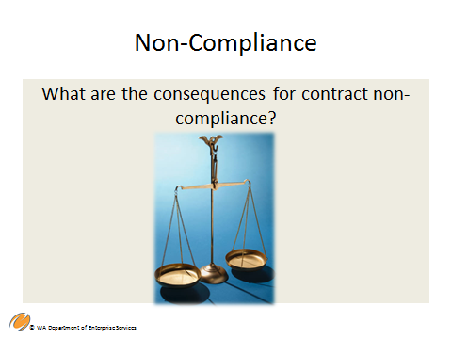

Non-Compliance - What are the consequences for contract non-compliance?

Non-Compliance is about the language that is used in the contract. Your contract should contain the language that states “the contractor shall perform pursuant to contract terms” or something similar to ensure your agency ability to hold the contractor to performance expectations. Always use an active voice, such as the contractor “will” or “shall” rather than “may” or “should.”

In addition to possible termination, depending on the procurement, you may want to add a “liquidated damages” clause to your contract. * They may be applied on a daily basis for as long as the breach is in effect. They may not be imposed as an arbitrary penalty. The key to establishing liquidated damages is *reasonableness*. It is incumbent upon the buyer or agency to demonstrate, through quantifiable means, that damages exist. Liquidated damages are a representation of actual loss caused by the breach.

ADD TO *Liquidated damages impose a specified sum on the defaulting contracting party for a specified default.

|  |  |
| --- | --- |
| Notes |  |

**Slide 31 – Section Three**



Section Three – Best Practices and Lessons Learned

|  |  |
| --- | --- |
| Notes |  |

**Slide 32 – Best Practices and Lessons Learned**

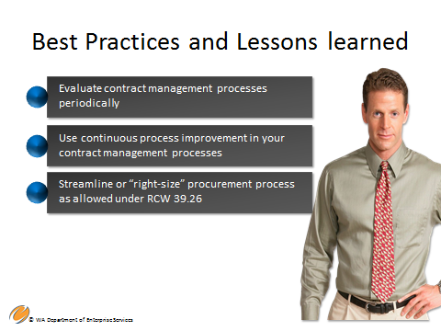

Best Practices and Lessons Learned

* Evaluate contract management processes periodically.
* Use continuous process improvement in your contract management processes.
* Streamline or “right-size’ procurement processes and contract management as allowed under RCW 39.26, procurement reform, and DES policies.

Contract management can be performed on a continuum from ad-hoc to using formal integrated processes, procedures and tools.

Best practices are those contract management practices and approaches having current and common use among the various state agencies and that reflect the principles of RCW 39.26, such as:

* + Transparency
  + Open competition
  + Ethical standards, and
  + Support of Washington small and minority businesses.

Conduct a risk assessment early on and then periodically throughout the life of the contract. Base your monitoring plan on those assessments. Remember, risk is dynamic and subsequently, so are your monitoring plans!

While this is a very strict state statutory requirement, there are also best practices around professional ethics. Those best practices include making sure that there is no perception of ethical misconduct. Open, transparent practices protect you from negative perception. As a contract manager you are representing the state of Washington and your agency and have a responsibility to be a good steward of state resources.

Throughout the entirety of Contract Management 101, many best practices were identified with regard to contract management and a purchasing and procurement overview. Use these best practices within the structure of statute, statewide policy and your agency policies and procedures.

|  |  |
| --- | --- |
| Notes |  |

**Slide 33 – Summary and Key Points**

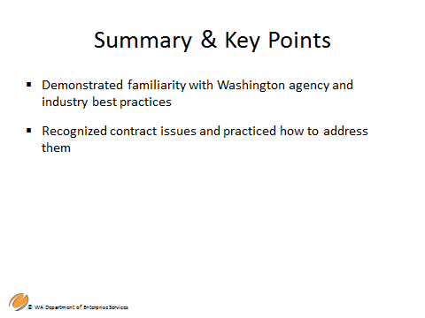

In this module, you have learned;

* Familiarity with Washington agency and industry best practices
* Recognized contract issues and practiced how to address them

You have now completed all four modules of WA-State Contract Management 101 course. Upon successfully completing the module 4 assessment, you will receive your Contract Management 101 certificate of completion.

|  |  |
| --- | --- |
| Notes |  |

**Slide 34 – Questions**



Contact Cheryl A. Shaw, Contract and Legal Services Training Manager, Department of Enterprise Services

1500 Jefferson St SE

Olympia, WA 98504

|  |  |
| --- | --- |
| Notes |  |

## Resources

DES Policies – Contracting & Purchasing Policies, Training, and Resources

<http://des.wa.gov/services/ContractingPurchasing/Pages/default.aspx>

RCW 39.26 – Procurement of Goods and Services

<http://app.leg.wa.gov/rcw/default.aspx?cite=39.26>

SAAM 16.20 – Client Service Contracts – Contract Award, Management, and Monitoring

<http://www.ofm.wa.gov/policy/16.20.htm>

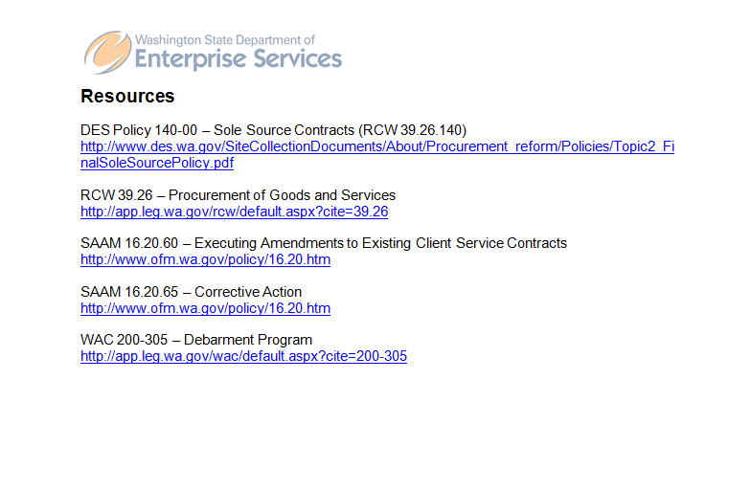

Contact Us By Phone

For questions, feel free to contact us by phone at 360-407-2200.

Locations & Directions

Our headquarters office is at 1500 Jefferson, on the Capitol Campus in Olympia, Washington. DES operations are also located throughout the state.

[Enterprise Services headquarters at 1500 Jefferson Building](http://www.des.wa.gov/about/AboutDES/Pages/LocationsDirections.aspx#1500Jefferson)

[Other Enterprise Services locations](http://www.des.wa.gov/about/AboutDES/Pages/LocationsDirections.aspx#OtherLocations)

DES Headquarters at 1500 Jefferson Building

The headquarters of Enterprise Services is the 1500 Jefferson Building, which will also serve as the state’s new data center. The building is part of state government’s historic Capitol Campus and is the newest structure built on the grounds since 1992.

Mailing Address

Washington State Department of Enterprise Services PO Box 41401 Olympia, WA 98504-1401

Physical Location

1500 Jefferson Street SE Olympia, WA 98501 - [Map](http://www.des.wa.gov/SiteCollectionDocuments/campus-map.pdf)