Contract Management 101
Module 1
Contract Management Overview
03/06/2015 Current Version
12/02/2014 Original Version

Table of Contents

Contract Management Overview 2
Course Introduction 4
Defining Contract Management 7
The Basics of a Contract 28
Contracting Tools to Guide You 44
Resources 67

Contract Management Overview

Course Introduction
Slide 2 – Course Introduction
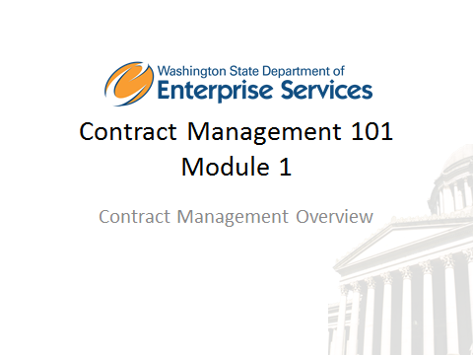

Welcome to Contract Management 101, Module 1. This is a new Training driven by Procurement Reform, and is required for all Contract Managers.

In order to receive credit for this course, you will need to score 80% or higher on the module assessment. The assessment will begin at the end of this module. Once you have successfully completed all four modules and assessment, you will receive a Contract Management 101 certificate of completion.

Also included in the training course are knowledge checks. These are not graded, they are simply used to test your knowledge of the materials in the course.

We strongly recommend you print the workbook for the course. As you proceed through the training, use the workbook to write down any notes and/or questions you might have.

The workbook can be accessed here: http://des.wa.gov/about/pi/ProcurementReform/Pages/PRTraining.aspx

Disclaimer:
At the time of this revision March 6, 2015, all materials and RCWs referenced are current. Updated course work will be made available if and when revisions are needed. As always, confirm current RCW references.

Notes

Slide 4 – Module Overview
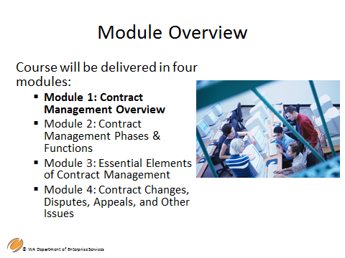

This course is Module 1:
- Contract Management Overview

The audience for the Contract Management 101 training course is contract management professionals in agencies with responsibility for administering, managing and monitoring contracts, vendor performance, and payments.

The desired outcome of this training course is to equip all Washington State contract management professionals with the basic knowledge and understanding to manage contracts and ensure compliance to the statements and scope of work for contractor performance. These professionals will understand the roles and responsibilities of a contract manager, the contract management cycle, and obtain the basics skills to handle situations that require contract changes or modifications due to contract disagreements.

Note: This course does not address federal requirements that may apply to your contracts; for example if federal funding is part of your funding source, federal reporting and contract terms are also often required. Always check your funding source to identify any additional reporting or budget requirements and restrictions to ensure the proper use of funds.

Notes

Slide 5 – Course Overview
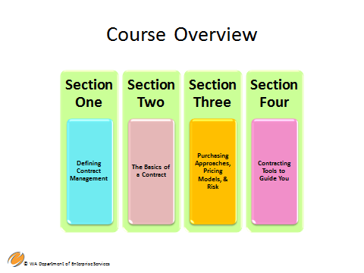
Contract Management 101 Module 1 Overview – there are 4 sections in this module:

Section One – Defining Contract Management
- Contract Management Overview
- Contracting Approaches, Types, and Pricing Methodologies
- Contracting in Washington
Section Two – The Basics of a Contract
- What is a Contract?
- Basic Elements of a Contract
- Procurement Reform and Delegation of Authority
Section Three – Purchasing Approaches, Pricing Methodologies, and Risk
- Competitive Procurements
- Competitively Awarded Contracts through Master Lists
- Convenience & Sole Source Contracts
- Types of Contracts
- Pricing Methodologies & Risk
Section Four – Contracting Tools to Guide You
- Washington State Laws and Policies
- Collaboration and Critical Thinking

These topics are intended to take you through the objectives for this module.
It is important to note that this training module will cover the topics identified on the slide. It is therefore important for you understand your roles and responsibilities within the contract management process. It is also important to be familiar with the roles and responsibilities of other purchasing, procurement, and contracting staff you collaborate with to accomplish your task. For example, the Purchasing and Procurement Professional, not the contract manager will advise on things such as types of contract and pricing model.
This course will also define contract management as well as discuss the key components and qualities of good contract management. It will be important to understand the laws and policies that provide the framework to conduct contract management in Washington, the different types of contracts and pricing methodologies, and to apply critical thinking and flexibility in order to uphold the intent of procurement reform and the current way of conducting good business practices in our state.

For purposes of this training course, the laws and policies discussed herein are those of the state and individual agencies, and do not reflect federal requirements. Federal requirements tend to be more restrictive and may apply if federal funds are used.

Notes

Slide 6 – Learning Objectives
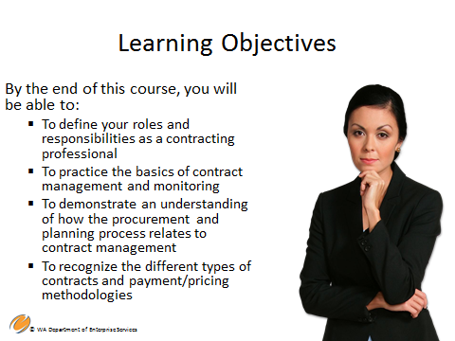

This module addresses:

- Define your roles and responsibilities as a contracting professional
- Practice the basics of contract management and monitoring
- Demonstrate an understanding of how the procurement and planning process relates to contract management
- Recognize the different types of contracts and payment/pricing methodologies

Notes

Slide 7 – Defining Contract Management
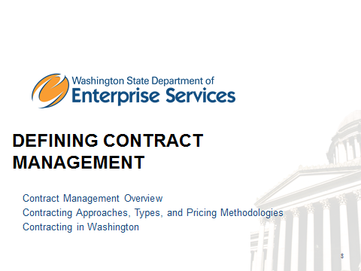

Section One: Defining Contract Management will cover the following topics:
- Contract Management Overview
- Contracting Approaches, Types, and Pricing Methodologies
- Contracting in Washington

Notes

Slide 8 – Definition of Contract Management
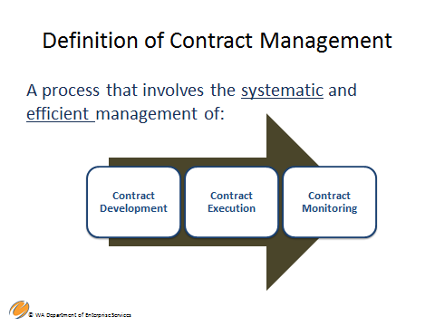

So, what is the definition of contract management?

Contract management is the management of:
- Contract Development – the procurement phase including evaluation and contractor selection.
- Contract Execution – those activities leading up to the final execution of the contract, including negotiation and approval of the final statement of work.
- Contract Monitoring – those activities used to track and monitor the contract from the date of execution to contract expiration.

These are the general process steps for managing a contract. These steps are broken down into greater detail throughout the lifecycle of contract management. This process will be discussed in more detail throughout the Contract Management training course.

Notes

Slide 9 – Key Components of Contract Management
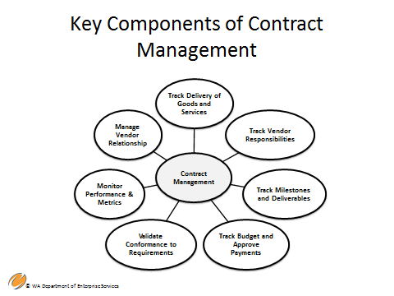

The following are key components of Contract Management:
- Tracking Delivery of Goods and Services – throughout the performance of the contract.
- Tracking Vendor Responsibilities – are they doing what they are responsible for in accordance with the contract.
- Tracking Milestones and Deliverables - making sure deliverables and milestones are on schedule.
- Tracking Budget and Approving Payments - making sure you are within your budget and not overspending.
- Validating Conformance to Requirements– this will be examined in Module 2, but should align with validating the scope of work or functional/business requirements for the contract.
- Monitoring Performance and Metrics– this requires upfront planning to establish the metrics for reporting. The initial monitoring plan should be developed early in the contract and development phase and be based on early risk assessment. Because risk is dynamic, the monitoring plan can change throughout the contract term. Work with subject matter experts, stakeholders, and your contractor to determine what these are.
- Managing Vendor Relationship
These are the key components involved with contract management, this list is not complete as more goes into contract management.
As you can see from the list, the contract manager’s primary role is to manage and mitigate risk.
Contract management is one of the highest audit risk areas of procurement. You can have a perfectly written contract, but without proper management, there is every probability the project will fail.

Notes

Slide 10 – Qualities of Good Contract Management
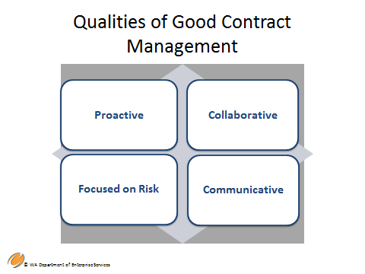

Qualities of Good Contract Management:
- Be Proactive – By actively managing and monitoring your contract, you can address issues before they potentially become a problem.
- Be Collaborative – Work collaboratively with your contractor as well as other members of your team and stakeholders.
- Be Focused on Risk – Watch for increases and decreases in risk throughout the contact term – measure and mitigate.
- Be Communicative – With all members of your team, management, stakeholders and most importantly, with your contractors.

Notes

Slide 11 – Contract & Project Management
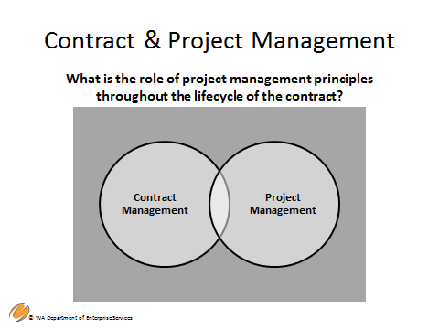

The role of project management principles throughout the lifecycle of the contract….

Contract and Project Management: What is the role of project management principles throughout the lifecycle of the contract?

In most agencies, Contract Management and Project Management are viewed as different functions.

Contract Management can benefit from the application of processes, methods, knowledge, skills, and experience commonly used by project managers. A contract manager is responsible for monitoring the quality, timeliness, completeness of work, continual movement toward the objectives of the contract, and managing and mitigating risk.

Many of the principles and activities that project managers perform to plan, implement, and control projects effectively can be used to effectively manage contracts.

For example, some project manager activities may include setting up systems and processes to track and report progress and budgets, maintaining clear and comprehensive documentation, and working to identify and resolve risks before they become issues.

While project management principles can help contract managers as they focus on developing, executing, and monitoring a contract and project delivery, there are some exceptions.

Not all contracts involve “projects”, for example, ongoing contracts for supplies or simple services.
As the contract manager, you should use applicable project management principles throughout the contract management lifecycle, wherever applicable.

Notes

Slide 14 – Employee vs. Contractor
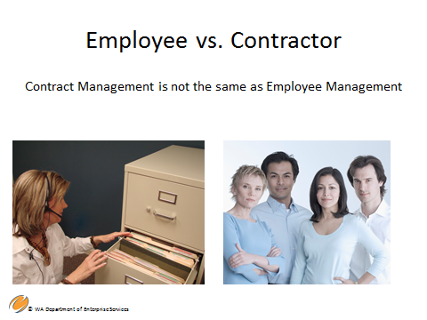

Employee vs. Contractor - As the contract manager, you don’t supervise the vendor. For example, you would not tell a vendor when to take lunch, or when to leave or take a break. While a contract may use state issued supplies such as an office desk or phone, these things are specific to the contractor’s agreement with the agency. It is important to understand your role as contract manager as well as the role of the contractor.

There are some factors to consider when determining an employee vs. contractor relationship:
- Behavioral Control: Does the business have the right to direct and control how the worker does the task for which they were hired. The following are examples of instructions about how to complete work:
- When and where to do the work
- What tools or equipment to use
- What workers to hire or to assist with the work
- Where to purchase supplies and services
- What work must be performed by a specified individual
- What order or sequence to follow

The key consideration is whether the business has retained the right to control the details of a worker's performance or has given up that right.

Treatment of the contractor is of the upmost importance.
- If an agency retains the right to direct or control the Contractor, then that person is an Employee, NOT a Contractor.
- In many cases Contractors are required to work onsite. They are provided a workspace, sometimes a computer, and a telephone. These business decisions are based on the needs of the agency.
- However, as long as the Contractor does the work based on his or her expertise, the agency does not tell them how or when to do the work (other than the possible limitation of core business hours), a contractor relationship exists.

Employee Management has very specific HR rules and applicable laws, including the payment of employer taxes and providing medical and other benefits. By treating our contractors as employees we run the risk of IRS penalties and paying other benefits to the contractors, sometimes being forced to put them on the payroll, especially after a long working relationship.

Notes

Slide 17 – Contract Management & Monitoring
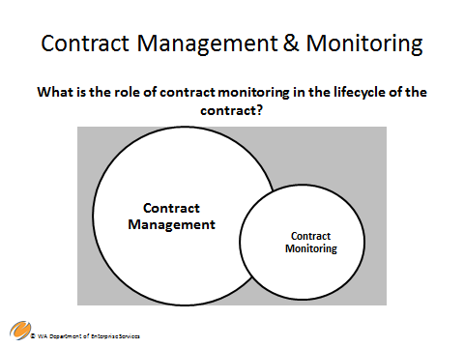

What is the role of contract monitoring in the lifecycle of the contract?

Contract monitoring is only one aspect of Contract Management, and is comprised of a variety of tools and activities that fall within the realm of contract management.

Monitoring a contract means any planned, ongoing or periodic activity that measures and ensures contractor compliance with the terms and conditions of the contract. The level of monitoring should be based on a risk assessment of the services provided and the contractor’s ability to deliver those services. Every communication with a contractor is an opportunity to monitor activity.

The purpose of monitoring is to ensure the contractor is:
- Complying with the terms and conditions of the contract and applicable laws and regulations;
- Adhering to the project schedule and making appropriate progress toward the expected results and outcomes;
- Providing the quality of services expected;
- Identifying and resolving potential problems and providing constructive, and timely feedback.

Monitoring activities may include, but are not limited to, the following:
- Periodic contractor reporting. Contractors submit progress reports or other appropriate data and deliverables to report on services being provided, adherence to the contract, and degree of progress being made. Substandard performance can also be determined.
- On-site reviews and observations. Contract managers may conduct on-site reviews, interview contractor staff to ascertain their understanding of program goals, interview clients about services received (if appropriate), review key systems and service documentation, review client case records, review personnel records to ensure staff have appropriate credentials, review fiscal records, and observe operations whenever possible. The results of these reviews should be documented in writing and compared with contract requirements.
- Invoice reviews are one of the most common monitoring activities. Contract managers compare billings and invoices with contract terms to ensure the costs being charged are accurate and consistent with the contract requirements, and are within the compensation limits set by the contract. Verifying that funds are tracked by fund source will help prevent over-payments.
- Audit report reviews. Contract managers review any required audit reports and audit work papers to ensure the contractor takes appropriate and timely corrective action, if required.
- Other periodic contact with contractor. Meetings and other periodic contact with the contractor to review progress facilitates continuous dialog and mitigates problems.

Documentation of monitoring activities must be maintained by the agency to verify that monitoring has been conducted. Contract files should include, for example, copies of letters and e-mails, meeting notes, and records of key phone conversations as evidence that conscientious monitoring has occurred during the contract. This is especially important where there are issues with the contractor’s performance.

Notes

Slide 18 – The Basics of a Contract
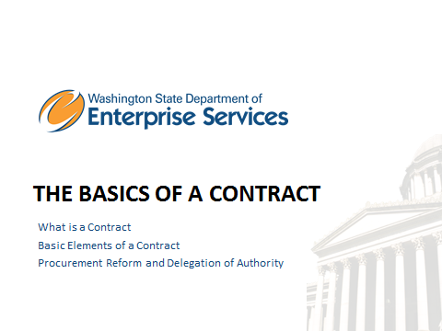

Section Two: The Basics of a Contract, in this section we will cover the following topics:
- What is a Contract?
- The Basic Elements of a Contract
- Procurement Reform and Delegation of Authority

Notes

Slide 19 – What is a Contract
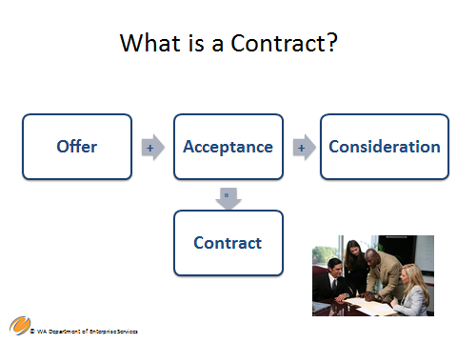

According to Black’s Law Dictionary, a contract is an agreement, upon sufficient consideration, to do or not to do a particular thing OR a covenant or agreement between two or more persons, with a lawful consideration or cause.

A contract is:
- A Legally binding agreement
- An Exchange of Legal consideration
- Enforceable
- Per the laws of the State of Washington, it must be Written
- Creates an obligation for named parties to fulfill

Note: The term “contract” is not explicitly defined in RCW 39.26

Notes

Slide 20 – Basic Elements of a Contract Part 1
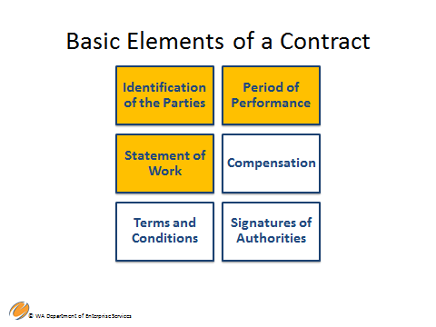
There are many basic elements to a contract. Let’s begin with the first three,

- Identification of the Parties: Typically, the first paragraph of a state contract identifies who the contracting parties are. Example: DES Contract No. K6, is made and entered into by and between the State of Washington, Department of Enterprise Services hereinafter referred to as the "AGENCY", and the ABC Consulting Company, hereinafter referred to as “CONTRACTOR”.

- Period of Performance: This includes the start date and end date of the contract. The start date (or effective date, date of execution, or date of final signatures) is the date the contractor can begin providing services and will get paid for those services. The end date is the date on which the contractor will stop providing paid services.

- Statement of Work: This is the most important section of your contract because it will describe for the contractor what services they will provide, your expectations about how they will provide them, and identify outcomes, deliverables, timelines, and tasks. This section may also describe the responsibilities of your agency relative to the contracted-for services. For example, if the contractor is providing training for your staff, your agency may provide the room and equipment for the training. In the Statement of Work section, you will also include any reports required from the contractor, along with due dates for those reports. All deliverables must be within the stated period of performance. If the Statement of Work is attached as an exhibit, the contract should state that the exhibit is attached to the contract and incorporated by reference.

Notes

Slide 21 – Basic Elements of a Contract Part 2
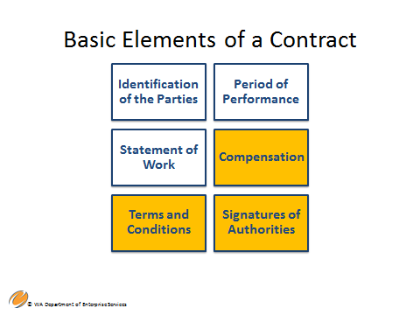

4. Compensation: This section of the contract deals with contractor payment.
- Specifically identify the payment methodology(s) describing how the contractor will be paid, i.e., by deliverable measure or outcome, hourly rate, etc.
- Total maximum value of the contract (any money being paid to the contractor under this contract – includes professional fees, other expenses, taxes, travel at state per diem rates etc.).

Some contracts require that you identify how the contractor will be paid, however, you are not always required to include the total maximum value of the contract.
- Instructions on how the contractor may request payment, either by invoice or some other documentation method. Instructions should include what information the contractor should provide on the payment request.

5. Terms and Conditions: The contract contains many “terms and conditions” which are the clauses that explain to both parties all the rights, obligations, and protections in the contract. Contracts are often split into:
- Special Terms and Conditions, which explain all the information pertaining to the particular service you are buying. This section of the contract will include the Period of Performance, Statement of Work, Compensation, Insurance, and other provisions.
- General Terms and Conditions, which are the clauses that apply to everyone that your agency contracts with. This section will include termination, dispute resolution, compliance with non-discrimination laws and many other provisions. These provisions have been approved by your agency’s Assistant Attorney General and can’t be changed without their approval (check your agency’s process).

6. Signed by Individuals with Signature Authority: The contract must be signed and dated by people with the authority to bind their agency/company to the contract. This applies to both the contractor and the state agency. So, make sure you don’t sign contracts unless you have been authorized to do so!

Notes

Slide 24 – Procurement Reform Delegation of Authority
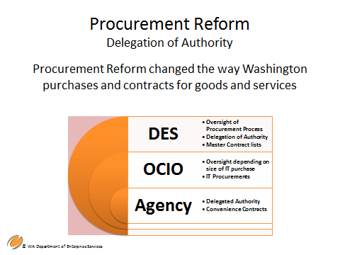

Procurement Reform, codified as RCW 39.26, changed the way Washington State agencies purchase and contract for goods and services.

- The Director of Department of Enterprise Services (DES) was charged with establishing policies for delegating procurement authority to state agencies.
- The authorization must specify restrictions as to dollar thresholds or to specific types of goods and services, based on the risk assessment developed and assessed by DES and other stakeholders.
- Agencies are then responsible for the specific policies and procedures to implement delegated authority and those that reflect the outcomes of Procurement Reform and the risk assessment. These are based on a risk assessment and will be discussed further.
- DES is responsible for policies addressing purchasing and procurement and informing agencies about the processes to follow. Office of the Chief Information Officer (OCIO) informs agencies about what IT they can purchase and exercises oversight based on risk level.
- RCW 39.26.090 – Outlines the DES Director’s duties and responsibilities
- Higher Ed is given delegated authority under RCW 28B

Your agency’s ability to contract in Washington is based on:
- Delegated Authority as defined in policy and based on risk assessment
- The state agency or public entity governed by public law engaging in a contract for services or goods.

First, make sure your agency has delegated authority and that it aligns with the mission, vision, and values of your organization. As a contract manager it’s important you understand your individual agency spending threshold and delegation of authority based on the risk assessment. Delegations are assigned to your agency and sent to your agency head. Please check with your procurement professionals for details about your particular agency.

Notes

Slide 27 – Procurement Reform
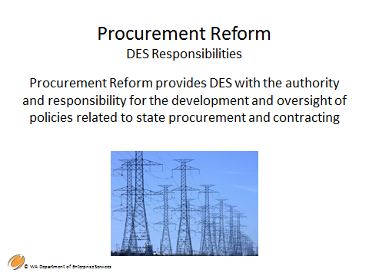

Procurement Reform or RCW 39.36 provides the Department of Enterprise Services (DES) with the authority and responsibility for the development and oversight of policies related to state procurement and contracting.

Key aspects of these responsibilities include:
  - Charges the Department of Enterprise Services (DES) with oversight of state procurement of goods and services – including delegation of authority as discussed earlier.
  - Requires procurements to be based on a competitive solicitation process, with exceptions (RCW 39.26.125).
  - Requires transparency to ensure the highest ethical standards, proper accounting for contract expenditures, and ease of public review of contract and procurement documents.

DES continues to develop new procurement policies, guidelines and best business practices (BBP’s).

The DES website contains final policies for the following topic areas: This list is not all inclusive and more will be added as they are developed.
- Delegation of Authority
- Sole Source Contracts
- Emergency Procurements/Purchases
- Direct Buy Procurements/Purchases
- Complaints and Protests
- Agency Contract Reporting

Notes

Slide 28 – Purchasing Approaches, Pricing Methodologies, & Risk
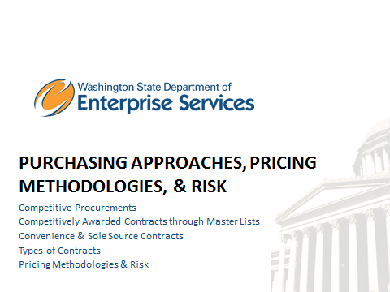

Section Three: Purchasing Approaches, Pricing Methodologies, and Risk will cover the following topics:
- Competitive Procurements
- Competitively Awarded Contracts through Master Lists
- Convenience & Sole Source Contracts
- Types of Contracts
- Pricing Methodologies & Risk
Notes

Slide 29 – Qualified Master Contract
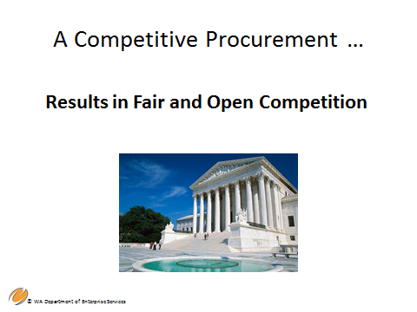

Competitive Procurements
A competitive procurement is a documented formal or informal process that provides an equal and open opportunity to bidders and results in a selection based on predetermined criteria per RCW 39.26.

Competitive procurements are required to be based on a competitive solicitation process, with exceptions per (RCW 39.26.125).

Procurement Reform brought focus and renewed energy to promote open competition and transparency for all contracts for goods and services. Fair and open competition requires that we apply critical thinking skills to ensure the highest ethical standards are engaged, that proper accounting for contract expenditures occur, and the public is easily able to review the process used.

The competitive process instills public confidence and encourages participation of the business community to meet State’s purchasing needs and Procurement Reform (RCW 39.26) provides the opportunity to balance critical thinking and compliance with the ability to “right-size” your procurement to meet your need.

Notes

Slide 32 – Purchasing Approaches That Result in Contracts
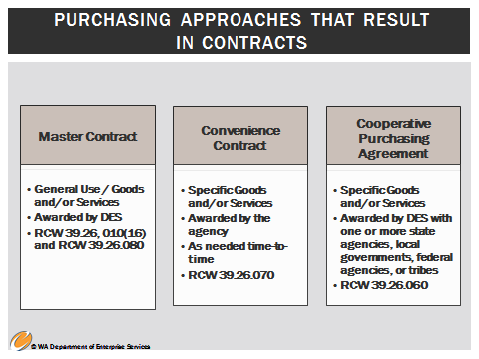
The first step in the competitive procurement process is to determine if procurement from a qualified master contract will meet your agency’s need.

A Master Contract: is a contract for specific goods and/or services, that is solicited and established by DES in accordance with laws and rules on behalf of and for general use by agencies as specified by DES. (RCW 39.26.010(16)).

Is a Master Contract available? If “yes”, use it if it meets your needs!

Convenience Contract: is a contract for use by a specific agency or group of agencies as needed from time to time that is solicited by the agency or group of agencies, and follows the procurement rules and laws in RCW 39.26.

Specifically, as stated in law “A convenience contract is a contract for specific goods or services, or both, that is solicited and established by the department in accordance with procurement laws and rules on behalf of and for use by a specific agency or group of agencies as needed from time to time. A convenience contract is not available for general use and may only be used as specified by the department per (RCW 39.26.070).“

Please note: Legislation is currently before the legislature to change the reference from “Department” to “Agency” in the authorizing statute to reflect the original intent of the law. It is considered a technical fix to a law.

- A convenience contract is an agency’s contract and is within their delegated authority.

Is a Convenience Contract available? If “yes”, use it if it meets your needs!

RCW 39.26.060 Cooperative purchasing: is a cooperative purchasing agreement for the procurement of any goods or services with one or more states, state agencies, local governments, local government agencies, federal agencies, or tribes located within the state.

- On behalf of the state, DES may participate in, sponsor, conduct, or administer a cooperative purchasing agreement for the procurement of any goods or services with one or more states, state agencies, local governments agencies, federal agencies or tribes located in the state, in accordance with an agreement entered into between the participants. The cooperative purchasing may include, but is not limited to, joint or multiparty contracts between the entities and master contracts or convenience contracts that are made available to other public agencies.
- All cooperative purchasing conducted under this chapter must be through contracts awarded through a competitive solicitation process.

Notes

Slide 33 – Competitively Awarded Contracts Through Master Lists
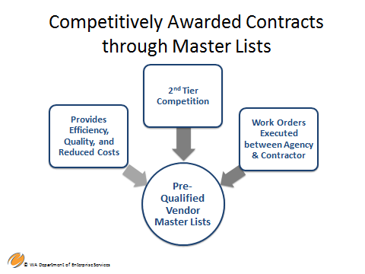

The benefits of these types of pre-qualified contract lists (Master Contract, Convenience Contract, Cooperative Purchasing Agreement) include:

- Such contracts provide efficiency, quality, and reduced cost to procure a vendor.
- Some require 2nd-tier competition, but the 2nd-tier is often more efficient than a new procurement.
- Work orders issued under the master contracts are executed between the agency and the contractor.

Notes

Slide 34 – What is a Qualified Master Contract
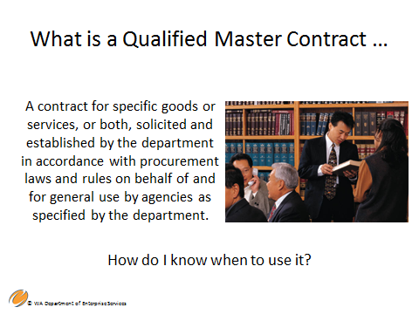

The next few slides will cover Qualified Master Contracts, Convenience Contracts, and Sole Source Contracts and how and when to use them. You will learn where to find and how to search the Qualified Master Contracts Database as well as be able to apply the criteria presented.

Definition of a Master Contract: A contract for specific goods or services, or both, that is solicited and established by the department in accordance with procurement laws and rules on behalf of and for general use by agencies as specified by the department. RCW 39.26.010(16)

DES conducts a Master Contract competitive procurement that results in the selection of vendors that are prequalified to be on the Master List.

Additional qualified master contracts are cooperative contracts that conform to Washington State Procurement laws, rules, policies and trade agreements. DES maintains a list of cooperative contracts that meet state requirements. An example of this is the Western States Contracting Alliance (WSCA). DES enters into participation agreements in order to use those contracts that meet state requirements and are “qualified” for use by agencies.

Overall, if an Agency has a need that can be met with one of these prequalified vendors, they can contract directly with the vendor or in some cases, must go through a 2nd tier competition, which is less complex and less lengthy than a full competitive procurement.

1st Tier and 2nd Tier Qualified Master Contract

Tier One – For each category of service, DES maintains a pre-qualified list or “pool” of vendors within Washington’s bid notification and contractor registration system for purchasers to use when soliciting for goods or services. In order to be included on a category’s pre-qualified list, companies must pre-qualify through a competitive “first-tier” solicitation process conducted by DES.

Tier Two – Once pre-qualified, a company has the ability to view, download, and respond to agency purchaser work requests or “second-tier” solicitations which specify that category only.

How to use a Qualified Master Contract: If you are eligible to receive services from Enterprise Services, including state and local government entities and qualifying non-profits, and have completed a Master Contracts Usage Agreement (MCUA), you can procure directly from the contractor, whose contract information is listed for each Master Contract.

How do I place an order? Products and service orders are submitted directly to the contact (follow your agency policy and procedures – whoever actually places the order if this isn’t you). You must include the master contract number on all documents.

Qualified Master Contracts Database: There is a list of vendors with current master contract agreements on the DES website. You can search by commodity, vendor or by contract number.

Higher Education and Cooperative consortiums: An arrangement among higher Ed institutions that have entered into a cooperative arrangement for the purpose of carrying out common procurement objectives. Higher Education is not required to use State Master Contracts if they choose not to.
Notes

Slide 37 – What is a Convenience Contract
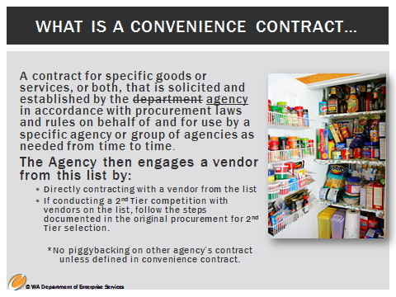

What is a Convenience Contract and How Do I Know When to Use it?

Definition of a Convenience Contract: A convenience contract is a contract for specific goods or services, or both, that is solicited and established by the department agency in accordance with procurement laws and rules on behalf of and for use by a specific agency or group of agencies as needed from time to time. A convenience contract is not available for general use and may only be used as specified by the department agency. (RCW 39.26.070).

Note: Legislation is in the works to change the reference from “Department” to “Agency” in the authorizing statute.

Convenience contracts are different from a master contract in that the Agency itself establishes and conducts the procurement that results in vendors that are prequalified to be on the Convenience Contract List.

The Agency itself establishes the Convenience Contract, which represents a list of pre-qualified vendors solicited by the Agency who can provide specific goods and/or services the Agency uses. A convenience contract can be one vendor or multiple vendors, therefore there needs to be a fair way to select these vendors.

If more than one vendor is contracted, the Agency then engages a vendor from this list by:
- Directly contracting with a vendor from the list (e.g., by rotation basis, based on geographic area, or through 2nd Tier selection)
- If conducting a 2nd Tier competition with vendors on the list, follow the steps documented in the original procurement for 2nd Tier selection.

Notes

Slide 38 – Sole Source Contract
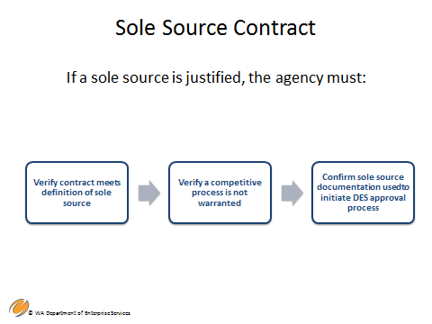

Definition of a Sole Source:
"Sole source" means a contractor providing goods or services of such a unique nature or sole availability at the location required that the contractor is clearly and justifiably the only practicable source (best source) to provide the goods or services.

There are three actions required with a Sole Source:
- Post to Washington’s Electronic Business Solution (WEBS) the intent to procure sole source goods and/or services – minimum five working days.
- Make all contracts available for public inspection – on your agency’s website – minimum of ten working days.
- Submit / File through the Sole Source Contracts Database (SSCD) for approval. Minimum of ten working days.

Note – As a reminder there is a direct buy threshold. You can purchase below that threshold. There are multiple exemptions to the Sole Source criteria. See Policy DES#-140-00 for a detailed list and explanation of these exemptions.

If an agency determines a sole source contract is justified, the agency must:
- Ensure the proposed contract meets the definition of sole source
- Verify that a competitive process is not warranted
- Confirm the sole source documentation is used to initiate the DES approval process. This includes a compelling and detailed justification for the Sole Source. When determining to Sole Source. Work with your procurement professionals or DES to help you decide if you meet the Sole Source litmus test.

Notes

Slide 39 – Typical Types of Competitive Solicitations
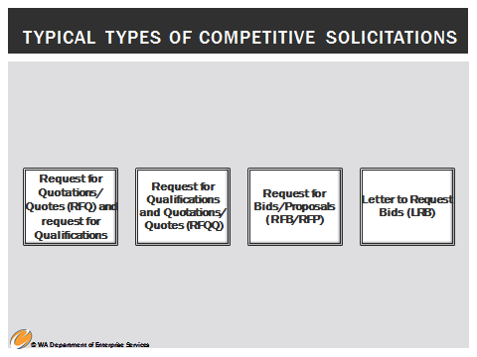
The Competitive Process – Typical Types of Competitive Solicitations

Starting the Competitive Process, which results in a contract…
- Develop the competitive solicitation document
- Typical document types include:
- Request for Quotations/Quotes (RFQ) OR REQUEST FOR QUALIFICATIONS
  - Request for Quotes – Used most often when procuring commodities (goods) or commodity-like services. Goods and services are typical and provided to all buyers. Vendors are selected based on price only.
  - Request for Qualifications – Scope and statement of work is solidified and all vendors will be paid a set fee. Vendors are selected based on qualifications.
- Request for Qualifications and Quotations/Quotes (RFQQ) – Scope and statement of work is solidified. Vendors are selected based on both qualifications and price.
- Request for Bids/Proposals (RFB/RFP) – Only scope of work has been determined (what is to be done). Vendors are selected based on their submitted statement of work (how they will achieve/perform the scope of work), qualifications and price.
- Letter to Request Bids (LRB) - a simplified competitive procurement for low dollar value and/or low risk – Informal

Definitions:
Scope of Work: A detailed, written description of the conceptual requirements for the project contained within a Request for Proposal (RFP). The scope of work should establish a clear understanding of what is required by the vendor.
Statement of Work: The response from the vendor outlining very specifically how they propose to complete the work as outlined in the Scope of Work. It defines what will be done, how, by whom, and cost factors.

Notes

Slide 40 – Types of Contracts Covered
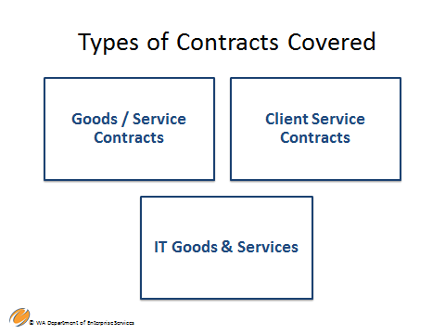
The types of contracts used by your agency are based on specific delegated authority. You receive delegated authority for services, commodities, (goods), and IT goods and services.

Any of these types of contracts can result from the competitive solicitation methods just discussed in the previous slide or procured as a Sole Source if necessary.

- Goods / Service Contracts (RCW 39.26)
- “…Professional or technical expertise provided by a consultant to accomplish a specific study, project, task, or other work statements.
- “… Routine services… offered for sale by a supplier(s) and required by an agency to accomplish continuing and necessary functions.
- IT Goods & Services found in Section 121 OCIO Policy Manual (what can be purchased) and RCW 39.26 (How it can be purchased)
- Client Service Contracts (RCW 39.26)
- “Services provided directly to agency clients by contractors including, but not limited to, medical and dental services, employment and training programs, residential care, education and subsidized housing. Clients are considered to be those individuals whom the agency has statutory responsibility to serve, protect, or oversee.”
- Clients are the targeted individuals in the public that an agency is responsible to serve.
They are not:
  - Providers of services, for example foster parents served by Department of Social and Health Services (DSHS), or teachers served by the Office of Superintendent of Public Instruction (OSPI).
  - Federal, State, or Local Government Employees
  - Firms or businesses
  - General Public

Note: Client Service Contracts are exempt from competition per RCW 39.26.125 (6)

Examples of agency clients that client service contractors provide services to:
- Clients of the Department of Social and Health Services include nursing home patients, institutionalized individuals, and children in need of therapy – children, senior citizens, developmentally disabled, etc.
- Clients of the Employment Security Department include unemployed and displaced workers
- Clients of Institutions of Higher Education include their students
- Clients of veterans affairs – vets and their families

Example of non-Client Service Contracts:
- DES serves other agencies and public entities, vendors, etc. While DES provides services, they do not meet the definition of client services.

Other Contracts you may manage include but are not within the scope of this training:
- Public Works RCW 39.04
- Architectural and engineering RCW 39.80
- Interagency Agreement RCW 39.34

For purposes of this training we are focused on RCW 39.26, but it’s important to note that the contract management strategies discussed throughout this training are applicable to other contracts as well.

Notes

Slide 41 – Pricing Methodologies
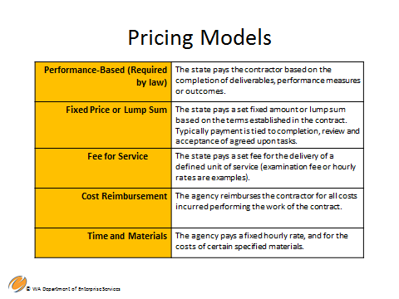
Each pricing methodology comes with a different type of risk. Work with your procurement professional. They will be able to advise on the best pricing methodology for your situation. Pricing methodology decisions may also be influenced by the market place or industry standard.

WHAT ARE THE DIFFERENT METHODS USED TO PAY CONTRACTORS?

Typical compensation methods include:
- Performance based: The state pays the contractor based on the completion of deliverables, performance measures, or outcomes. Lower risk, requires less monitoring. This method is required by law to the extent practicable (RCW 26.180(3).
- Fixed price or lump sum: The state pays a set fixed amount or lump sum based on the terms established in the contract. Typically payment is tied to completion, review and acceptance of agreed upon tasks. Lower risk requires, less monitoring.
- Fee for service: The state pays a set fee for the delivery of a defined unit of service (examination fee or rate percent encounter are examples). Lower risk, requires less monitoring.
Note: These 3 methods are considered lower risk because it’s easier to track successful completion and billing.

- Cost reimbursement: The state reimburses the contractor for all costs incurred while performing the work of the contract. (Salaries, benefits, travel and other line item costs). This pricing methodology is also referred to as line item or budget. High risk, requires more monitoring.
  - It is recommended that a report be required with each invoice that validates and describes the amount requested under this method.
- Time and materials: The state pays a fixed hourly rate for the costs of certain specified services. This type of reimbursement may be used when the agency is unable to clearly identify the level of effort required to accomplish the work. High risk, requires more monitoring.
  - It is recommended that a report be required with each invoice that validates and describes the amount requested under this method.

Notes

Slide 44 – Contracting Tools to Guide You
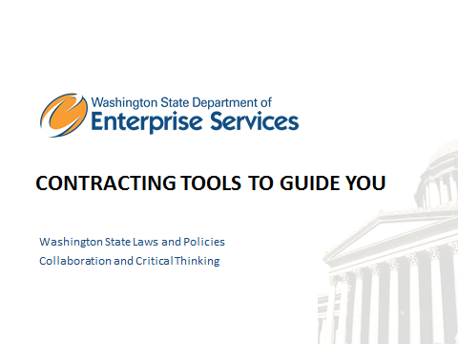
Section Four: Contracting Tools to Guide You will cover the following topics:
- Washington State Laws and Policies
- Collaboration and Critical Thinking

Notes

Slide 45 – Contracting in Washington

When contracting in Washington, the following resources may be helpful:

Resources, such as sample forms, links, training guides, and policies and rules are available on the DES website. A link has been included at the end of your participant workbook in the Resources section.

Notes

Slide 46 - Laws and Policies
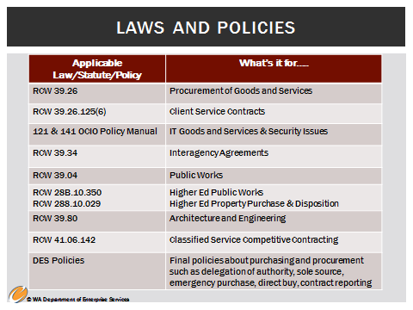

Washington State Laws and Policies

Contracting in Washington is established through laws and policies and in some cases, rules. The laws provide a framework to conduct contract management. Your individual agency will have policies and procedures to depict “how” contract management is applied in your agency. DES policies are also available to set overall policies that apply to agencies.

The following is a list of the relevant laws and policies that apply to contract management. For purposes of this training, the first three laws and policies are within the scope of this training. Please see the Resource page in your workbook for a link to each of the laws and policies identified in the slide.
- RCW 39.26 – Goods and services
- RCW 39.26.125 (6) – Client Service Contracts
- 121 & 141 OCIO Policy Manual – IT goods and services and security issues
- RCW 39.34 – Interagency agreements
- RCW 39.04 – Public Works
- RCW 28B.10.350 – Higher Ed Public Works
- RCW 28B.10.029 Higher Ed Property Purchase & Disposition
- RCW 39.80 – Architecture and engineering
- RCW 41.06.142 – Classified service competitive contracting
- DES Policies – final policies about purchasing and procurement on DES website with more to come.

Notes

Slide 47 – Balancing Consistency and Flexibility
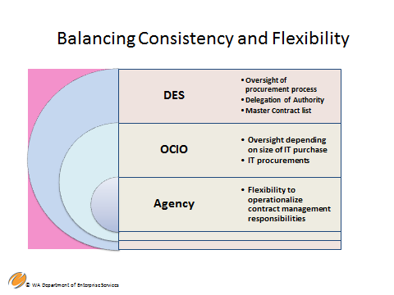

Agencies have flexibility within their delegated authority to purchase (this topic is covered in the Purchasing and Procurement training). Be sure to balance consistency and flexibility. There are limitations with flexibility, however, including your own agencies policy and practices.

It is important to follow laws, rules, and policies related to contract management and to work with contract and procurement specialists in your agency.

DES, under Procurement Reform (RCW 39.26), is providing consistent tools, practices and structures that agencies can use in their contract management, and within that, there is flexibility for your own methods, formats, and organization to manage the contracts you are responsible for.

All contract management must include key items, including but not limited to the following:
- In almost all instances, written contracts must be signed by both parties before work can begin under the contract.
- Written contract amendments must be signed prior to the contract expiration date (end date) whenever there is a change to the statement of work, period of performance, or maximum dollar amount (or other financial terms) of the contracts - any substantial change.
- Adequate protection for the State should be included in the contract.
- Services should be performed to the satisfaction of the contract manager before payment is approved. Approval should not be unreasonably withheld.
- All work must be completed within the contract period of performance, including deliverables.

There is flexibility in how contract managers perform these responsibilities; for example, internal agency process for approving payment of invoices.

Agencies may choose a contract format appropriate to the services being acquired. For example, an agency may wish to use a short-form contract or letter of agreement when the contract services are not complex.

Notes

Slide 48 – Collaboration and Critical Thinking
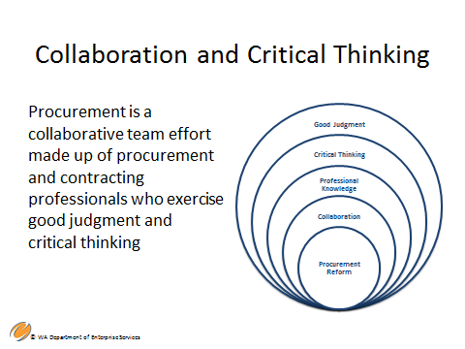

Collaboration and Critical Thinking

While procurement professionals still need to follow the applicable laws and policies set forth (compliance), Procurement Reform shifted culture from one of strict compliance to a more collaborative team environment made up of procurement professionals who exercise good judgment and critical thinking skills when purchasing or contracting for goods or services.

Examples of critical thinking include:
- Refer back to the agency mission, the RFP, and original scope of work to address issues and discrepancies.
- Be clear about the signature authority.
- Be familiar with and use the contract and refer to it always.
- Ability to “right size” your procurement within statute and policy

Agencies approach critical thinking in different ways. It’s important to understand how critical thinking applies in your agency. It’s important as a contract manager to understand all aspects of a contract lifecycle, as you are an integral part of its success.

Notes

Slide 49 – Summary and Key Points
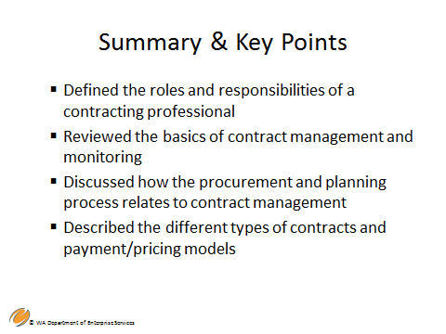

In this module, we:
- Defined the roles and responsibilities of a contracting professional
- Reviewed the basics of contract management and monitoring
- Discussed the procurement and planning process related to contract management
- Described the different types of contracts and payment/pricing methodologies
The next course is: Contract Management 101 Module 2 – Contract Management Phases and Functions

Notes

Slide 50 - Questions
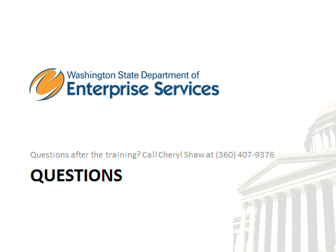

Contact Cheryl A. Shaw, Contract and Legal Services Training Manager, Department of Enterprise Services
1500 Jefferson St SE
Olympia, WA 98504
360-407-9376
Notes

Notes

Resources
DES Policies
- Policy # DES-140-00 - Sole Source Exemptions
http://www.des.wa.gov/SiteCollectionDocuments/About/Procurement_reform/Policies/SoleSourceContractingPolicy_3-7-13.pdf

- Resources, such as forms, links, training guides and rules are available on the DES site at: http://des.wa.gov/services/ContractingPurchasing/Pages/default.aspx

A Guide to the Project Management Body of Knowledge (PMBOK Guide) 5th Edition
http://www.pmi.org/PMBOK-Guide-and-Standards.aspx

OCIO Policy Manual 121 – IT Investments – Approval and Oversight
https://ocio.wa.gov/policies/121-it-investments-approval-and-oversight

OCIO Policy Manual 141- Securing Information Technology Assets
https://ocio.wa.gov/policies/141-securing-information-technology-assets

RCW 28B.10.350 – Construction work, remodeling, or demolition – Public Bid – Exemption – Waiver – Prevailing rate of wage – University and The Evergreen State College
http://app.leg.wa.gov/rcw/default.aspx?cite=28B.10.350

RCW 39.26 – Procurement of Goods and Services
http://app.leg.wa.gov/rcw/default.aspx?cite=39.26

RCW 39.26.010 (22) – Definition of ‘Services’
http://app.leg.wa.gov/rcw/default.aspx?cite=39.26.010

RCW 39.26.060 – Cooperative Purchasing
http://apps.leg.wa.gov/rcw/default.aspx?cite=39.26.060

RCW 39.26.070 – Convenience Contracts
http://apps.leg.wa.gov/RCW/default.aspx?cite=39.26.070

RCW 39.04 – Public Works
http://app.leg.wa.gov/rcw/default.aspx?cite=39.04

RCW 39.34 – Inter Local Cooperation Act (Interagency Agreements)
http://app.leg.wa.gov/rcw/default.aspx?cite=39.34

RCW 39.80 – Contracts for Architectural and Engineering Services
http://app.leg.wa.gov/rcw/default.aspx?cite=39.80

RCW 41.06.142 – Purchasing services by contract – Criteria to be met – Bidding – Definitions
http://app.leg.wa.gov/rcw/default.aspx?cite=41.06.142

RCW 39.26.125(6) – Client Service Contracts
http://apps.leg.wa.gov/RCW/default.aspx?cite=39.26.125

Contact Us By Phone
For questions, feel free to contact us by phone at 360-407-2200.
Locations & Directions
Our headquarters office is at 1500 Jefferson, on the Capitol Campus in Olympia, Washington. DES operations are also located throughout the state.
Enterprise Services headquarters at 1500 Jefferson Building
Other Enterprise Services locations
DES Headquarters at 1500 Jefferson Building
The headquarters of Enterprise Services is the 1500 Jefferson Building, which will also serve as the state’s new data center. The building is part of state government’s historic Capitol Campus and is the newest structure built on the grounds since 1992.
Mailing Address
Washington State Department of Enterprise Services PO Box 41401 Olympia, WA 98504-1401
Physical Location
1500 Jefferson Street SE Olympia, WA 98501 - Map

