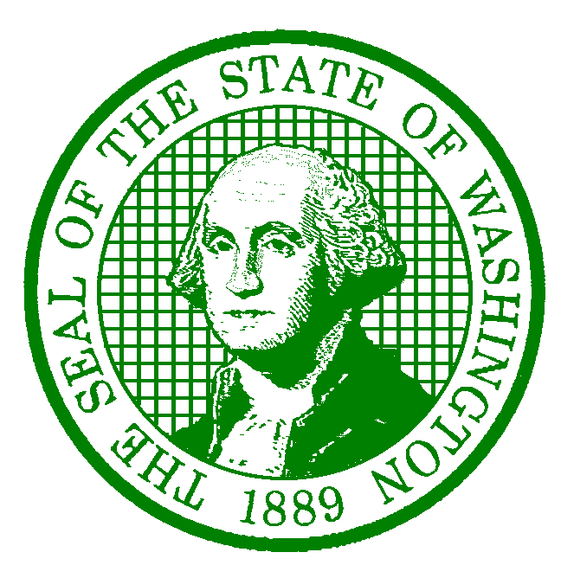**AGENCY LETTERHEAD**

December 20, 2022

Employee Name

Employee Address

City, State Zip-Code

Dear Employee Name:

This letter is confirmation of your approved salary increase. Effective Effective Date, your salary will increase to $Monthly OR Hourly Wage per month OR hour, RangeRange, Step Step**,** in accordance with the Washington Federation of State Employees (WFSE) Collective Bargaining Agreement (CBA), Article 42.11.

In the event you have questions concerning your salary increase, please feel free to contact Name at Phone # or Email Address.

Sincerely,

Supervisor/Appointing Authority/HR Liaison

Title

cc: Supervisor Name, Supervisor

saa@des.wa.gov

Personnel File