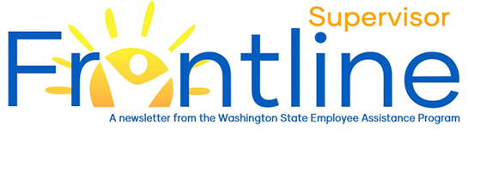
Nana korobi ya oki
Fall down seven times, get up eight (Japanese Proverb)

September is Suicide Prevention Month
In this month’s newsletter:
Suicide Prevention Month
Emotions and Leadership Styles
Training and Development
Resources
Contact EAP
eap.wa.gov
Toll free: (877) 313-4455
Phone: (360) 407-9490
Interpreters available.
TTY: call 711 via WA Relay

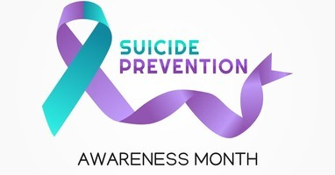
September is National Suicide Prevention and Awareness Month, a time to destigmatize suicide, raise awareness and strengthen our commitment to support the well-being of our families, friends, co-workers and community members. Read the September Frontline Employee Newsletter to learn more about this awareness month and about how you can help. (Word | PDF)

Emotions and Leadership Styles
The past 18 months have been a test of resilience, tenacity and emotional capacity. In and outside the workplace, worry, anxiety and fear have become common emotional experiences. What should a leader do with their emotions? Stay positive for the sake of team members? Suppress and/or ignore emotions and focus on strategy and operations? Openly acknowledge and share their emotions – even negative ones? One recent attempt to answer these questions suggests that sharing your stresses, fears and anxieties might be more beneficial for you and your team than other approaches. The authors of the Harvard Business Review article Leaders, Don’t Be Afraid to Talk About Your Fears and Anxieties analyzed the journal entries of leaders and identified three leadership styles – Heroes. Technocrats and Sharers. In the authors’ analysis, Sharers were “most effective when it came to building cohesive, high-performing teams that were resilient in the face of the myriad challenges posed by the pandemic.” Read the full article.

Training and Development
Workforce Learning and Performance (WLP), the training and development program in the Workforce Support and Development (WSD) division of Department of Enterprise Services (DES) offers a variety of instructor-led training (virtual and in-person) and on-demand courses (e-learning courses and LinkedIn Learning licenses). The following courses might be helpful, as you navigate the ongoing challenges.
- Foundations of Emotional Intelligence (1 Day)
- Emotional Intelligence in Practice (1 Day)
- Emotional Intelligence - Foundations & In Practice (2 Days)
- Make Work More Human (1 Day)
- Crucial Conversations
- LinkedIn Learning
  - Managing Organizational Change for Managers
  - Change Management Foundations
  - Having Difficult Conversations: A Guide for Managers

Resources
The following resources might be helpful, as you your employees navigate the recent challenges related to the crisis in Afghanistan and COVID-19 vaccination requirements.
- Afghanistan Crisis Support Resource Guide, WA State EAP
- COVID-19 Vaccine Requirement Well-Being Resource Guide, WA State EAP
- Healthy Washington – Roadmap to Recovery Guide, OFM
- COVID-19 Return to Work Playbook, Kaiser Permanente
- Washington State Department of Health
  - Vaccine Information
  - Testing for COVID-19
  - You and Your Family
  - Workers
- County, City and Town Web Sites, Access Washington
- COVID-19, Center for Disease Control and Prevention (CDC)

