Sole Source Market Research Worksheet
PUBLISHED DATE: June 6, 2024
Per the Sole Source Contracts Policy, section 10, agencies must conduct sufficient market research prior to filing a new sole source contract or an amendment that extends the period of performance or proposes scope changes. In order to demonstrate that a particular vendor is a sole source for a good/service, agencies must present compelling evidence to DES that the agency conducted market research for each contract term (including each/any term extension) and amendments. This optional worksheet can be used to assist with meeting this requirement.
Note: this worksheet is not an exhaustive list of market research techniques. If you have any questions or require assistance using this worksheet, please contact the Policy Team via email, DES.Contracting@des.wa.gov.

Jump to section:
- Determining Business Need
- Market Research Techniques
- Reviewing past solicitations
- Internet search
  - Market Analysis
- Database Searches
  - WEBS
  - Statewide contracts
  - OMWBE
- Conducting an RFI
- Additional Market Research Techniques
  - Contacting peer agencies
  - Interviewing vendors
  - Trade publications
  - Other/Assistance

A. Determining Business Need
Understanding the business need of your agency is the key to successful market research. Before drafting your sole source justification, take steps to understand the specific business need of the agency, the pool of potential vendors, the services they are able to offer, and whether sole source is the appropriate procurement route; per RCW 39.26.010(23), “the contractor is clearly and justifiably the only practicable source to provide the goods or services”. This is primarily accomplished through the following steps prior to market research:
- Understand previously delivered services (i.e., performance and specification requirements)
- Understand your target population (i.e., conduct stakeholder work to assess the needs of those that will receive the service and/or good)
- Understand the legal requirements (i.e., review legislative requirements, policy changes, environmental considerations)
Once you have determined the business need, you can proceed with conducting market research.

B. Market Research Techniques

1. Reviewing past solicitations
If your agency has procured the commodity or service in the past, reviewing the previous solicitation(s) can potentially provide evidence to support sole source determination, such as if there is a documented history of only one responsive/responsible vendor.
Has the agency purchased the good/service before? If yes, provide the results of the previous solicitation:
Date of purchase | Procurement Type | Notes supporting sole source determination
 |  | [add more rows as needed]

2. Internet search
Internet searches are helpful to understand what similar programs exist and what contractors or organizations might be able to meet your agency’s business needs. Many state governments publicly post their RFPs online, so you may be able to find good examples of RFPs for similar services.
Use a spreadsheet or table (see example below) to track businesses you identify through your internet search.
Search terms used: [provide list]
Business name | Date & Method of Contact (phone, email, etc.) | Notes (can/cannot meet the business need, explanation)
 |  | [add more rows as needed]

Record research results about the commodity/service industry that support sole source determination here:
[Notes]

3. Database searches

DES Statewide Contracts
- Navigate to the DES Statewide Contracts Search Tool
- Enter keyword(s) related to your commodity/service/business need.
- Search terms used: [provide list]
- Record search results:

Statewide Contract No. | Contractor Name | Method of Contact (phone, email, etc.) | Notes (can/cannot meet the business need, explanation)
 |  |  | [add more rows as needed]

- Did you locate a statewide contract that can meet your agency’s business need? For more information, see How to use statewide contracts. DES manages statewide contracts that leverage the state’s collective buying power to help agencies save money, reduce risk, and streamline purchasing. Agencies should use statewide contracts and/or DES-approved cooperative agreements (i.e., NASPO ValuePoint contracts) before any other procurement method.

WEBS
Searching for Similar Solicitations posted by other agencies.
- Navigate to the Washington Electronic Business Solution (WEBS) for Government Customers webpage.
- Navigate to the “Search for Solicitations” tab.
- Select relevant commodity codes:
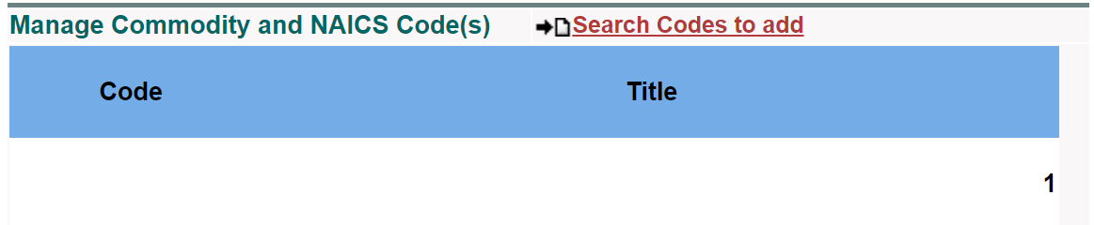
- Open solicitations from the search results to review details.
- Call or email the agency contact if more information is needed.
- Record results:

Solicitation title | Cust. Ref # | Notes
 |  | [add more rows as needed]

Searching for Vendors
- Navigate to the Washington Electronic Business Solution (WEBS) for Government Customers webpage.
- Navigate to the “Search for Vendors” tab:
- Select relevant commodity codes:

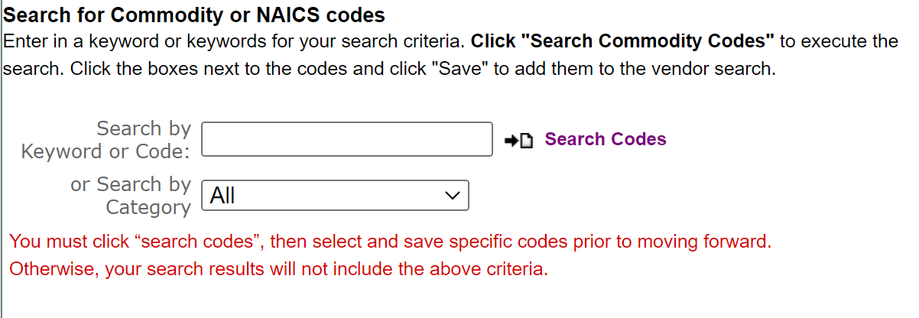
- Record search results:

Contractor Name | Method of Contact (phone, email, etc.) | Notes (can/cannot meet the business need, explanation)
 |  | [add more rows as needed]

OMWBE Directory of Certified Businesses
- Navigate to the Office of Minority and Women’s Business Enterprises (OMWBE)’s Certified Business Directory.
- Use search criteria/search terms relevant to your agency’s business need.
- Contact OMWBE staff for assistance if your search results is zero vendors, contact technicalassistance@omwbe.wa.gov.
- Record search results:
Contractor Name | Method of Contact (phone, email, etc.) | Notes (can/cannot meet the business need, explanation)
 |  | [add more rows as needed]

4. Conducting an RFI
An RFI is an informal solicitation of ideas, solutions and/or recommendations (usually to assist in the development of a scope of work for an RFP; an RFI does NOT result in a contract being awarded). An RFI can strengthen sole source determination as it can be used to gather additional information about the marketplace (such as vendor availability and interest).
DES provides a Request for information (RFI) template with examples of questions that may be helpful to gather information.
After conducting an RFI, the results can be saved to the contract file. Record results that support sole source determination here: [Notes]

5. Additional Market Research Techniques
Depending on the commodity and/or service being procured, there may be additional or alternative market research techniques that are applicable.

Contacting Peer Agencies
Speaking with peer agencies, associations, cities, counties, states etc., can be an easy way to understand what best practices exist in contracting for a specific service or product. It is likely that others have experienced some of the same challenges you have. Know who your sister agencies and counterparts are and reach out.
Contact Name | Date/Method of Contact (phone, email, etc.) for follow-up, if applicable | Notes
 |  | [add more rows as needed]

Interviewing Vendors
Pending the results of a database search or RFI, the agency may be able to conduct interviews with vendors for collecting information on the market. Interviews can be conducted in-person, virtual, by phone, or written via email. Interview questions include:
- Briefly describe your idea/technology to meet the agency’s business need.
- Who is your direct competition?
- Are there any other potential markets and/or possible emerging markets?
If your search turns up a large number of vendors, it may be faster to conduct a survey via email instead of reaching out to vendors individually.
Record results of interviews here:
Contact Name | Date/Method of Contact (phone, email, etc.) for follow-up, if applicable | Notes
 |  | [add more rows as needed]

Trade Publications
Trade Publications (i.e., trade journals, industrial publications/catalogues/magazines) are a great source for industry information, as they are published by and for people in a particular industry. Historically these publications were print only, but many are now available online and easily accessible. Trade publications are periodicals that keep professionals up to speed on a given industry’s trends and best practices.
You can search for trade publications using an internet search engine or through specific databases for trade journals. The way the search is conducted will be very specific to the commodity/service area, so we suggest working closely with your SMEs/program staff to assess which sources are appropriate.

Other Methods
This worksheet is not an exhaustive list of market research methods. Some commodities or services will require a different approach. For example, if the purchase is for social or human services, it may be necessary to take additional steps to understand the needs of the population receiving your services and how the target population will be matched and referred to the services. Understanding the business need of your agency is key to successful market research.
If you have any questions or require assistance, please reach out to the Policy Team via email, DES.Contracting@des.wa.gov.

