Executive Order 18-03 Workers’ Rights & Bidder/Contractor Certification – Desk Aid

Executive Order 18-03 | Overview of EO 18-03 | POL-DES-xxx-xx | EO 18-03 Webpage

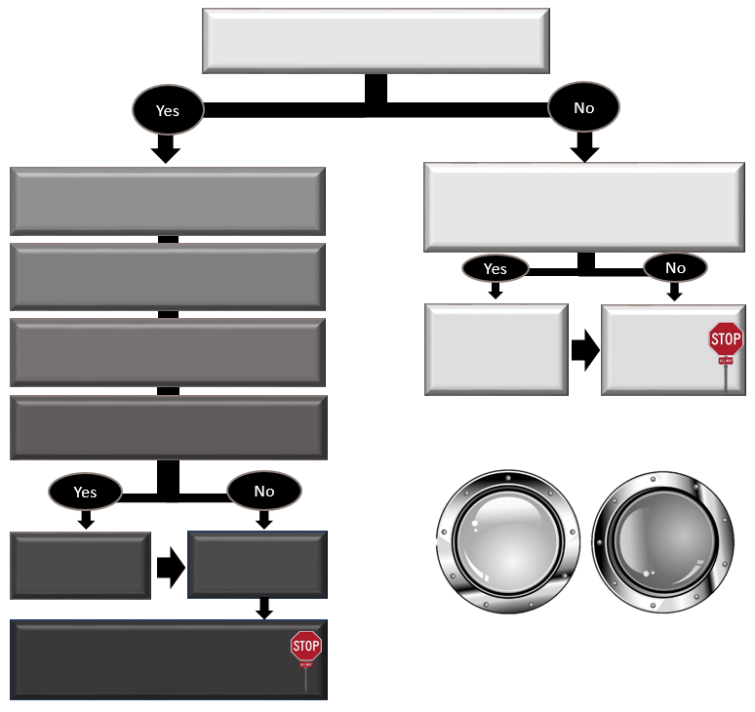
Other Links:
1.a
Is this a direct buy, sole source, or public works, and is it reasonably practicable to certify 18-03 eligibility?
- Specify evaluation/award criteria, and include the EO 18-03 solicitation clause.
- Determine the lowest responsive and responsible bidder.
Is the bidder 18-03 eligible?
- Check the box in WEBS.
- Include the Contractor Certification form in your solicitation.

- Mark 18-03 eligibility in WEBS.
FAQs
EO 18-03
Documini: Worker’s
Rights
1.c

Keep records.
1.b (optional)
Require the Vendor complete the vendor certification.
- Put the 18-03 Contract Clause in the contract.
- Keep complete records.
- Determine if your procurement is a competitive purchase for goods or services.

Overview of Executive Order 18-03 & State Procurement Law

Watch the 3 minute EO 18-03 Documini: Worker’s Rights or read below.

Executive Order 18-03 – Supporting Workers’ Rights to Effectively Address Workplace Violations (dated June 12, 2018) directs covered state agencies, to the extent permissible under state and federal law, to seek to contract with persons and firms who do NOT, as a condition of employment, require employees to agree to mandatory individual arbitration and/or class or collective action waivers regarding employment disputes. EO 18-03 is effective immediately and applies to all state executive and cabinet agencies.

Pursuant to Executive Order 18-03, Enterprise Services is charged with the responsibility to administer the EO and to collaborate with necessary workgroups to establish best practices and consistent application of the EO statewide. Accordingly, Enterprise Services collaborated with covered agencies to develop strategies and tools to implement the EO.

Regardless of whether the purchase or procurement is a noncompetitive direct buy purchase or a competitive procurement, covered agencies need to be able to determine whether bidders and potential contractors are persons or firms who utilize mandatory individual arbitration and/or class or collective action waivers. This will require potential contractors or bidders to provide that information. Accordingly, a Contractor Certification for Executive Order 18-03 enables potential contractors or bidders to provide that information to the State/agency during a solicitation process. Also, a Vendor Certification for Executive Order 18-03 does the same for non competitive purchases if reasonably practicable.

Step 1. Determine If your purchase is a competitive goods or services procurement

Competitive Procurements

Competitive Procurements: Covered agencies can easily implement Executive Order 18-03 in competitive procurements. The key is to identify relevant information from bidders. Agencies can identify the requisite information, factor it into their procurement process, and, as appropriate, include relevant contractual requirements. If your procurement is competitive, skip to Step 2.

Non-Competitive procurements (Steps 1.a – 1.c): As stated earlier, if a purchase is a noncompetitive direct buy purchase, covered agencies need to be able to determine whether bidders and potential contractors are persons or firms who utilize mandatory individual arbitration and/or class or collective action waivers if reasonably practicable. DES provides a vendor certification for direct buy purchases provided for agencies to use at their own discretion.
Type of non-competitive purchase | Required to apply 18-03, if reasonably practicable?
Direct Buy Purchase | Yes
Sole Source Contracts | No
Emergency Contracts | No

Step 2. Specify evaluation and award criteria, and include the clause in your solicitation

- Include 18-03 as part of the evaluation and award criteria
- Include the 18-03 solicitation clause
- Include required Contractor Certification

The Following is an example of an evaluation:

Evaluation | MAXIMUM POINTS
Responsiveness | Pass/fail
Responsibility | Pass/fail
Capabilities and Qualifications | 50
References | 25
Small business status | 10
Executive Order 18-03 Certification | 5
Pricing in region(s) bid | 25
Work history in region(s) bid | 50
Total Available Points | 165

Solicitation Clause for EO 18-03

Procurement Evaluation for Executive Order 18-03 (Firms without Mandatory Individual Arbitration for Employees) (Step XX). Pursuant to RCW 39.26.160(3) (best value criteria) and consistent with Executive Order 18-03 – Supporting Workers’ Rights to Effectively Address Workplace Violations (dated June 12, 2018), [insert agency] will evaluate bids for best value and provide a bid preference in the amount of [insert applicable percentage or evaluation points] to any bidder who certifies, pursuant to the certification attached as Exhibit X – Contractor Certification for Executive Order 18-03 – Workers’ Rights, that their firm does NOT require its employees, as a condition of employment, to sign or agree to mandatory individual arbitration clauses or class or collective action waiver.

Step 3: Include the Contractor Certification form in your solicitation
The contractor certification template is an option. Covered agencies can modify the template to fit their mission and contracting tools. Keep in mind, however, that there are requirements that inform the certification language to make it an enforceable commitment.

Using the Contractor Certification Template: Instructions

Using the template (last revised April 10, 2019), do the following:
- Intro Paragraph (italicized text)
  - Insert the applicable agency name.
- Solicitation Number:
  - Insert the applicable solicitation number.
- Return email address
  - Insert the applicable return email address for the applicable procurement coordinator at the bottom of the certification.
- Provide the Contractor Certification form to the Bidder to complete (the certification form must be included as part of the solicitation). The Bidder must:
  - Provide their full legal name – e.g., Sunshine Fulfillment LLC, a Delaware limited liability company.
  - Mark one of the boxes.
    - Note: If the bottom box is marked (i.e., the firm DOES have mandatory employee arbitration clauses and/or class or collective action waivers), the Contractor would not be eligible for an EO 18-03 bid preference.
  - Sign the Certification.
  - Print their name.
  - Print their title.
  - Print the City and State where signed (this is an element of the certification).
  - Print the date of the certification.
  - Return the completed Certification to the Procurement Coordinator via email at the email address provided at the bottom of the certification.

Contractor Certification Template For Competitive Purchases

Contractor Certification
Executive Order 18-03 – Workers’ Rights
Washington State Goods & Services Contracts
Pursuant to the Washington State Governor’s Executive Order 18-03 (dated June 12, 2018), the Washington State Department of _______________ is seeking to contract with qualified entities and business owners who certify that their employees are not, as a condition of employment, subject to mandatory individual arbitration clauses and class or collective action waivers.

Solicitation No.: | __________________

I hereby certify, on behalf of the firm identified below, as follows (check one):
- No Mandatory Individual Arbitration Clauses and Class or Collective Action Waivers for Employees. This firm does NOT require its employees, as a condition of employment, to sign or agree to mandatory individual arbitration clauses or class or collective action waivers.
or
- Mandatory Individual Arbitration Clauses and Class or Collective Action Waivers for Employees. This firm requires its employees, as a condition of employment, to sign or agree to mandatory individual arbitration clauses or class or collective action waivers.

I hereby certify, under penalty of perjury under the laws of the State of Washington, that the certifications herein are true and correct and that I am authorized to make these certifications on behalf of the firm listed herein.

Firm Name: _____________________________________________________
Name of Contractor/Bidder – Print full legal entity name of firm
By: ______________________________  Signature of authorized person  Title: ______________________________  Title of person signing certificate  Date: ________________________________ | ___________________________________  Print Name of person making certifications for firm  Place: ________________________________  Print city and state where signed

Return Contractor Certification to Procurement Coordinator at:
[Agency email]

Vendor Certification Template For Non-Competitive or Direct Buy Purchases

Vendor Certification
Executive Order 18-03 – Workers’ Rights
Washington State Goods & Services Contracts
Pursuant to the Washington State Governor’s Executive Order 18-03 (dated June 12, 2018), the Washington State Department of [insert Agency] is seeking to purchase from or contract with qualified entities and business owners who certify that their employees are not, as a condition of employment, subject to mandatory individual arbitration clauses and class or collective action waivers.

I hereby certify, on behalf of the firm identified below, as follows (check one):
- No Mandatory Individual Arbitration Clauses and Class or Collective Action Waivers for Employees. This firm does NOT require its employees, as a condition of employment, to sign or agree to mandatory individual arbitration clauses or class or collective action waivers.
or
- Mandatory Individual Arbitration Clauses and Class or Collective Action Waivers for Employees. This firm requires its employees, as a condition of employment, to sign or agree to mandatory individual arbitration clauses or class or collective action waivers.

I hereby certify, under penalty of perjury under the laws of the State of Washington, that the certifications herein are true and correct and that I am authorized to make these certifications on behalf of the firm listed herein.
Firm Name: _____________________________________________________
Name of Vendor – Print full legal entity name of firm
By: ______________________________  Signature of authorized person  Title: ______________________________  Title of person signing certificate  Date: ________________________________ | ___________________________________  Print Name of person making certifications for firm  Place: ________________________________  Print city and state where signed

Return Vendor Certification to :
[insert Agency email]

Step 4: Check the box in WEBS

Updates to both the Manage Solicitations screen as well as the Solicitations Responses screen in WEBS to include Executive Order 18-03 eligibility made in May 2019.
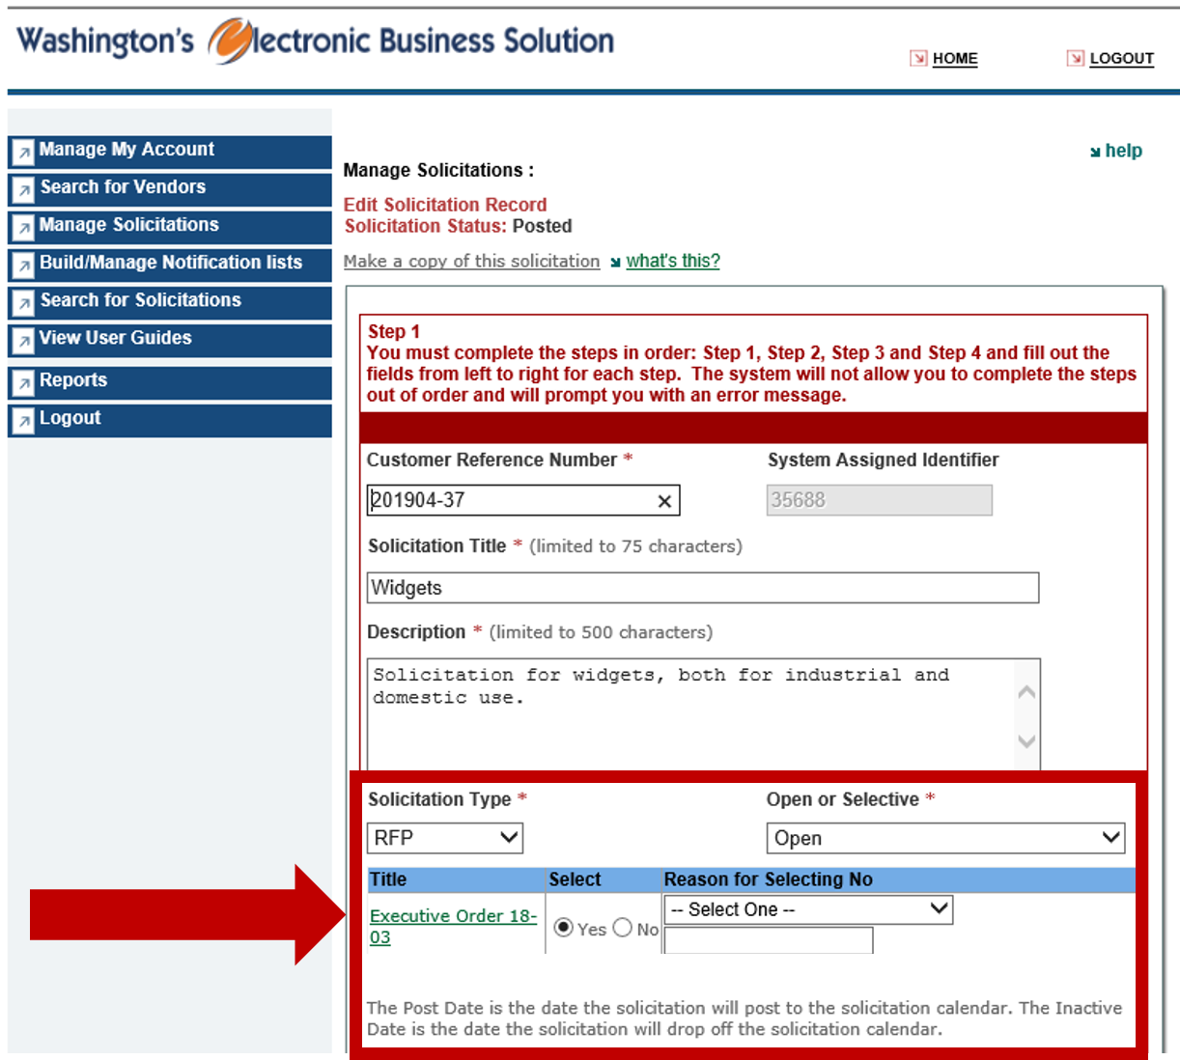

Step 5: determine the lowest responsive and responsible bidder and whether or not the awarded bidder is 18-03 eligible.
In determining the lowest responsive and responsible bidder, state agencies may consider best value criteria. See RCW 39.26.160(3). Accordingly, as part of the ‘best value criteria,’ agencies may define and specify in the Solicitation that firms will be evaluated to determine whether the firm’s employees are required to agree to mandatory individual arbitration and class or collective action waivers.

Frequently Asked Question: When should I collect the Contractor Certification?
When bids are due.
Both to maximize agency due diligence and to minimize opportunity costs, covered agencies should require bidders (e.g., vendors/contractors) to provide the Contractor Certification as part of their bid.
The purpose of requiring the Contractor Certification as part of the bid rather than waiting until a contract is to be awarded is that covered agencies’ options decrease significantly and costs increase significantly as the procurement process moves forward. If a bidder is unable to provide the required Contractor Certification, both the bidder and the procuring agency need to understand that fact (and its consequences) earlier; rather than later.
In addition, because the bidder may be evaluated – as part of a best value evaluation – on whether it requires it employees, as a condition of employment, to sign or agree to mandatory individual arbitration clauses or class or collective action waivers, the certification MUST be included as part of the bid submission.

Frequently Asked Question: What happens if a bidder marks ‘the bottom box’?
Firms are NOT deemed to be ‘nonresponsive’ if they submit a Contractor Certification in which they CANNOT certify that, as a condition of employment, they do not require their employees to sign or agree to mandatory individual arbitration clauses or class or collective action waivers.
Such firms, however, would be ineligible to align with that portion of a solicitation’s best value criteria to distinguish vendors that implement this procurement priority as compared to firms that can certify that, as a condition of employment, they do not require their employees to sign or agree to mandatory individual arbitration clauses or class or collective action waivers. Such firms are eligible to be awarded the resulting contract pursuant to the competitive solicitation.
Note: The applicable solicitation evaluation criteria (e.g., bid evaluation points or a percentage) must be set forth in the Solicitation document. In addition, the bid evaluation for the competitive solicitation must follow the process set forth in the Solicitation document.

Step 6: Put the 18-03 contract clause in the contract

- If appropriate, include contractor representation and warranty (as shown below)
- Include prohibition on contract assignment (as shown below)

Sample Contract Clause: Contractor Representation & Warranty regarding EO 18-03

- Contractor Representations and Warranties. Contractor makes each of the following representations and warranties as of the effective date of this Contract and at the time any order is placed pursuant to this Contract. If, at the time of any such order, Contractor cannot make such representations and warranties, Contractor shall not process any orders and shall, within three (3) business days notify [insert agency name], in writing, of such breach.
  - ...
  - Executive Order 18-03 – Workers’ Rights (Mandatory Individual Arbitration). Contractor represents and warrants, as previously certified in Contractor’s bid submission, that Contractor does NOT require its employees, as a condition of employment, to sign or agree to mandatory individual arbitration clauses or class or collective action waivers. Contractor further represents and warrants that, during the term of this Contract, Contractor shall not, as a condition of employment, require its employees to sign or agree to mandatory individual arbitration clauses or class or collective action waivers.
  - …

Sample Assignment Prohibition Clause:

Assignment. Contractor may not assign its rights under this Agreement without [Insert agency name] prior written consent and [Insert agency name] may consider any attempted assignment without such consent to be void; Provided, however, that, if Contractor provides written notice to [insert agency name] within thirty (30) days, Contractor may assign its rights under this Agreement in full to any parent, subsidiary, or affiliate of Contractor that controls or is controlled by or under common control with Contractor, is merged or consolidated with Contractor, or purchases a majority or controlling interest in the ownership or assets of Contractor. Unless otherwise agreed, Contractor guarantees prompt performance of all obligations under this Agreement notwithstanding any prior assignment of its rights.

Step 7: Mark it in WEBS

Updates to both the Manage Solicitations screen as well as the Solicitations Responses screen in WEBS to include Executive Order 18-03 eligibility made in May 2019.
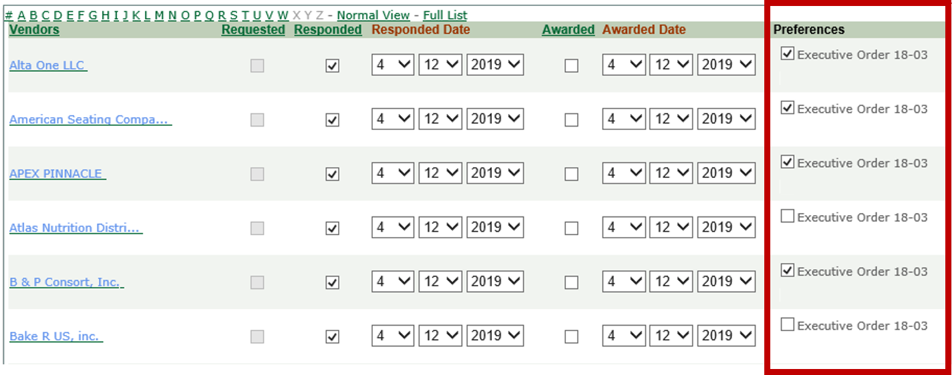

Step 8: Keep Good Records

Keep Complete Records in accordance with the Washington State Records Retention schedule.

Contacts & Resources
The following are useful additional resources:
- Washington State Department of Enterprise Services Webpage for EO Order 18-03
- Washington State Department of Enterprise Services, Procurement Policy Regarding Executive Order 18-03 – Supporting Workers’ Rights to Effectively Address Workplace Violations (dated October 1, 2018)
- Washington State Department of Enterprise Services, EO Order 18-03 – State Procurement & Mandatory Employee Arbitration Clauses & Class Action Waivers (dated August 2, 2018) [Overview training provided to covered agencies]
- Covered Agencies - the EO applies to all state executive and small cabinet agencies:
  - Executive Cabinet
  - Small Agency Cabinet
- Executive Order 18-03 – Supporting Workers’ Rights to Effectively Address Workplace Violations (June 12, 2018)
- Epic Systems Corp. v. Lewis, 584 U.S. ___, 138 S. Ct. 1612 (May 21, 2018)
- AGO Opinion 1991 No. 21 (June 11, 1991)

This Desk Aid was made in collaboration with the following partners to whom much thanks is owed:

- Attorney General’s Office
- Enterprise Services
- Washington State Health Care Authority
- Washington State Department of Health
- Washington State Department of Revenue
- Washington State Training Advisory Group
- Washington State Department of Transportation
- Washington State Patrol
- Washington State DSHS
- Washington State Department of Natural Resources
- Washington State DCYF
- The Evergreen State College
Please contact Enterprise Services with revisions or suggestions for improvement.

FAQs.

FAQs TABLE OF CONTENTS

- what is the effective date of eo 18-03?
- what is a ‘mandatory individual arbitration clause’?
- what is a ‘class or collective action waiver’?
- does eo 18-03 apply to me?
- who is tasked with administering implementation of eo 18-03?
- can state agencies do business with a firm that requires their employees, as a condition of employment, to use mandatory individual arbitration for workplace grievances?
- can state agencies do business with a firm that requires their employees, as a condition of employment, to forgo class or collective action dispute resolution for workplace grievances?
- does eo-18-03 apply to competitive procurements?
- does eo-18-03 apply to legacy contracts?
- does eo-18-03 apply to master contracts?
- does eo-18-03 apply to non-competitive procurements?
- Example when it may not be reasonably practicable to apply 18-03 to a Direct Buy
- Example of when it is reasonably to apply 18-03 to a Direct Buy
- does eo-18-03 apply beyond goods & services?
- does eo-18-03 change the procurement code?
- what if a vendor is a critical supplier, does eo-18-03 still apply?
- does eo-18-03 apply to contract extensions?
- does eo-18-03 apply to subcontractors?
- how do state agencies obtain legal advice on implementing eo-18-03?
- where can i find a copy of the supreme court’s decision?
- What does Reasonably Practicable mean for Direct Buys?
- What are the ramifications if an Agency doesn’t implement 18-03
- What does 18-03 mean for P card purchases?
- What if I am making a new purchase on a Master Contract that was established prior to June 2018?

What is the Effective Date of EO 18-03?

The effective date of EO 18-03 is June 12, 2018.

What is a ‘Mandatory Individual Arbitration Clause’?

For purposes of EO 18-03, a ‘mandatory individual arbitration clause’ is a requirement, by an employer, to arbitrate (rather than litigate) employment grievances. It is mandatory in the sense that it is a condition of employment.

Such clauses can be found…
- In employment agreements
- In employee handbooks
- In employer policies
- Or even in an email or other communication delivered to employees

What is a ‘Class or Collective Action Waiver’?

For purposes of EO 18-03, a ‘class or collective action waiver’ is a requirement, by an employer, that employees individually arbitrate employment grievances. It precludes class actions or employees pursing workplace grievances as a group.

Such clauses can be found
- In employment agreements
- In employee handbooks
- In employer policies
- Or even in an email or other communication delivered to employees

Does 18-03 Apply to me?

EO 18-03 applies to all state executive and small cabinet agencies.

- State Executive Agencies
- Small Cabinet Agencies

Who Is Tasked With Administering Implementation of EO 18-03?

Enterprise Services is tasked with administering implementation of EO 18-03.
“To ensure operational success and consistent application of this Order across state agencies, the Department of Enterprise Services (DES) shall administer implementation of this Order.”
See EO 18-03 at § 2

Can state agencies do business with a firm that requires their employees, as a condition of employment, to use mandatory individual arbitration for workplace grievances?

Yes. EO 18-03 creates an opportunity.
- EO 18-03 requires covered agencies to seek to purchase and procure from firms that do not have mandatory individual arbitration clauses.
- EO 18-03 is similar to other Legislative and Executive procurement preferences regarding how the state spends its money.

Can state agencies do business with a firm that requires their employees, as a condition of employment, to forgo class or collective action dispute resolution for workplace grievances?

Yes. EO 18-03 creates an opportunity.
- EO 18-03 requires covered agencies to seek to purchase and procure from firms that do not have mandatory individual arbitration clauses.
- EO 18-03 is similar to other Legislative and Executive procurement preferences regarding how the state spends its money.

Does EO-18-03 Apply to Competitive Procurements?

Yes. EO-18-03 applies to competitive procurements for covered state agencies.

See FAQ 4 to understand which state agencies are covered state agencies for purposes of EO 18-03.

Does EO-18-03 Apply to Legacy Contracts?

No. EO-18-03 does not apply to existing contracts. The EO is forward looking.

Does EO-18-03 Apply to Master Contracts?

Yes. EO-18-03 applies to any Master Contracts after June 12, 2018. EO 18-03 has been implemented in the solicitation process for Master Contracts after this date.

Does EO-18-03 Apply to Noncompetitive Procurements?

‘Non-competitive procurements’ are identified in RCW 39.26.125. With the exception of ‘direct buy purchases (see RCW 39.26.125(3)), EO 18-03 does not apply to non-competitive procurements such as emergency or sole source procurements. EO 18-03 does, however, apply to direct buy purchases if reasonable practicable. See the FAQs 12 and 13 for examples.

Some of our staff are required to make small and unusual purchases, sometimes at the last minute, such as refreshments for remote location meetings, or a nerf gun for a demonstration for a class. Are we required to check with Hasbro and the local grocery stores to ensure that they don’t require employees to sign arbitration clauses?

This policy states that application of executive order 18-03 is expected for direct buy purchases when reasonably practicable and up to the discretion of the agency. Acquiring a vendor certification from the vendors in the scenarios you provide is not likely to be reasonably practicable. However, just because it isn’t practicable in the scenarios you provided, doesn’t mean that requiring a vendor certification for other direct buy purchases won’t be practicable. DES has provided a sample vendor certification for you to customize and use at your own discretion.

When would it ever be reasonably practicable to ask a vendor to certify they don’t have their employees sign arbitration agreements if it isn’t a competitive purchase?

An example of requesting the vendor complete a vendor certification during a direct buy or non-competitive purchase could be as follows: If your agency needs to purchase customized lightweight jackets for all of the employees for a total cost of $8,000, it may be reasonably practicable to request vendors certify if they do or don’t have their employees sign arbitration clauses when submitting their cost estimations.

Does EO-18-03 Apply Beyond Goods & Services?

Yes. EO 18-03 applies beyond purchases and procurements for goods and services. The EO implementation, however, will be prioritized. The implementation prioritization begins with –
  - Competitive Goods and services procurements; and
  - Direct buy purchases, when reasonably practicable.

Covered agencies, if authorized by their statutory authority, can implement the EO more broadly.

Does EO-18-03 Change the Procurement Code?

No. EO 18-03 does not amend any RCW provisions.

What If A Vendor Is A Critical Supplier, Does EO-18-03 Still Apply?

Yes, but ...
- “To the extent permissible under state and federal law …”
- Legislature may have required certain vendors – e.g., ferry vessels must be built in Washington

EO 18-03, however, does NOT preclude state executive and small cabinet agencies from purchasing or contracting with particular firms.

Does EO-18-03 Apply to Contract Extensions?

It depends on the contract. For contract renewals – No. Here, for example, you have a 6-year term, but contract was set up to require year-by-year ‘renewal.’

For Contract extensions – possibly. It depends on the contract. If original contract term is over, then yes, EO 18-03 does apply.

Does EO-18-03 Apply to Subcontractors?

It depends on what the contract states. Generally speaking, the EO will apply to the Contractor.

how do state agencies obtain legal advice on implementing eo-18-03?

The AGO is coordinating legal advice regarding EO 18-03 through the AGO’s TPC Division. Start by asking your assigned AAG for advice. Your AAG then will consult with TPC and then get back to you.

Where Can I find a Copy of the Supreme Court’s Decision?

The U.S. Supreme Court’s decision is available here: Epic Systems Corp. v. Lewis, 584 U.S. (May 21, 2018).

What does “reasonably Practicable” mean for Direct Buys?

In the case of direct buy purchases, “Reasonably practicable” means practicable unless the Agency can show that there is a gross disproportion between the benefit of applying 18-03 and the cost, in time, trouble and money, of requesting vendors certify whether or not they require employees sign arbitration/class action clauses. See examples of when it may or may not be reasonably practicable to apply 18-03 to direct buy purchases in FAQ # 12 and FAQ #13.

- what are the ramifications if an agency doesn’t implement 18-03?
Executive order 18-03 is a directive from the Governor to state agencies communicating to those agencies what the Governor wants the agency to accomplish. The EO does NOT have the force of law, but Agency heads serve at the pleasure of the Governor.

what does 18-03 mean for purchasing card purchases?

Purchasing Card (P-card) purchases are no different than any other purchases when it comes to 18-03. Regardless of the method of payment (p-card, purchase order etc…) 18-03 applies. See FAQ #8 – FAQ #14 for more information about applying 18-03 to p-card purchases.

Do I need to ask the vendor if they make their employees sign arbitration clauses, if I am making a new purchase or a second tier purchase on a master contract that was established prior to June 2018?

When using Master Contracts that were established before June 2018 for new purchases, there is no need to request a contractor provide certification that they do not require employees to sign arbitration/class action clauses as 18-03 is not required for legacy contracts. However, covered agencies can apply 18-03 within the Master Contract at their own discretion. An example of this may be if there are several contractors to choose from on a Master Contract, the Agency could choose to research whether or not each contractor on that contract requires their employees to sign arbitration/class action clauses. The Agency could us their findings to choose which contractor they use. Again, this is not required but up to the discretion of the Agency.

