Using Boosters to Avoid Training Malpractice
This one-pager briefly looks at the concept of increasing retention of memorized material through the use of “boosters” to stimulate information recall. DES C&P Training Team is collaborating with our customers in implementing this best practice. Please contact The DES C&P Training Team for more information.
Neuroscientists have demonstrated how humans, without engaging in active and meaningful recall, lose information from memory as time passes. Dr. Kohn, a neuroscientist with Portland State University, states that, for the sake of information retention, what you do after learning material is more important than what you do while learning material.
Dr. Kohn teaches that neuroscience disagrees with the notion that forgetting is a failure of memory. Instead, the field recognizes that forgetting is an essential, adaptive process; we actively suppress information that we don’t use. Kohn’s suggestion, therefore, is that using information is the most effective algorithm for remembering it. He offered a simple example by asking if anyone in the room remembered their hotel room number from the last conference that they attended (not the current conference). Of course, nobody did, because that information has not been actively recalled over time.
Dr. Kohn instructs about the use of “boosters” to reset the forgetting curve. Essentially, research that he and others have undertaken has shown that regularly stimulating the recall of information is useful for increasing the retention of learned information over time. The way that Dr. Kohn advocates providing these boosts to learners is through a “2-2-2” method: This includes asking a meaningful question about the material that requires them to recall information after 2 days, 2 weeks, and 2 months. Taken at face value, this seems relatively obvious, but Kohn offered interesting specifics about how these boosts work:
- Recalling information for five seconds, thirty seconds, and five minutes all result in nearly the same amount of benefit in terms of longer term retention of material.
- Boosting just three major subtopics from a one hour lecture increases retention of all the material from the lecture, not just those topics that were “boosted.”
- The type of boost (multiple choice question, fill-in-the-blank question, application question) makes no difference, provided the boost inspires effortful information processing in order to respond.
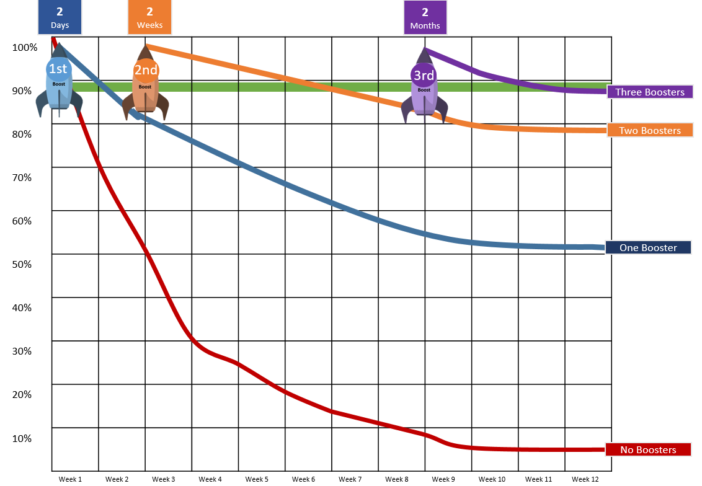
11/20/2019

