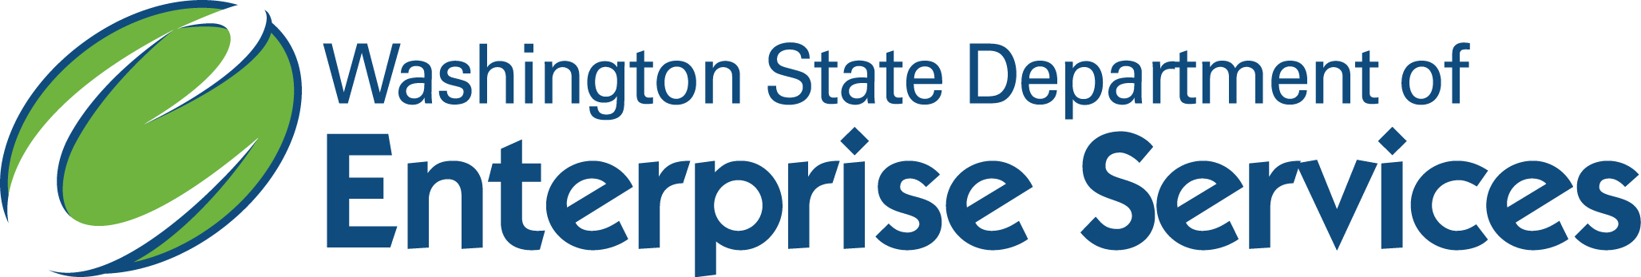

**WA State Small Purchases**

**(Total Time: 30 minutes)**

This eLearning course is designed for people who make small purchases. This is a new Training driven by Procurement Reform, and is required for all employees who make routine, small purchases and those who use agency purchasing cards.

In order to receive credit for this course, you will need to score 80% or higher on the module assessment. The assessment will begin at the end of this course. Once you have successfully completed the course and assessment, you will receive a WA-State Small Purchases certificate of completion.

 We strongly recommend you print the workbook for the course. As you proceed through the training, use the workbook to write down any notes and/or questions you might have.

**Performance Objectives:**

**Upon completion of this course participants will be able to:**

* Define basic purchasing and small purchases
* Recognize the rules, regulations and laws that govern purchases
* Describe the guidelines for small purchase methods
* Understand the Purchase Card Program

**Competencies covered in this course:** Responsible purchase decisions, development and continual learning.

**Cost:** None