Adding Sub-Groups to your Washington State Amazon Business Account

How to invite your purchasers to join Amazon Business
Your account must be established by DES and you must have Administrator permissions to do this. Visit Getting Stated with Washing State Amazon Business.
- Open Amazon Business.
- Hover over the dropdown arrow on your account tab in the upper right-hand corner.
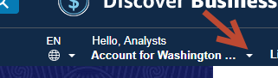
- If you have administrator permissions, you will see the selection to “Business Settings.” Select “Business Settings”.
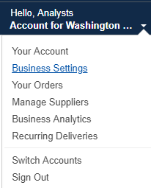
- This is the main screen for managing your agency. Do you have sub-groups in your account? If so, select “Groups” under “Members” on the left-hand side.
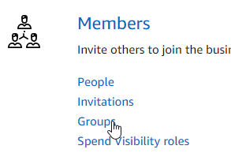
- Select “Add Group” on the right-hand side of the screen.
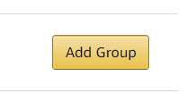
- A pop-up window will open to create a group. Enter the name of your sub-group and choose a payment method. You can choose Individual Payment, Shared Payment, or choose to restrict the sub-group from placing orders. The default and most common choice is Individual Payment. Shared Payment should only be chosen if the entire group is sharing payment methods. Select “Add Group”.

You have now created a sub-group that will appear under the Group list.

Remember: If you want to add people or make changes to a sub-group, you must be in the sub-group you wish to change. Login > Business Settings > Groups > Select subgroup

View adding people to a group, or the Amazon Business tutorials for additional help.

User Tip
Firefox and Chrome have been the most effective browsers with Amazon Business videos and system functions. Users of Internet Explorer continually report experiencing challenges.
If you have trouble with your browser, please try an alternative such as Firefox or Chrome. Please provide feedback on your issues to Amazon via their feedback tool.

