Adding People to Your Washington State Amazon Business Group

## How to invite your purchasers to join Washington State’s Amazon Business group.

Your account must be established by DES and you must have Administrator permissions to do this. View [**Getting Stated with Washington State Amazon Business**](https://des.wa.gov/sites/default/files/public/documents/ContractingPurchasing/AmazonBusiness/GetStarted.docx)**.**

1. Open Amazon Business.
2. Hover over the dropdown arrow on your account tab in the upper right-hand corner. 
3. If you have administrator permissions, you will see the option to “**Business Settings**.” Select “**Business Settings**”.

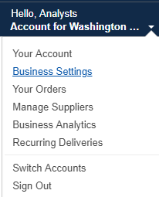

1. This is the main screen for managing your agency. Do you have sub-groups in your account? If so, select “**Groups”** under **“Members”** on the left-hand side.

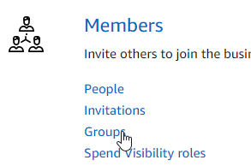

Select a sub-group to add people. You must be in the sub-group you want to add people to. (If you do not have sub-groups go to the next step.)

1. Click the drop down arrow and select “**Upload a list of people**”. 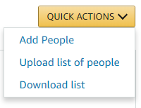
2. A pop-up window will open allowing you to either copy/paste or type in the email addresses of your purchasers. Select the “**Requisitioner**” check box. Add all the email addresses of the Requisitioners.

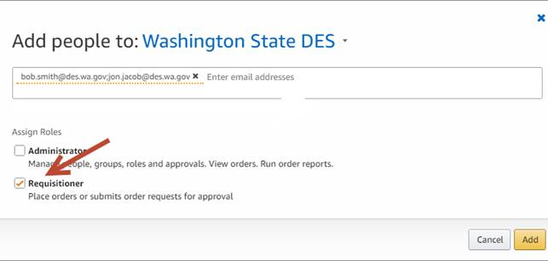

1. Select “**Add**” in the lower right-hand corner.

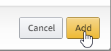

1. Amazon Business will automatically email invitations to the people you just selected.

You may add several people at a time with the same role (permission). Example: You can add 5 requisitioners at once.

If you need to add people with different roles, they must be entered separately.

See this for help [adding sub-groups](https://des.wa.gov/sites/default/files/public/documents/ContractingPurchasing/AmazonBusiness/AddGroup.docx) or, the [Amazon Business tutorials](https://www.amazon.com/b2b/info/howto?layout=landing).

### User Tip

Firefox and Chrome have been the most effective browsers with Amazon Business videos and system functions. Users of Internet Explorer continually report experiencing challenges.

If you have trouble with your browser, please try an alternative such as Firefox or Chrome. Please provide feedback on your issues to Amazon via their [feedback tool](https://www.amazon.com/b2b/homepage.html/feedback).