Advanced Configuration

Step 1: How to get started
Amazon Business allows your organization to take the current purchases your organization is making from Amazon.com and move them into a more controlled environment. This requires establishing some basic definitions and roles.
- Group – this is your organization (agency, board, commission, school, university, city, county, etc.).
- Sub-group – a delineation below the Group level. (For example: DES would be the group, while DES Finance would be a sub-group.) This delineation may reflect a division, program, region, or section level of your organization.
- Administrator - The person at each group level who has permission to add, delete, and make configuration changes to all users at the group or sub-group level (depending on how you choose to structure the permissions).
- Requisitioner - An employee who has permission to make purchases and get reports on their purchase history.
- Administrator, Requisitioner – combination of both roles.
Here is an example using the fictitious Department of Innovation (DOI):

- The agency number and acronym are assigned by DES based on OFM’s state chart of accounts.
- Based on DOI’s review of P-Card data and their organization’s structure, they will have four sub-groups.
- Sub-groups are named by the organization and do not have a naming structure.
- Each sub-group can have as many purchasers as necessary to conduct the business of the department.
  - Let’s assume they already have two Administrators set up when they completed the Getting Started step.
  - They have determined they do not need Administrators at the sub-group level, so all sub-groups will be comprised of Requisitioners (purchasers).

Step 2: Think Lean
The main goal behind Amazon Business is to add value to your purchasing process. You do not want to build redundant steps into your purchasing process - just because a feature exists in Amazon Business does not mean you have to use it!

Amazon Business Features
Workflow approvals is a good example. You can add steps to send approval emails to supervisors for purchases at certain dollar thresholds or based on restricted categories. But if you already have a direct buy purchase approvals process in place, would this step add value? If it is useful, use it; but don’t add delays and emails without critically thinking about if it adds value to your organization.
With Amazon Business, administrators can run transaction detail reports at any time. If after examining the feature you feel it adds value to your purchasing process, then add the feature to your purchasing process.
Guided Buying is another feature you will need to examine to determine if it adds value to your purchasing process. If you have a trained staff and order approval processes in place, you may not find any value in restricting categories. In fact, you may frustrate users and slow down the procurement process.
Categories in Amazon are very broad. You may have the intent to restrict the ‘Furniture’ category because you know there is a state contract. The challenge is there are thousands of furniture-related items in that Amazon category including many items not on the state contract. Yet every time your requisitioner attempts to use this category for a purchase, a pop-up warning message will appear and it will appear again at checkout.
If you tie workflow approvals to restrictions, approvers get emails and must approve the purchase in addition to the pop-ups. This can become frustrating quickly for users and approvers.

Step 3: Map out your plan
Determine how many sub-groups you will need and their layers of approval workflows (if any). Map it out in a tool that makes sense to you. Here is an example of what it could look like:
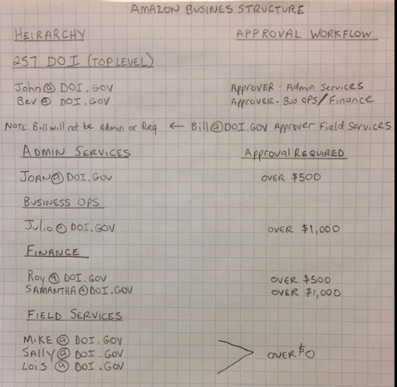

Step 4: Launch
DES and Amazon Business have collaborated to develop email communication templates you can customize for your agency. Prior to the launch, use Email Template 1 to send out a communication to let purchasers know about the transition to Amazon Business.

Launch Day
Have your group administrator in charge of setup login to begin configuring your organization’s groups and adding people.
- Open Amazon Business
- Hover over the dropdown arrow on your account tab in the upper right corner
- If you are the group administrator, you will see the selection “Business Settings.”
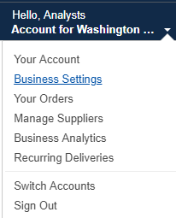
- This is the main screen for managing your agency. Click the drop down arrow on the right hand side and select “Upload a list of people”.
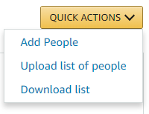
- A pop-up window will open. Select “download this spreadsheet template”. This will download the template where you can begin entering your agency information.
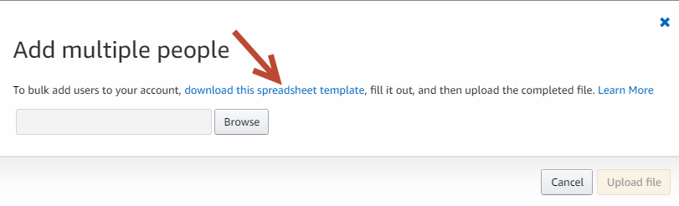
- When the spreadsheet download completes, select “learn more” in the pop-up window for instructions on how to use the template.
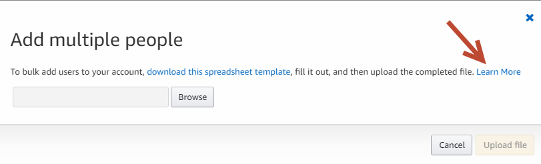
When entering information in a spreadsheet:
- Double-check email addresses for accuracy.
- In column B add a “/” to the primary group name to add sub-groups. Add a slash between each sub-sub-group. Your organization (primary group) is named by DES and follows a state naming convention, but you may name sub-groups anything you want.
- In the user permission column, an administrator may also be a requisitioner (but does not have to be). It would be entered as “Administrator,Requisitioner” (comma with no space).
- If your organization wants to use order approvals, the approval hierarchy is not done on this sheet. There is not an approver role on the template.
This is an example of the fictitious DOI’s upload spreadsheet based on the sketched plan:
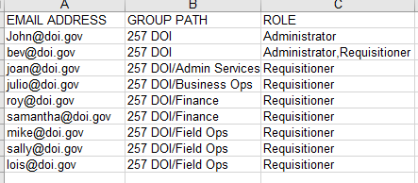
When your spreadsheet is complete and saved, go to select “Upload a list of people”. The pop up window will open again. Select browse to find your spreadsheet, select “Open”, and then select “Upload File”.
If your agency believes the approval workflows feature of Amazon Business would be beneficial, then watch the video: Set up workflows. Approval workflows may be setup by dollar amount or category restriction for groups or sub-groups. If you wish to have different approval levels in an office, you may decide to create sub-groups to facilitate the approval levels.
Remember, orders with workflow approval settings will not be processed without approval. Some people use multiple approvers for redundancy – creating double the emails – but eliminating the need to remember to assign delegates for absences. It’s a good idea to pilot the feature and get feedback from requisitioners and approvers to see how you can best implement in your organization.
Administrators should watch the training videos found on the Amazon Business video tutorial webpage.
- Manage your Account (For Account Administrators)
- I’m new to Amazon
- I want to migrate my account
- I want to add an account
If your agency, or some areas within your agency, already have Amazon Business accounts, you may want to watch the video: Already on Amazon Business?
The FAQ has answers to many common questions, from Amazon Business and our Washington State customers.
If you have additional questions, please contact Contracts and Procurement Business Operations at cprmanalytics@des.wa.gov or (360) 407-2214.

User Tip
Firefox and Chrome have been the most effective browsers with Amazon Business videos and system functions. Users of Internet Explorer continually report experiencing challenges.
If you have trouble with your browser, please try an alternative such as Firefox or Chrome. Please provide feedback on your issues to Amazon via their feedback tool.

