Checking Transition Status of Your Washington State Amazon Business Group

Once your account is established and people are invited, how do you know if they have accepted?
You must have Administrator permissions to do this. If you do not and think you should, check with your organization’s purchasing card manager.
- Open Amazon Business.
- Hover over the dropdown arrow on your account tab in the upper right-hand corner.
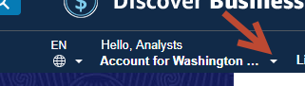
- If you have administrator permissions, you will see the selection to “Business Settings.” Select “Business Settings”.
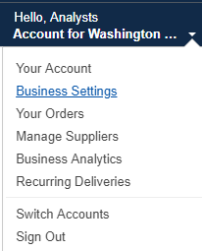
- This is the main screen for managing your agency. Click the drop down arrow on the right hand side and select “Download list”.
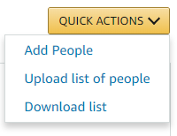
An email will be sent to your inbox with a link to a file. Follow the instructions to open the file.
- The file will be in Excel format. Sort the sheet by column ‘D’, Invitation Status. If you use sub-groups, you can also sort by column ‘B’ Group Path. You will be able to see who has accepted (Active), who has not accepted but has a valid invitation (pending), and those who did not accept invitations whose invitation have expired.
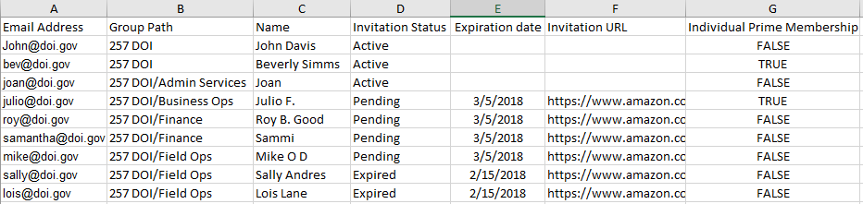

An additional useful field on this report is column ‘G’ Individual Prime Memberships. If the word ‘TRUE’ appears in this column, the person has an active Prime membership associated with their email address and is eligible for a prorated refund by contacting Amazon Business Customer Support at (866) 486-2360 or use the Amazon Business Customer Support link.

Quick Tip
Another way to see an invitation status is by going to the group or sub-group and selecting “Invitations”.
Business Settings > Groups > (Select Sub-group) > Invitations
This will display invitation status for that group only.

