Washington State Amazon Business Simple Setup

Steps
- Assemble a list of email addresses for purchasers in your organization that will purchase from Amazon Business. There are three possible permission levels in Amazon Business:
- Administrator: May add, delete, make changes to permissions, and create and view reports for the business
- Requisitioner: May purchase and create and view reports for their own transactions and history
- Administrator, Requisitioner: Combines both of the above (common in small agencies and as the backup to Administrators)
We recommended each organization have at least two (2) Administrators. If you do not already have two, consider making one of your requisitioners an “Administrator, Requisitioner.”
- DES and Amazon Business have collaborated to develop email communication templates you can customize for your agency. Prior to the launch, use Email Template 1 to send out a communication to let purchasers know about the transition to Amazon Business.
- Invite your purchasers to join Amazon Business by following the steps below:

How to invite your purchasers to join Amazon Business
- Open Amazon Business.
- Hover over the dropdown arrow on your account tab in the upper right-hand corner.
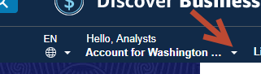
- If you have Administrator permissions, you will see the selection to “Business Settings.” Select “Business Settings”.
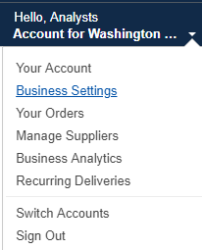
- This is the main screen for managing your agency. Click the drop down arrow on the right hand side and select “Add People”.
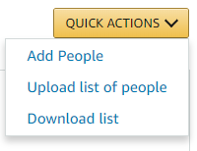
- A pop-up window will open allowing you to either copy/paste or type in the email addresses of your purchasers. Select the “Requisitioner” check box. Add all email addresses of the Requisitioners.
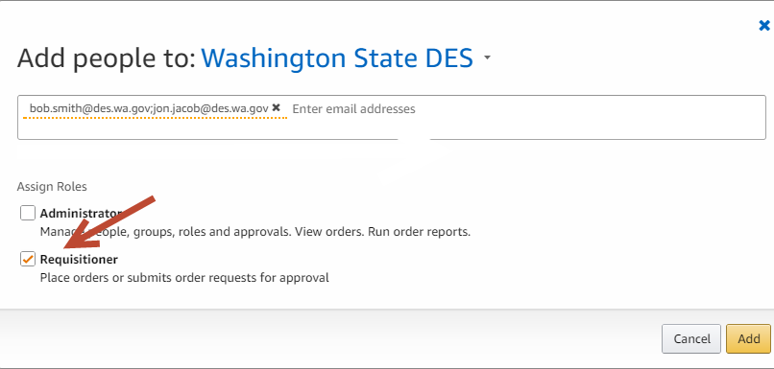
- Select “Add” in the lower right-hand corner.
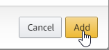
- Amazon Business will automatically email invitations to join to all requisitioners. NOTE: If you are adding an Administrator or Administrator/Requisitioner repeat the same steps, but each role type must be added separately.

See how many of your invited people have joined Amazon Business
See how many purchasers in your organization have accepted the invitation to join and are active in the account at any time.
- Log into your account and select “Business Settings.”
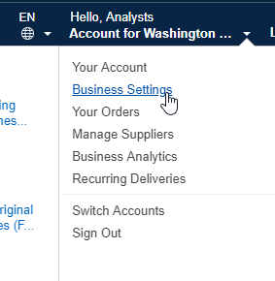

- On then the left-hand side under Members, select the option for “People.”
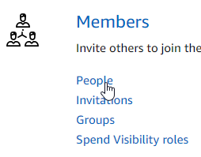
- A list of all people with permissions in your account will be displayed.
“People” shows you who has accepted. “Invitations” shows you who has not accepted. If your purchasers have not accepted the invitation to join Amazon Business, use Email Template 3 to follow up and encourage participation.

User Tip
Firefox and Chrome have been the most effective browsers with Amazon Business videos and system functions. Users of Internet Explorer continually report experiencing challenges.
If you have trouble with your browser, please try an alternative such as Firefox or Chrome. Please provide feedback on your issues to Amazon via their feedback tool.

If you have additional questions, please contact Contracts and Procurement Business Operations at cprmanalytics@des.wa.gov or (360) 407-2214.

