How to transition an existing Amazon Business account in your agency to a Washington State Amazon Business account
Scenario: You are the Administrator of a pre-existing Amazon Business account in an organization transitioning to the Washington State Amazon Business account. You have been informed you need to close or deregister the pre-existing account.
To complete this process you must be an Administrator in the pre-existing account.
- All data will transition with each user’s email address. This will capture business-level data. Use Business Analytics to download an order history report for the past 12 months. Hover over the dropdown arrow on your account tab in the upper right corner. This step is optional.
- Select Business Analytics from the drop-down menu.
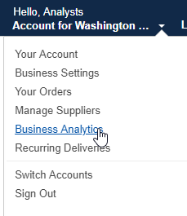
- Select the “Orders” report under “Reports”.
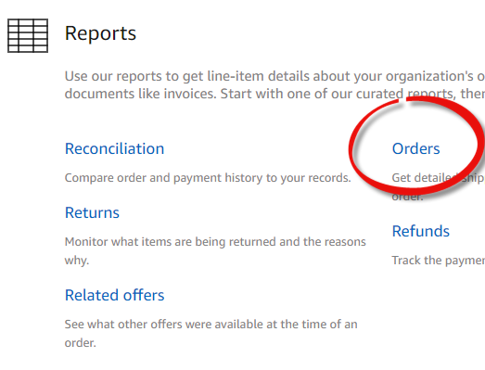

- From the drop-down menus, select Past 12 months or a period you wish.
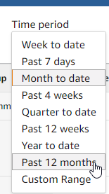
- A report will generate. Select “Download CSV” in the upper right corner.
- Save the downloaded file of your order history.

- Remove all users from the pre-existing account. Select Business Settings. NOTE: This step will only work for administrators with permissions at the top level of the business, not sub-group admin level.
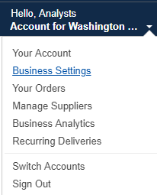
- On the left side of the main screen under Members, select People.
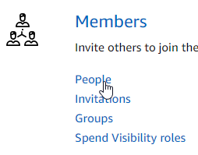
- A list of all people will come up. Select the name of the first person on the list (not your own). A new screen displaying the information for that person will appear. In the upper right corner, select Remove From Business.
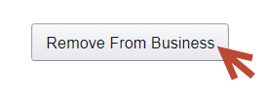
- Repeat this step for all users except yourself. NOTE: There is not a bulk removal step, each user must be removed, individually. If you are the only person, move to step 10.

The top-level administrator for the pre-existing account cannot be deleted (in other words, the admin cannot delete themselves when they are the last person on the list). If you attempt to delete yourself, you will get a message that says, “You cannot remove yourself from the account you are the only administrator.” When you are sure you are the only person remaining in the account proceed to step 10.
- Select the following link to deregister the existing account (Please note: it will not remove any information on the account, simply the Amazon Business account tag): Use this link to deregister the existing account. https://amazon.com/gp/b2b/manage/deregister

- After you have completed the deregistration process, contact Contracts and Procurement Business Operations at cprmanalytics@des.wa.gov or (360) 407-2214 to be added to the Washington State Amazon Business account.
If you have additional questions, please contact Contracts and Procurement Business Operations at cprmanalytics@des.wa.gov or (360) 407-2214.
You may also contact the Amazon Business Customer Support team at (866) 486-2360.

