How to Use the Timesheet

- The highlighted fields on the timesheet below are required fields:
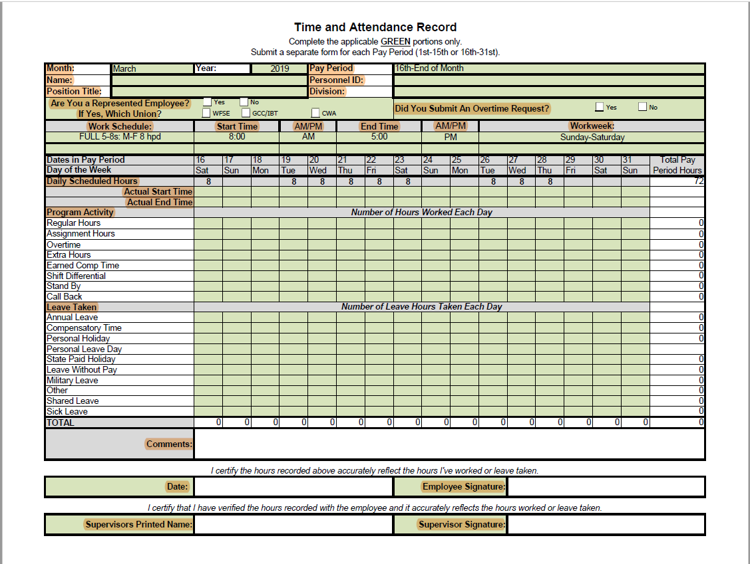

Description of Fields:

Top Section:
- Select the Month, Year and if it is the beginning or end of the month pay period
- Last name, First name, Personnel ID
- Position Title, Division
- Check the box of the appropriate union or non-rep and if an OT request was submitted.

Work Schedule:
- Please select from the drop down menu your working schedule and the start and end times with AM/PM. This helps payroll to determine if rules surrounding overtime and shift differential are being met if applicable.
Workweek:
- If you work M-F / T-St 5-8's or one of these 4-10's M-TH / T-F / W-St then select Sunday - Saturday. If another 5-8 or 4-10 contact payroll for accurate selection.
- If you have a 9-80 schedule please contact payroll to correctly record your workweek. They vary depending on what your flex day off is. This helps payroll determine overtime if applicable.
Daily Scheduled Hours:
- This line is what you were scheduled to work for each day during the pay period.
Actual Start Time:
- Enter your actual start time if different from your scheduled start time
Actual End Time:
- Enter your actual end time if different from your scheduled end time.
Program Activity:
- These lines are what you actually worked and other compensation the employee is entitled to.
Leave Taken:
- These lines are leave actually taken. This should match ESS with the exception of Personal Holidays and Personal Leave days taken for hourly employees.
- Hourly Employees only: Payroll will pro-rate and enter the Personal Holiday and Personal Leave day for hourly employees. This will be paid out on the 10th paycheck because we need all hours worked in that month to pro-rate.

