DES Instructor Guide
Table of Contents (Press control then click on topic to jump to that section)

DES TEAM INTRODUCTION 2
GLOSSARY (ACRONYMS & DEFINITIONS) 3
LIFE CYCLE OF A DES CLASS 4
LEARNING CENTER 5
HOW TO ACCESS THE LEARNING CENTER 5
HOW TO LOCATE A CLASS 6
HOW TO VIEW ROSTERS 9
HOW TO SEND COMMUNICATION TO LEARNERS 10
HOW TO VIEW EVALUATIONS 11
DES PROCESS FOR LINKS 14
DES PROCESS FOR MATERIALS 14
DES PROCESS FOR SENDING COMMUNICATION TO LEARNERS 14
DES PROCESS FOR ROSTERS 14
DES PROCESS FOR EVALUATIONS 15
VIRTUAL PLATFORM SETTINGS 16
ZOOM INSTRUCTIONS 16
INCLEMENT WEATHER (In-Person Trainings) 18
QUESTIONS? 18

DES TEAM INTRODUCTION
Learning Solutions is the central training and development hub for the state of Washington. We provide high-quality, cost competitive training and development options for over 70,000 state agency employees and other non-profit customers (cities, counties, tribal entities, school districts, governmental subdivisions, federal government organizations, and nonprofits that are 501c (3)).

The Learning Solutions Team consists of 7 team members
- Justin Hahn (Justin.Hahn@des.wa.gov) - Operations Manager
Learning Consultants (LC)
- Rachael Stich (Rachael.Stich@des.wa.gov) - Lead Learning Consultant
- Taisha Perry (Taisha.Perry@des.wa.gov) - Learning Consultant
- Marcia Moody (Marcia.Moody@des.wa.gov) - Learning Consultant
- Renee West (Renee.West@des.wa.gov) - Learning Consultant

- Each LC has their own portfolio of classes that they manage. LCs must be involved in all training business associated with customers. The LCs work directly with the instructors to schedule classes in person and virtually. They also collaborate and consult with agencies and other non-profit employers about their training needs. You may contact the LCs directly or send emails to our shared inbox: DESMILearningSolutionsTeam@des.wa.gov
Learning Solutions Operation Team (LSOT)
- Christopher Cope (Christopher.Cope@des.wa.gov) – Learning Solutions Specialist
- Christina Klucarich (Christina.Klucarich@des.wa.gov) - Learning Solutions Specialist

  - LSOT works directly with learners, responding to registration requests and any class-related inquiries. LSOT forwards all your class-related communications, study guides, materials and links to learners before a training. Email LSOT’s shared inbox (Traininginfo@des.wa.gov) with any class-related communications, study guides, materials and links you need to share with learners.

GLOSSARY (ACRONYMS & DEFINITIONS)
ClassTrack - is our contract database system which creates a vendor work order.
External User (EU) - are employees of Washington State cities, counties, tribal entities, school districts, governmental subdivisions, federal government organizations, as well as Washington State registered Public Benefit nonprofits that are 501c (3) compliant and receiving public funding. Agency employees are not External Users.
Go, No-Go (GNG) - is a phrase used to determine if a class has enough learners enrolled to run the class. A DES Learning Consultant will reach out to you to share current enrollment numbers. If your class enrollment is below the minimum to pay your full class rate then your Learning Consultant (LC) will email you within 10 business days from the class start date to see if you still want to run the class.
Instructor-Led Training (ILT) – is an in-person training run by an instructor at a physical location.
Learner (or Participant) – is any employee enrolled in one or more DES trainings.
Learning Consultant (LC) - works directly with instructors to schedule classes in person and virtually. They also collaborate with agencies and other non-profit employers about their training needs. You may contact the LC’s directly or send emails to the shared LC inbox: DESMILearningSolutionsTeam@des.wa.gov
Learning Solutions Operation Team (LSOT) - work directly with learners, responding to registration requests and any class-related inquiries. LSOT forwards all your class-related communications, study guides, materials and links to learners before a training. Please email all learner materials to be shared with learners to LSOT’s shared inbox: Traininginfo@des.wa.gov 3 business days before the class start date.

Open Enrollment (OE) - is used when referencing a training that is open registration for any state agency employee or External User (EU) learners. The class will often fill with participants from various agencies and other employers.
Secure Access Washington (SAW) - Secure Access Washington is a central login that lets you access the Learning Management System for DES hosted Classes, also referred to as the Learning Center.
Single Agency Agreement (SAA) - is used when referencing a training request/agreement from a State Agency for their employees only.
Training Managers (TM) – Agency managers are responsible for developing and determining their agency’s training and development program.
The Learning Center (TLC) – is the Washington state Learning Management System (LMS).
SumTotal - is the vendor that provides and maintains the State of Washington Learning Management System (LMS) / The Learning Center.
Virtual Instructor-Led Training (VILT) – is a training run by an instructor remotely by utilizing software such as Zoom.
Washington Electronic Business Services (WEBS) - is an internet-based bid notification system that many state agencies and educational institutes use to notify businesses of opportunities. It takes approximately 5-10 minutes to sign up. Your firm will receive email notifications of bid opportunities that match commodity codes you select. http://www.des.wa.gov/services/ContractingPurchasing/Business/BidOpportunities/Pages/bidNotification.aspx

LIFE CYCLE OF A DES CLASS

- Open enrollment (OE) classes are planned out one year in advance in six-month increments. Learning Consultants (LCs) coordinate with vendors to schedule out classes by month on the DES planning calendar. We then add, as needed throughout the year, any additional open enrollment classes, usually 3-4 months in advance of training date. Agencies may also request training and those are referred to as Single Agency Agreements (SAA) for a particular class(es).
- The LC then add classes in ClassTrack (our contract database system) which creates a vendor work order.
- The LC emails the work order to the vendor for review and signature to confirm acceptance of terms.
- The vendor emails the signed copy back to the LC for a final DES signature. Once both signatures are obtained, the LC will send a final copy to the vendor for their records.
- The LC then sends the class information to the Learning Solutions Operations Team (LSOT) to build the class in the Washington State Learning Management System (Learning Center or LMS).
- Once classes are built in the LMS
  - Learners can see the class offerings and register for their desired date.
  - Vendors can view class rosters by logging into the LMS.
- Go No Go and Virtual training links– within 10 business days prior to the class
  - The LC will check the roster and email the vendor to determine if the class is a going to run at a full or negotiated rate or cancel due to low enrollment. The LC will also ask you to provide a virtual platform link for the training if the class is being taught virtually.
  - If there are sufficient learners enrolled in the class, the LC will confirm the full compensation rate with the vendor.
  - If there are less than sufficient learners enrolled in the class, then the LC will communicate a reduced class rate to the vendor based on the number of learners enrolled. The vendor must reply and accept or reject this compensation offer.
- Materials for classes, it’s preferable that vendors provide the materials to class participants through the virtual platform the day of the class. This will ensure everyone has a copy and that copies are not provided to participants that don’t appear the day of the class. If you have preference to have the materials or other communication sent out in advance:
  - 3 business days, or more, prior to the class The vendor will email training materials to LSOT (Traininginfo@des.wa.gov). This will include electronic version of materials for participants, handouts, and any other communication that is drafted by the vendor.
  - LSOT will email the training materials to all enrolled learners.
- On the day of the class the vendor will mark attendance using the official LMS roster (if class is multiple days, then vendor must mark attendance every day). “Completed” and “Not Completed” or “No Show” is preferred.
Please include any pertinent notes such as substitutions sent or other matters that we may need to be aware of.
- After the conclusion of the class, the vendor will send the LMS attendance roster to the LC along with the instructor invoice. We cannot process invoices without a completed roster.
- After the first day of the class, learners will have access to an Evaluation form in the LMS. The evaluation form will be available to the learner for 10 days from the first day of class. The instructor must describe to learners how to complete the evaluation. The following instructions will be provided to the vendor from the LC:
“Class evaluations are assigned within the Learning Center and can be found in the learner’s profile the day of the class: Learning Activity Evaluations - SumTotal. After the first day of the class concluding, learners will receive a notification from the Learning Center (SumTotal) explaining where to find and complete the evaluation. Instructors can view evaluation feedback by accessing the class within the Learning Center.”
- Vendors are expected to review each evaluation form for constructive feedback and opportunity to improve upon the course content or delivery.
- The vendor must submit an invoice to DES within 5 business days of class completion.
- Invoices should include the following:
  - Vendor name, address, telephone number, and email address
  - Vendor’s Federal Tax Identification Number
  - DES Vendor’s Contract number and Work Order number
  - Course title, course date(s) and Class sequence number
  - Course sign-in/attendance roster(s) noting who should receive completion credit, those that did not attend (no-shows) or enrollee substitutions.
  - Invoice amount and payment terms
- The LC receives the invoice, reviews for accuracy and completion, and forwards to the LSOT to update learner transcripts and close the class. LSOT then forwards the invoice to the DES Finance Department for payment.
- Invoices are typically paid within 30 days of receipt.

LEARNING CENTER

Also referred to as the LMS

HOW TO ACCESS THE LEARNING CENTER
- Open Chrome browser.
(TIP: Learning Center works better if used in Chrome)
- Paste the Learning Center link to the address bar. The link to the Learning Center environment is: https://sowa.sumtotal.host
- Press ENTER on your keyboard. The link will direct you to a sign in page if you are logging on the stage environment for the first time.
- Select “Secure Access Washington” if you are directed to the page below.
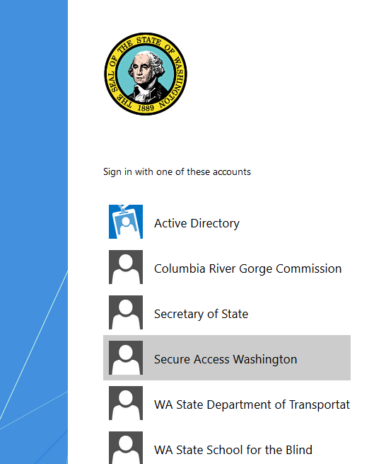
*Note – The second time you go into Learning Center, you will skip this screen and no longer have to select “Secure Access Washington.”

If you have a habit of clearing your cache, your browser will direct you to this web page every time and you will have to select “Secure Access Washington.”
After selecting the “Secure Access Washington” option, you will be directed to the Learning Center’s landing page or home page.

You are now ready to use Learning Center.
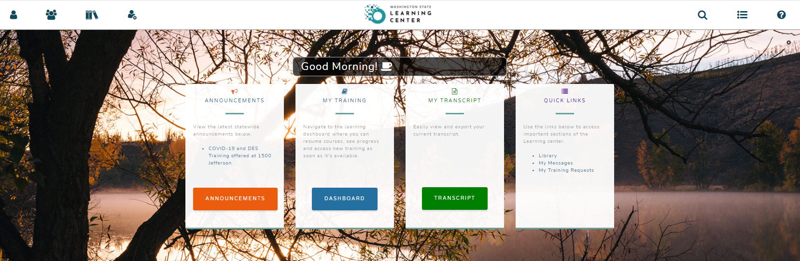
Please note that some screen shots may look slightly different based on roles assigned.

HOW TO LOCATE A CLASS

At the top of the screen click on the “Administrative” drop down
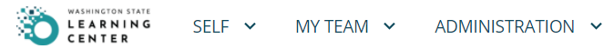

From the drop-down menu click on “Learning Management”, “Activity Management” and “Learning Activities” It will look similar to the below screen shot.

Your screen should look similar to the screen shot below.

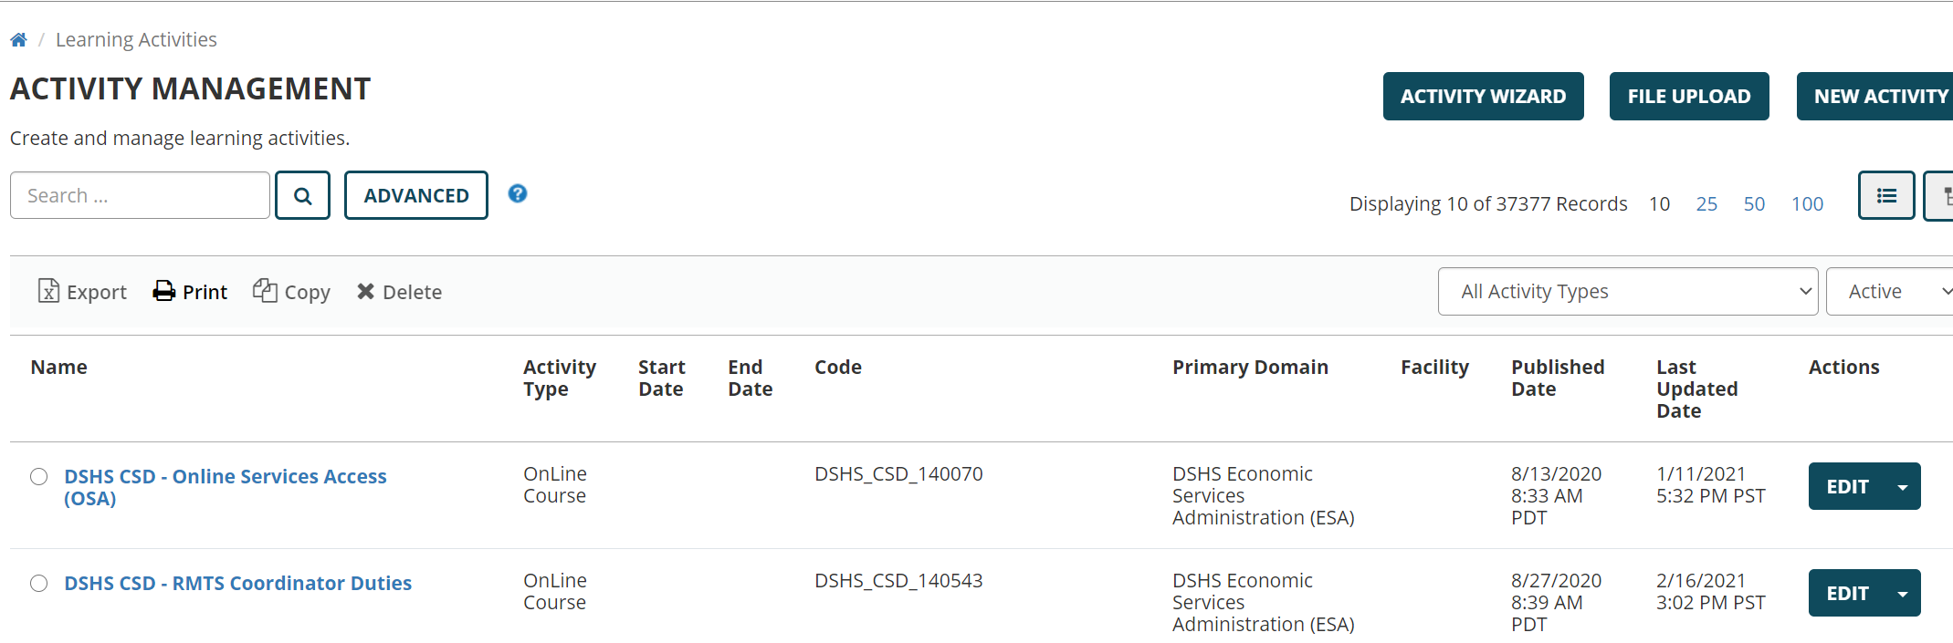
From here, you will enter the name or sequence number of the class you are searching for within the search bar.
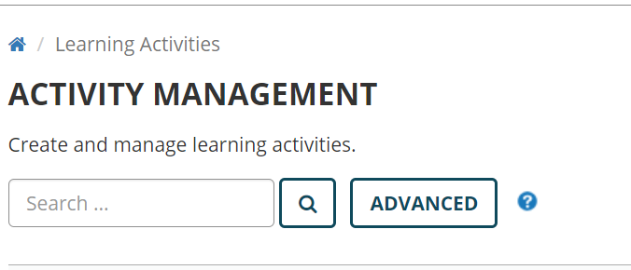

Example: if you choose to put in the search box 7780, it should pull up the WA-State Writing Policies & Procedures class captured below.

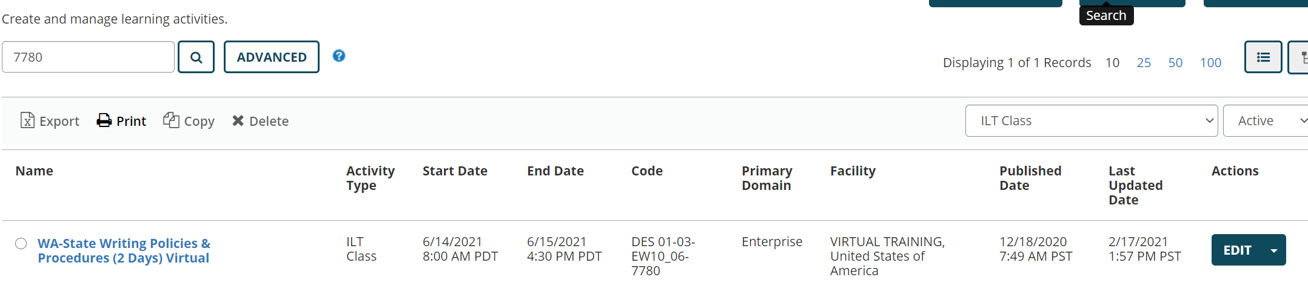
If you are not seeing your class and the facilitation date has already passed, this is because our team has closed out the class so it’s no longer in an “Active” status.
Your search field is pre-set to search for active classes so you will need to change this using the drop- down menu on the right hand side of the tool bar and select “All”
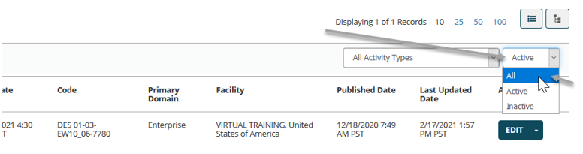

Once you’ve found your class, click on the blue “EDIT” box drop down and select “Manage Roster”
NOTE: It is important to note that instructors should only be using the “Manage Rosters” option when accessing classes. If you accidently click “EDIT” or anywhere else, please click on the Learning Center logo at the top of the screen to navigate back to the home screen.

HOW TO VIEW ROSTERS

Once you’ve navigated through the “How to Locate a Class” section and have clicked on “Manage Roster”, you’ll be able to view how many learners are registered for the class.
Please note that this screen will show you everyone who has registered for or cancelled the training.
You can use the “Filter by Status” drop down box and select “Registered” so you’re only seeing the active registered learners.
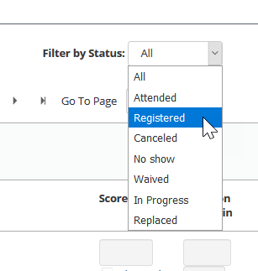
NOTE: It is important to make sure that your “Show Records” drop down is changed to “50”. This way, you’ll see everyone on one screen.
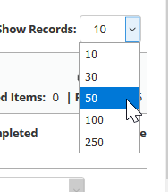
TIP: You can also click on the “Show More Details” link. This will show you the active number of learners registered for the class while also showing you the number of learners who are currently in a “pending approval” status. This means that they have asked to take the class and are waiting on their supervisor’s approval.
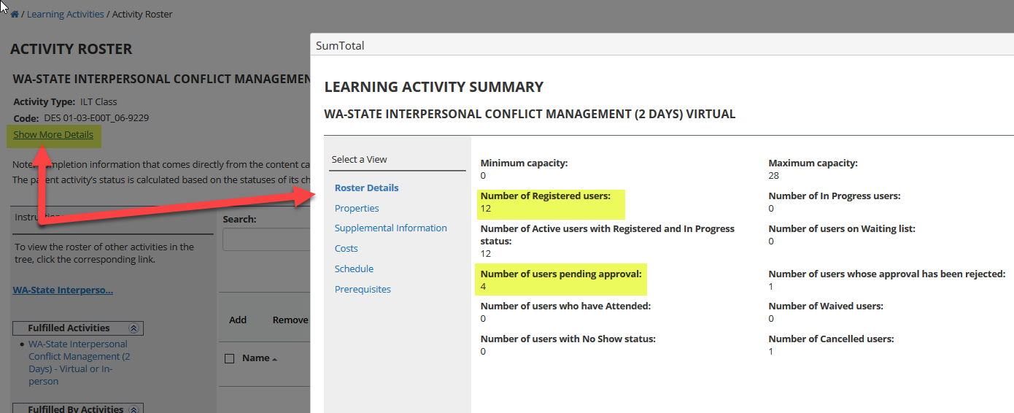

HOW TO SEND COMMUNICATION TO LEARNERS

It is best practice to allow DES to send communication to learners. This reduces the risk of your email being caught in a firewall/spam folder. Please draft your communication and forward that to Traininginfo@des.wa.gov inbox and request that we send out the communication on your behalf. Our team will CC you on this correspondence.
If you do send out communication to learners, you’ll want to check the box next to “Name”. This will select-all. If you want to send an email to only a few individuals, select just their name.
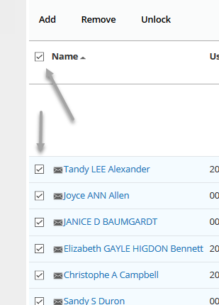
Once all the learners are selected, click on the “SEND E-MAIL” at the bottom of the screen.
Please copy Traininginfo@des.wa.gov on all communications sent out.
To view/print the Roster, a “Reports” box should be visible on the left-hand side of the screen. Click on “Activity Sign-in Sheet” then click on “Export to PDF” or “PRINT”
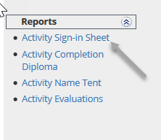

HOW TO VIEW EVALUATIONS

It’s important to make sure that you’re changing the search parameters to view “ILT Class” and “All” trainings vs. just active trainings.
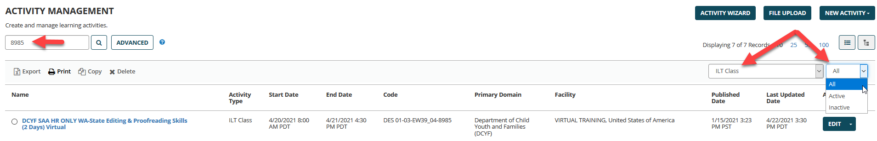

Once you have located the class, click on the Edit drop down menu and select “Manage Roster”
A “Reports” box should be visible on the left hand side of the screen. Click on “Activity Evaluations”
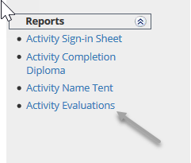
On this screen, you’ll want to click on the “Start” button.
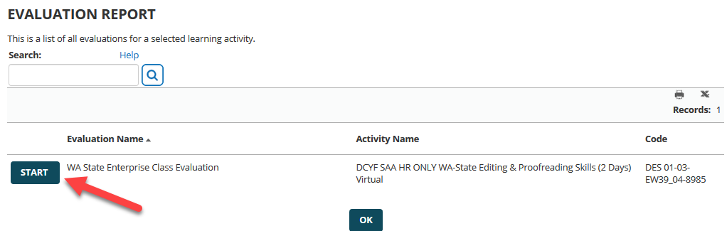
A window will open and show you the evaluations compiled into one report. This reflects the number of respondents and a compiled percentage of how the evaluators responded to each question.
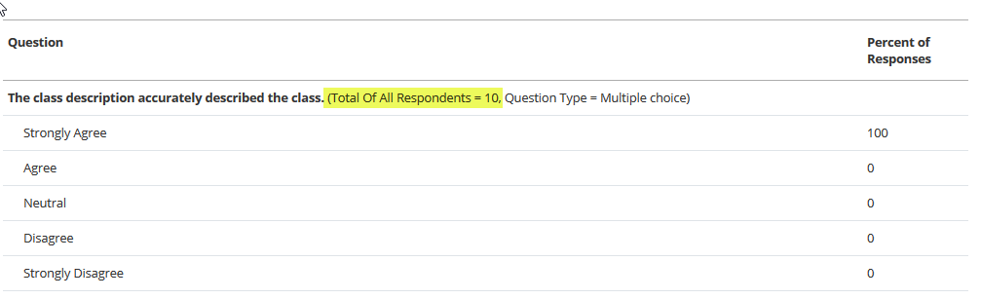
At the bottom of this page, you’ll also see a “View comments” option. By selecting this, you can view all of the free form feedback that evaluators left.
If no evaluations are available, please continue to check back.

DES PROCESS FOR LINKS, MATERIALS AND EVALUATIONS

DES PROCESS FOR LINKS
Links will be provided by the instructor to DES 10+ business days before the class date
On the participant cancellation date, DES we will reach out to share how many learners are enrolled.
If you wish to move forward with facilitating the class, we will ask that you provide a link for the platform training session. DES will email this information to learners and include this link in the class description so that any new learners will receive the link when they enroll.

This process should resolve issues when learners register last minute and did not receive the initial communication regarding the platform link.

DES PROCESS FOR MATERIALS
Materials will be provided by the instructor to learners on the day of class through the virtual platform.
Class Materials will be provided to learners at the beginning of each class from the instructor. All platforms (such as Zoom) now allow you to share documents through the platform.
If there is pre-work to complete, DES can send that information out in advance by the instructor’s request. DES ask that the instructor drafts the email communication as if it’s written for the learners along with any attachments, send that to traininginfo@des.wa.gov and request that they forward the email to all registered learners.

Printing options: If you require learners to print materials or need materials prior to a training, please include that within the pre-communication email so that can be shared before the class date. Some instructors allow extra time during the first break for learners who may wish to print something off at home.

This process should resolve issues where learners share that they did not receive materials in advance. This will also resolve issues where instructors are providing class materials and the learner cancels or no-shows. They will not receive a copy of the class materials.

DES PROCESS FOR SENDING COMMUNICATION TO LEARNERS
DES will send email communication to learners. DES asks that the instructor drafts the learner email communication that LSOT can copy and paste along with any attachments. Send the email communication to traininginfo@des.wa.gov and request that they forward the email to all of the registered learners. DES will copy the instructor on these communications.

This process should resolve the issue of communication being caught in learners spam folder. This will also provide DES a copy of the communication to forward to any late registering learners.

DES PROCESS FOR ROSTERS
Rosters will be sent 1 business day prior to scheduled class date
For the time being, DES will continue to send class rosters to the instructor 1 business day prior to the scheduled class.

It’s recommended that instructors begin logging in to the Learning Center and download their own copy of the LMS Roster. Instructors should update the roster to reflect who attended and should receive completion credit and those who did not attend or should not receive completion credit.

DES will need a copy of the completed roster along with the Invoice within 5 days of the class being completed.

DES PROCESS FOR EVALUATIONS
Evaluations will be completed by learners within the Learning Center
Class evaluations are assigned within the Learning Center, and can be found on the learner’s profile the day of the class (Learning Activity Evaluations - SumTotal). After the first day of class concludes, learners will receive a notification from the Learning Center (SumTotal) explaining where to find and complete the evaluation.

Instructors can view evaluation feedback by accessing the class within the Learning Center.

VIRTUAL PLATFORM SETTINGS
(Zoom example provided)

VIRTUAL PLATFORM SETTINGS
DES asks that instructors use the following settings within virtual platforms when facilitating a DES training:
- Do not record training sessions
- Prevent participants from saving chat
- Not allow participants to send private chats to other students
- *Turn off “Auto Saving Chats” feature
- Turn on the “File transfer” option so that you can send materials through the platform to learners on the day of class.
This process is to minimize the administration burden of managing public records requests.

ZOOM INSTRUCTIONS
- Login to your account at https://zoom.us/
- Click on “Settings” within the left-hand column then “In Meeting (Basic) in the second left hand column.
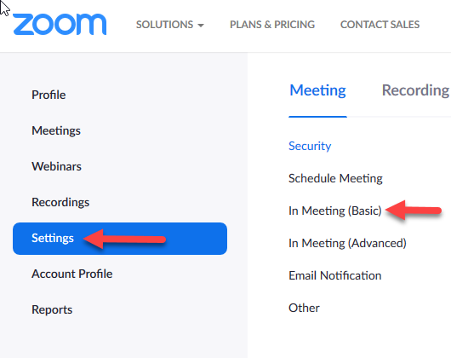
- Activate Chat “Allow meeting participants to send a message visible to all learners
  - Check the box “Prevent participants from saving chat.”
- Deactivate Private chat “Allow meeting participants to send a private 1:1 message to another participant.”
- Deactivate Auto saving chats “Automatically save all in-meeting chats so that hosts do not need to manually save the text of the chat after the meeting starts.”
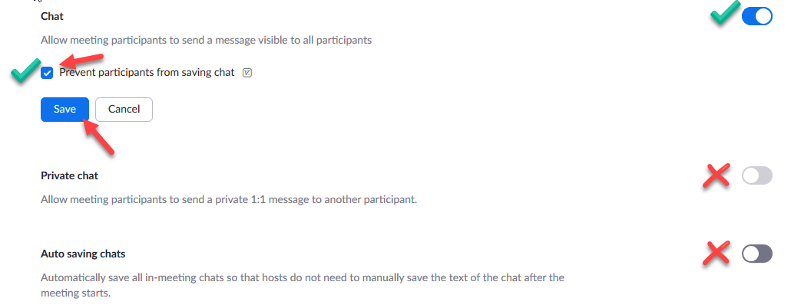
- Scroll down and activate File Transfer “Hosts and learners can send files through the in-meeting chat
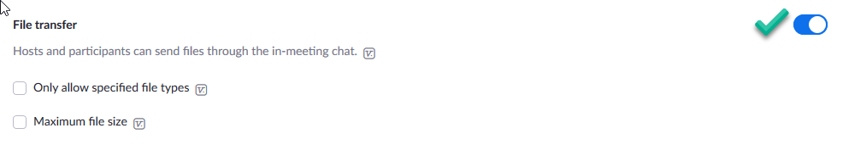
- Enable “Closed Captioning”
- Click on “Settings” within the left-hand column
- In Meeting “Advanced”
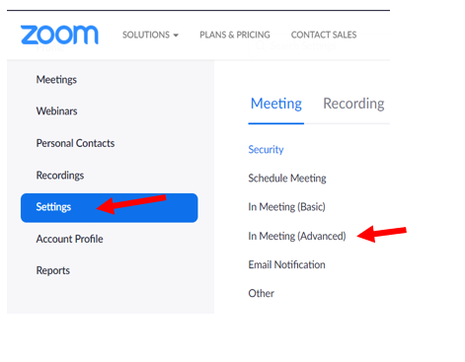
- Turn on “Closed Captioning”
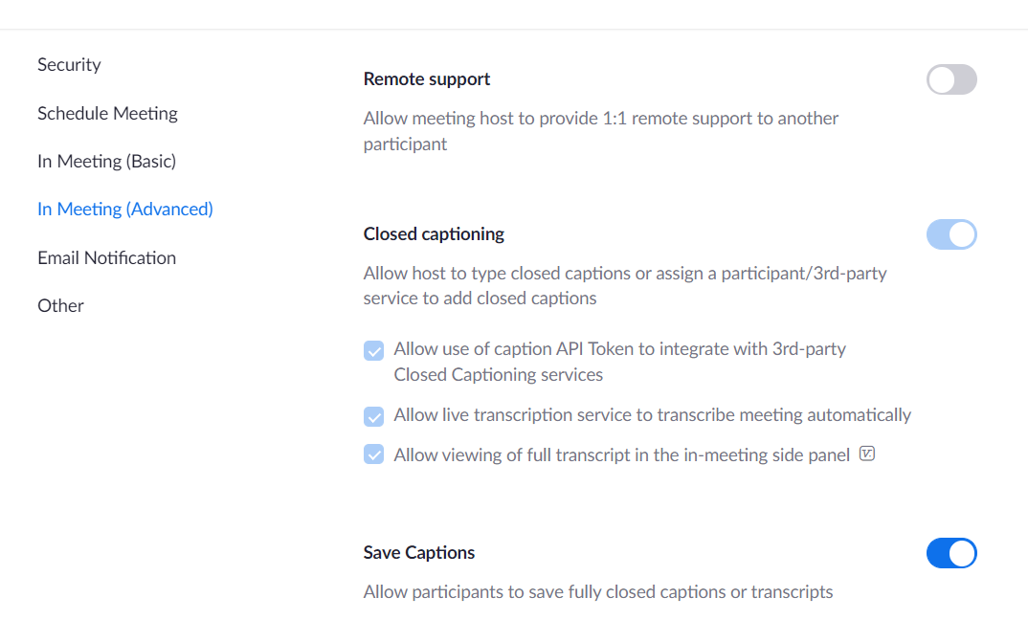
- Other features are optional and up to the discretion of the facilitator.

INCLEMENT WEATHER (In-Person Trainings)
Inclement weather can slow or impede instructor and learner ability to be on-time or to show up to an in-person class at all. If you have travel concerns the morning of you training, please communicate with us as early as possible, but no later than 6:15 a.m. Instructors notifying us in a timely manner allows us to send a notification to class participants by 6:30 a.m. Please send that communication to our shared inbox at: DESMILearningSolutionsTeam@des.wa.gov.

For the status of DES 1500 Jefferson building operations during inclement weather, please call 1-800-418-5174. If this recording indicates a closure or delay, classes will also be cancelled or delayed based on information provided. This line should be updated no later than 5:45 a.m. You may also sign up for email or mobile building notifications via Gov. Delivery DES Building Notifications. You can unregister from receiving these notifications at any time. If your class is cancelled due to building closures, a DES Learning Consultant will be reaching out to you to coordinate rescheduling.
If you have concerns regarding travel and you're aware that you won't be able to arrive safely, we will be happy to work with you on rescheduling that training. Please make any decisions you deem necessary as your safety is paramount.
In situations where inclement weather takes place during a training, please use your best discretion if or when it's best to wrap up for the day. Be sure to communicate with onsite DES LSOT staff. It will be up to you on whether you wish to give homework for the class for learners to get credit or if there is a need to reschedule the class. DES can be a point of contact for turning in assignments or we will do our best to work out any rescheduling needs.

QUESTIONS?
Please reach out to your DES Learning Consultants at: DESMILearningSolutionsTeam@des.wa.gov

